

I



S A F E T E 0 H ’98

SAFETECH '98 CINVENTION AND TRADE SHOW **•** VALLEY FORGE, PENNSYLVANIA **\*** MAY 18

Die Hard Manipulation Time Lock Servicing Advanced Servicing and *Defeat* Methods

Red Label GSA Containers Safe Opening Extravaganza Electric Locks and Safe Retrofitting Safe Moving and Installation



SAFE AND VAUL 9 0 03 LIVE OAK DALLAS, TEXAS Z1 4.8 27.7Z33 21 4.8 27.1 81 0 (

TECHNICIANS ASSOCIATION  
STREET  
75 2 04

AX)

E-MAIL: [C0NVIIIN@ANE1-DFW.CBM](mailto:C0NVIIIN@ANE1-DFW.CBM)



ALOA ’98 International Convention & Security Expo

*“No one succeeds alone*. *The  
input*, *tolerance and sharing  
of knowledge from others in  
this industry account for most  
of my success. My part was to  
learn—a lifetime process*—

*and to work hard”*

Dan Graffeo, CRL, CMS ALOA Member #8188 1996 recipient, ALOA Lifetime of Outstanding Achievement



Nashville Convention Center

Nashville, Tennessee



June 14-20, 1998

*Associated Locksmiths of America*

*3003 Live Oak Street*

*Dallas, Texas 75204*

*214.827.1701*

*800.532.2562*

*e-mail [convtion@anet-dfw.com](mailto:convtion@anet-dfw.com)*



**April**

Features



The Cover The professionals featured this month work, respectively, for the World Bank, the D.C. Water and Sewer Authority and a Fortune 500 corporation. Welcome to the institutional locksmithing game, where the choices are almost endless.

Cover illustration © Lynn Eskridge Art direction/design Valerie Rowe

**18**

All Around The World Bank cover topic

The locksmith for this Washington D.C. landmark fled from strife-torn Uganda at the age of 15. Now he protects the institution that protects third world nations.

By Mike Emery

20

Convention News

From ISC to ALOA ’98. From classes to Fan Fair in Nashville. Here’s the scoop. P.S. Reserve your hotel room.

22

How to Expand Your Shop

Find out if you’re ready to expand and how locksmiths get the money to grow their businesses.

By Jeff Siegel

**24**

Low Tech Products

Not every great thing is big, expensive and complicated. These handy tools make everyday life a little simpler.

By Sal Dulcamara, CML

**26**

Inside 3IVi cover topic

Find out about the changing face of institutional locksmithing from someone who made the transition from retail.

By Steven Spiwak, CRL

**28**

A Conversation With Rovey cover topic

The president of the Institutional Locksmiths Association shares his thoughts.

By Paul Chandler

**30**

The Evolution of the Security Industry, Part 3

Electronics. Here we are, staring down the future of locksmithing.

By Steven Spiwak, CRL

**34**

Servicing Mul-T-Lock Heavy Duty Padlocks

You’re not going to figure these out by just looking them over. Let us walk you through it.

By Sal Dulcamara, CML

**37**

The Viper

We’ve all been bitten by the tool bug. Here’s a good one.

By Sal Dulcamara, CML

**39**

Nine Costly Errors in Terminating Employees

Fire at will, but aim carefully.

By Philip Perry

**44**

Biometrics

Fact and fiction about the latest greatest ID systems.

By Steven Spiwak, CRL

April 1998

iH.HihiMiig

**Advertising**

President’s Journey

I’m listening, but you better know what you’re talking about.

9

Q&A

Correct key blanks and terminology.

11

Focus on Education Interview with David Lowell.

12

Legislative Comment Grassroots letter writing beats the NBFAA’s big bucks. Keep it up.

54

PRP Report

Frequently asked questions.

56

Chapter News How to start an ALOA chapter n your area.

Upcoming Events Mark June 14-20, Nashville.

8

Contest

Test your membership meeting voter IQ.

10

Applicants for Membership Scheduled for clearance May 1.

14

Industry News

ILA will be joining ALOA at ISC.

16

Security Marketplace

58

ALOA Extra

60

Back Page

47

Buyers’ Guide

48

Associate Members

52

Classifieds

58

Ad Index

J Keynotes

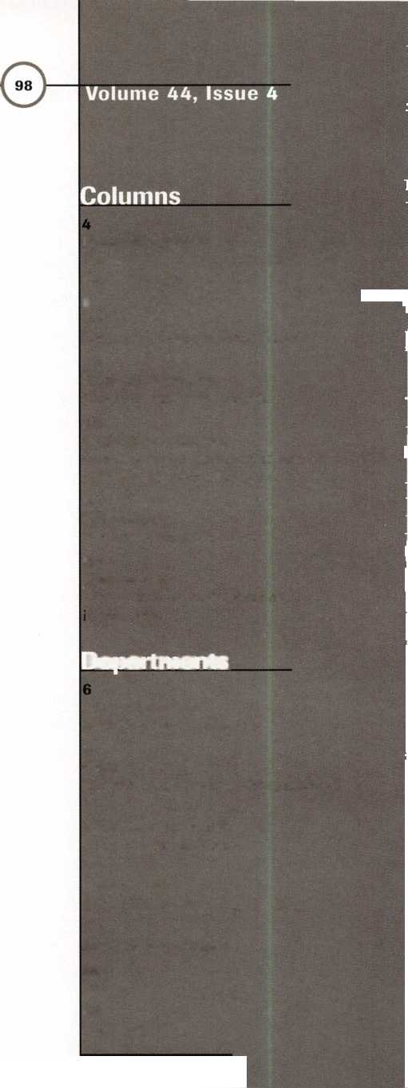

|  |  |  |
| --- | --- | --- |
| Sales Assistant | D’Anna Weber |  |
| Contributing Authors | Jerome V. Andrews, CML  Kim Bowers,CML  Paul Chandler, CRL  Claire Cohen, CML  Brian Costley, CML, CMS  Bob De Weese, CPL  Ray D’Adamo, CML  Sal Dulcamaro, CML  James Glazier, CML  Wayne Gurnee, CRL  A.J. Hoffman, CML  Ken Holmlund, CRL  Ray Lusk, CML  Mark Ohno |  |
|  | David Parrott | Complete address and |
|  | Randy Simpson, CML  Steven Spiwak  Robert Stafford, CPL | phone number listings for the ALOA Board and most |
|  | Dave Thielen | Keynotes authors are |
| Editorial Advisors | John D. Cannon, CML, Technical Content | available through "Locksmith |
|  | Jerome Andrews, CML | Search" on the ALOA |
|  | A.J. Hoffman, CML | website-[www.aloa.org](http://www.aloa.org), or by |
|  | Leonard J. Passarello, CPL | contacting the ALOA office at |
|  | Randy Simpson, CML | 3003 Live Oak Street; Dallas, |
|  | Robert Stafford, CPL | TX 75204; (.214)827-1701; |
| ALOA Professional Staff |  | FAX (214) 827-1810; e-mail |
| Executive Director | Charles W. Gibson, Jr. | publ@anet-dfw. com. |
| Office Manager | Mary May |  |
| Receptionist | Margo E. Vela |  |
| Comptroller | Kathy J. Romo |  |
| Financial Assistant | Debra Bradshaw |  |
| Meetings Manager | Jessica Vasquez |  |
| Meetings Assistant | Janelle Vergara |  |
| Legislative Manager | Tim McMullen |  |
| PRP/Education Manager | David Lowell, CML, CMS |  |
| Education Assistant | Ashley Spenser |  |
| Membership Coordinator | Brandon Durrett |  |
| Membership Assistant | Jackie Arnett |  |



Mission Statement: The Associated Locksmiths of America, Inc. is dedicated to enhancing the professionalism, education and ethics among locksmiths and hose in related sectors of the physical security industry. With approximately 10,000 members in the United States, Canada and the freeworld, ALOA is poised to lelp members obtain the knowledge, the strength, and the confidence to perform their role in the physical security field with pride and dignity. But it is only hrough active involvement and participation that ALOA can fully achieve its potential-and can help members to achieve theirs.

Policies: Keynoted is the official publication of the Associated Locksmiths of America, Inc. (ALOA). Keynotes? acts as a moderator without approving, Jisapproving, or guaranteeing the validity or accuracy of any data, claim, or opinion appearing under a byline or obtained or quoted from an acknowledged >ource. The opinions expressed by the authors do not necessarily reflect the official views of ALOA. Also, appearance of advertisements and new products or service information does not constitute an endorsement of products or services featured by the Association. The Association does not accept responsibility for he inaccuracy of any data, claim, or opinion appearing in this publication, due to typographical errors on the part of the authors, Association staff or its agents. Editor’s Note: This publication is designed to provide accurate and authoritative information in regard to the subject matter covered. It is provided and Jisseminated with the understanding that the publisher is not engaged in rendering legal or other professional services. If legal advice and other expert assistance is required, the services of a competent professional should be sought.

Authors’ Payment: Payment for eligible submissions to Keynotes will be based on the following criteria: topic, time spent and past contributions. Authors who egularly submit to Keynotes are generally paid a higher rate. The latter is especially true of authors who write to fit specific editorial needs and submit said copy )y Keynotes deadlines. As a general guideline: Average payment for a 750 word, business or 'light’ technical article would be $200. Payment for a 1500 word article nvolving significantly higher time and research efforts would be $400.

Payment will not be offered for articles submitted by ALOA employees or members of the ALOA Board of Directors (unless material is of a technical nature), tor for articles submitted by a company that promote that company’s products or services. ALOA reserves the right not to pay for articles submitted by an ndividual(s) that promote a particular company’s products or services.

Disclaimer: The Associated Locksmiths of America, Inc., (ALOA), reserves the right to refuse any article for any reason. Additionally, ALOA reserves the right o edit, amend or modify any article submitted for publication in order to preserve technical accuracy, clarity, fairness or grammatical correctness. ALOA will make he best efforts to notify the author of any changes. The extent of ALOA’s liability for any article or information contained therein will be a notice of correction or enaction in the next possible issue.

Keynoted (ISSN 0277 0792) is published monthly except for the combined June/July issue by The Associated Locksmiths of America, Inc., 3003 Live Oak St., Dallas, TX 75204-6186. Telephone: (214) 827-1701; FAX (214) 827-1810: e-mail [aloa@anet-dfw.com](mailto:aloa@anet-dfw.com). Subscription rates for members-$ 15.00 per year. Second Jass postage paid at Dallas, Texas. POSTMASTER: Send address changes to: Keynotes, 3003 Live Oak St., Dallas, TX 75204-6186. © Copyright 1998, All rights eserved. No part of the contents may be reproduced or reprinted in any form without prior written permission of the publisher.

President

Dallas C. Brooks (334) 826-8990

Regional Vice Presidents Southeast

♦Jeffreys. Nunberg, CML, CMS

(305) 324-8800

North Central

♦John J. Greenan, CML, CPS

(773) 486-2030

South Central

♦Randy L. Simpson, CML

(713) 780-7026

Southwest

John I. Shandy, CML

(303) 776-7898

Northeast

James H. Glazier, CML

(301) 831-5454

Northwest

Raymond C. Lusk, CML

(509) 624-3152

Secretary

John D. Cannon, CML (703) 960-6413

Trustees:

David M. Lowell, CML, CMS (214) 827-1701 Breck H. Camp, CML (770) 455-6244 Henry H. Printz, CML (201) 538-2737 Leonard J. Passarello, CPL (416) 752-7210 Edwin Toepfer, RL (416) 225-5589 Directors

*These officers also serve as directors.

Dana L. Bamum, CML (610) 565-9900 Mark E. Blum, CML, CPS (517) 482-5809 AJ. Hoffman, CML (714)572-6008 Barry K. Leas, CRL (610) 272-9292 Clyde Roberson, CML, CPS (540) 380-5000 Donald E. Rul6, CML (601) 324-2658

Anthony J. Ramunno, CML, CPS

(330) 782-6204

Robert H. Stafford, CPL

(860) 768-7917

Bruce J. Tarbet, CML

(601) 924-4184

Chairmen of International Affairs

Laurence P. Mills/Australia (129) 958-0445 Hans Mejlshede, CML/Europe FAX (453) 139-1004 Members-at-Large Jerome V. Andrews, CML (860) 621-3601 Steven G. Engel, CML, CPP (414) 731-5400

Past Presidents

1995-1997 David Lowell, CML, CMS 1993-1995 Breck Camp, CML 1991-1993 Henry Printz, CML 1989-1991 Evelyn Wersonick, CML 1987-1989 Leonard Passarello, CPL 1985-1987 Joe Jackman, CML 1983-1985 Stanley Haney, CPL 1981-1983 Louis LaGreco, CPL 1979-1981 John Kerr, RL 1977-1979 Clifford Cox, CM L 1974-1977 Charles Hetherington 1972-1974 Gene Laughridge 1970-1972 William Dutcher, RL 1968-1970 Constant Maffrey, RL 1966-1968 Harold Edelstein, RL 1964-1966 William Meacham 1962-1964 Robert Rackliffe, CPL 1960-1962 Edwin Toepfer, RL 1956-1960 Ernest Johannesen

April 1998

Keynotes **h**

>v

CD

C

with Dallas Brooks

KNOW WHAT YOU'RE TALKING ABOUT

**13**

O

CO

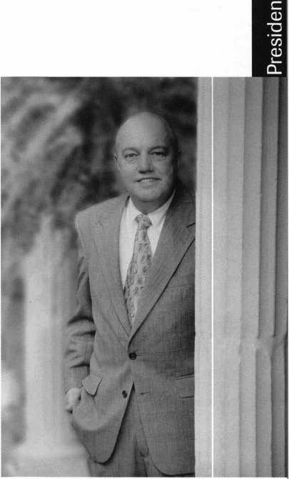

I don’t mind when somebody disagrees with me—if they have all the facts.  
After all, we all have our own point of view and that’s what makes life  
interesting. I find a good disagreement enjoyable in a way. An open forum  
between informed parties is actually one principle that the U.S. system of  
government is based on. The key word here is ‘informed.’ Lately, I’ve been  
running into a few people who aren’t.

One example. Just recently, we got a letter from a member complaining  
about the dues increase. Understood. I think ALOA’s a bargain. He doesn’t. It’s  
his life. But wait. One of the reasons he gave is that we don’t provide group  
health insurance. Interesting. It just happens to be illegal for associations to  
provide group health insurance. The American Society of Association of  
Executives has been fighting this battle for years. And it looks like victory may  
be in sight. Believe me, when it’s legal, we’ll do it. Our complainer went on to  
say that ALOA doesn’t need the new departments we added this year-that we  
should downsize instead AND provide additional services to members. Huh?  
How does that work? Let’s test your association management IQ.

For a national association with our number of members and basic association  
services to members, we have what could easily be referred to as a 'skeleton crew.'  
(Seventeen people—about the same number we've had for the past decade.) We  
have one- and two-person departments. Tell me who we don’t need. The two  
people who put on our convention AND SAVTA’s? The two people who manage  
the computers AND do all basic membership service functions-for both ALOA  
and SAVTA? The three people who put out the magazine each month AND  
handle all printed materials and communications—including the Web? And  
those two new staff? Shall we ditch the first regional education efforts in ALOA’s  
history and the best new classes? Is it time to walk away and let legislation eat us  
alive-just as we’ve begun to win battle after battle (Hello, Maryland)? Our  
comptroller? How about the switchboard operator? Do we really have to  
answer the phones?

You get my drift. Why would anyone go out of their way to damage  
something they haven’t taken the time to understand? Get your facts straight.  
Along those lines, be ready to vote at the membership meeting in June. Go  
back to January Keynotes and re-read “Business Not As Usual” and go over  
“New Rule Book” in the March issue. Take the quiz on page 8 of this issue  
and see how you do. And as more information comes out for the membership  
meeting, stay informed.

There’s a highly successful wholesale clothing store whose slogan is “An  
informed consumer is our best customer.” I think that’s true for ALOA too.

QjtfLc&tJL-

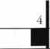

Keynotes

April 1998

|  |  |
| --- | --- |
| Kwok-kei Leung | 160 |
| Henry Raymond | 93 |
| Toshihiro Asano | 68 |
| Stewart Levine, CML | 67 |
| Mary Ohmit, CPL | 63 |
| Allen Konrath | 49 |
| Charles Robertson, CML | 48 |
| Jack Hobin, CPL | 47 |
| Yuriko Yanai | 43 |
| Mveonq-Rae Cho | 36 |
| William Neff, CML | 35 |
| Salvatore Dulcamara, CML | 35 |
| Thomas Freehling, CML | 32 |
| Jeanne Lodge, CML | 27 |
| Roy Renderer, CML | 25 |
| John Heckman, CML | 24 |
| Danny Rudd, CPL | 23 |
| James Watt, CML | 23 |
| Robert Carroll, CPL | 23 |
| David M A Federico | 23 |
| John Elliott, CML | 22 |
| Diana Barnum, CRL | 22 |
| Barbara Watt | 22 |
| J Thomas Hood, CML | 22 |
| Robert DeWeese, CPL | 22 |
| Larry Warnick, CML | 21 |
| Jerome Cohen, CML | 21 |
| Eugene Altobella | 21 |
| im Williams | 21 |
| D Michael Lee, CPL | 18 |
| James Fowler, CML | 18 |
| David Harris, CML | 18 |
| Elvis Hammerschmidt, CPL | 18 |
| John Kerr, RL | 17 |
| Marian Swann, CRL | 17 |
| John Dorsey, CPL | 17 |
| Charles Cole, CML | 17 |
| Ronald Heidzig | 17 |
| Joseph Ferrero, CML | 16 |
| William Grant, CRL | 16 |
| Brian Reetz | 16 |
| Walter Lascar, RL | 15 |
| James Cawby, CML | 15 |
| William McElhenev, CML | 15 |
| Michael Robinson, CRL | 15 |
| Rex Parmelee, RL | 14 |
| Lawrence Smith, CML | 14 |
| Thomas Vandersteen, CML | 14 |
| Philip Rovenolt, CPL | 14 |
| Edwin W Scott | 13 |
| James Gruber | 13 |
| Peter Gauthier, CPL | 13 |
| Gary Teams, CPL | 13 |
| Russell Fuller, CRL | 13 |
| Robert Rodocker, CRL | 12 |
| Frank Hartung, CML | 12 |
| Rolando Bouza | 12 |
| Lonnie McKinney, CML | 12 |
| James Brickler, CRL | 12 |
| Richard Sievers | 12 |
| Eric Veal | 12 |
| Herbert Dusenberry, CML | 11 |
| Robert Duman, CML | 11 |
| Jon Griswold, CML | 11 |
| Robin Horsley | 11 |
| John Engel, CRL | 11 |
| Daniel Landry | 11 |
| Ernest Wright | 10 |
| William Wickward, CML | 10 |
| Lester Brodsky | 10 |
| Joseph Whitaker, CPL | 10 |
| Dale Knowles, CPL | 10 |
| Paul Souber | 10 |

The Brightest

And The Best.



How can I join the President's Club?

You can earn membership in this prestigious dub by recruiting just 10 new members for ALOA.

*Any ALOA member may participate.

What do I get?

When you recruit 10 members, you receive a handsome blue blazer with a President's Club crest. For each additional five members you recruit, you receive a lapel pin with gold-filled numbers, indicating your recruiting successes.

You also get the satisfaction of knowing that you are helping your association, helping your industry grow, and you are helping fellow locksmiths achieve success.

How do I get started?

Contact the ALOA office for a supply of applications (214) 827-1701 or FAX (214) 827-1810. One President's Club credit is awarded for each new applicant. Credit is awarded only after the membership application is approved. However, the credit will apply for the period in which the application is received. Failure to identify yourself as the sponsor on the application form at the time it is submitted to ALOA for processing will forfeit any credit.

*AL0A Board of Directors not eligible for membership in the President's Club.

**Upcoming**

Events



(Deptl

S' Future Conventions

1998

ALOA ’98 June 14—20 Nashville, Tenn.

SAFETECH ’98 May 18-23 Valley Forge, Pa.

1999

ALOA’99 July 25-31 Cincinnati, Ohio

SAFETECH ’99 May 3—8 Las Vegas, Nev.

2000

ALOA 2000 Date TB A Las Vegas, Nev.

SAFETECH 2000 May 5—6

Birmingham, Ala.

2001

ALOA 2001 July 15-21 Baltimore, Md.

2002

ALOA 2002 July 21—27 Rosemont, 111.

For PRP dates**,** see p. 54. For ACE dates, seep. 11. Send in the dates of your organization’s activities today!

**L**J

61 Keynotes April 1998

APRIL ’98

3-4

Lockmasters Simplex Certification Nicholasville, Ky.

(800) 654-0637

7-10

Clark Security Products Trade Show Contact: Terri Burges (800) 854-2088, ext. 273

7-13

MLA of Great Britain Convention Birmingham, England Contact: Peter Hall 01327-262255 phone 01327-262539 fax

15-17

The 1996 National Electrical Code University of Wisconsin Madison, Wis.

(800) 462-0876

18-19

MBA

Defeating Dimple Key Locks Nicholasville, Ky.

(888) 622-5495

24-26

American Society Distribution Anaheim, Calif.

(800) 844-8545

26

South Jersey Locksmiths Association, Inc.

First Annual Swap Show Mount Laurel, N.J.

(609) 767-4977 (609) 894-0805 (609) 939-6373 fax (609) 894-2400

1. May 3

European Locksmith Federation San Sebastian, Spain 34-43-28-43-84 fax

MAY ’98

6

Lockmasters

Push Button Manipulation Nicholasville, Ky.

(800) 654-0637

7-10

Clark Security Products D.C. Trade Show Contact: Terri Burges (800) 854-2088, ext. 273

17

MBA

Time Locks Nicholasville, Ky.

(888) 622-5495

18-23

SAFETECH ’98 Valley Forge, Pa.

(214) 827-SAFE (7233)

(214) 827-1810 fax

e-mail: [convtion@anet-dfw.com](mailto:convtion@anet-dfw.com)

27-31

National Independent Bank Equipment & Systems Assoc. Annual Convention Montreal, CANADA (800) 843-6082

31-June 6 New Event

ALOA ACE Classes at ISC West Chicago, 111.

(800) 840-5602 (203) 840-5602

JUNE’98

14-20

**ALOA ’98 Security Expo** 59 full-day class sessions 54 half-day class sessions Six evening seminars Exhibits from leading security products/systems manufacturers and distributors City tours Annual banquet ALOA Membership Meeting

Nashville, Tenn.

(800) 532-2562

(214) 827-1810 fax

e-mail: [convtion@anet-dfw.com](mailto:convtion@anet-dfw.com)

20

ALOA Annual Membership Meeting (breakfast)

NEW BYLAWS VOTE 6:30-11 am Renaissance Hotel Nashville, Tenn.

(800) 532-2562

(214) 827-1810 fax

e-mail: [convtion@anet-dfw.com](mailto:convtion@anet-dfw.com)

25-28

National Burglar and Fire Alarm Association Annual Meeting San Antonio, Texas (301)907-3202

JULY’98

17-19

S. C. Association Meeting Columbia, S.C.

(803) 735-1600

23-25

South Carolina Locksmiths Association Quarterly Meeting Columbia, S.C.

Contact: Jean Griggs (803) 532-9008

25-26

California Locksmith Association Anaheim, Calif.

Contact: Kimber Smith (714) 632-6800

1. August 2

Clark Security Products ChicagoTrade Show Contact: Terri Burges (800) 854-2088, ext. 273

|  |  |
| --- | --- |
|  | Upcoming |
|  | Events |

AUGUST ’98

6-9

New Mexico Locksmith

Association

Las Cruces, N.M.

(505)247-9413

13-16

SAVTA Fall Board Meeting Las Vegas, Nev.

(214) 827-SAFE (7233) (214) 827-1810 fax

19-23

SERLAC Trade Show Orlando, Fla.

Contact: Bill Norris (850)433-5118

SEPTEMBER ’98

1-3

New Event

ALOA ACE Classes at ISC New York New York, N. Y.

Contact: (203) 840-5602 (800) 840-5602

1-13

The Association of Ontario Locksmiths Scarborough, Ontario (888) 272-8265

17-20

Clark Security Products Southern California Trade Show Contact: Terri Burges (800) 854-2088, ext. 273

OCTOBER ’98

1-4

POLA Trade Show ’98 Penn Ohio-Locksmiths’ Association, Inc. Independence, Ohio (Cleveland area)

Contact: Martha Eggler (216) 676-8464 Fax (216) 267-2411 e-mail: PALO 1 l6@aol,com

17-19

S. C. Association Meeting Columbia, S.C. (803)735-1600

19-25

25 th Tri-Regional Locksmith Conference Portland, Ore.

Contact: Stan Hauer (503) 325-6003 phone/fax

21-25

Yankee Convention Providence, R.I.

Contact: Rob Mahoney (800) 209-8266

1. Nov. 2

Door & Hardware Institute Orlando, Fla.

(703) 222-2010

"Mas Hamilton locks, parts and accessories... the professional's choice when **only**

the best will do!"

Model lOOR^—1

Introductory Price: $119.95

FEATURES

/Master code  
/ Audit-trail  
/Requires no batteries

/Five user codes / Time-delay / Self-powered

ASTER

127 SE 29th Street ♦ Topeka KS 66605 888 798 8464 ♦ Fax 800 798 TIME (8463) 785 232 8705 ♦ Fax 785 232 2603

Reader Service #1

April 1998

Keynotes

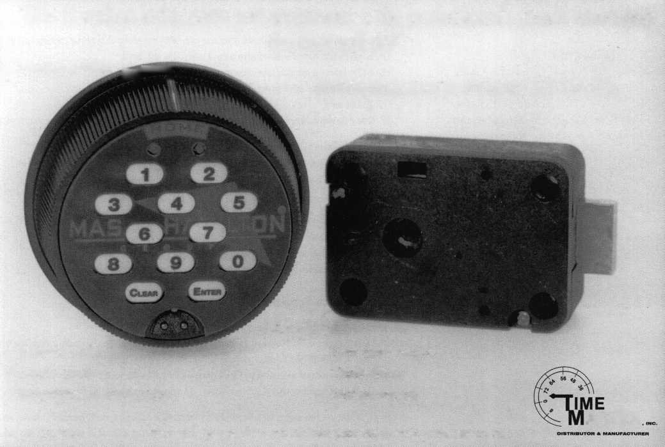

Test Your 1998 Membership Meeting IQ

1. When and where is the 1998 ALOA Membership Meeting being held?

* A. June 20 at Lerlene's Truck Stop in Maypeari, Texas (bring your own Breakfast Jack; meeting 8 am-?; no beer allowed)
* B. June 20 at the Renaissance Hotel in Nashville, Tenn. (breakfast 6:30-8am; meeting 8-11:30am)

1. What will ALOA members be voting on?

* A. New bylaws
* B. New curtains for the ALOA offices
* C. The menu for class lunches at future ALOA conventions

1. What are the two most major changes included in the proposed bylaws?

* A. ALOA members would be allowed to vote by mail and would elect the directors from their own regions.
* B. ALOA members would be allowed to bring their pets onto the Security Expo trade show floor and exhibitors would be

required to have dog treats available at each booth.

* C. ALOA members would be allowed to substitute chocolate for any member benef it and to pay their annual dues in the

third world currency of their choice.

1. Name two additional changes to the bylaws.

* A. Term limits have been set for directors and associate members will be allowed to elect one representative to the

ALOA board of directors.

* B. Members named either Bob or Mark are entitled to special discounts and benefits.
* C. Members who hog all the cookies at the membership meeting will be taken out and shot, and members who save a

cookie for an ALOA staff member will be canonized by the Pope.

1. The proposed bylaws also support ALOA's new governance policy. What were some goals of the new governance policy?

* A. To facilitate long-term policy determination and goal setting by the ALOA board.
* B. To allow day-to-day operations to be conducted more efficiently.
* C. To provide ALOA staff with overt and clearly stated specifications for doing their jobs.
* D. All of the above.
* E. None of the above; the new governance policy just allows the president to actually wear a crown during board meetings.

1. Which of the following is a direct quote from ALOA President Dallas Brooks on the new governance policy?

* A. 'The first and most important goal for the survival and future of our association is to change the way we govern."
* B. "This stinks. It's time to fix it."
* C. All of the above.

1. How did the ALOA board arrive at the provisions of the new governance policy and the proposed bylaws?

* A. The majority opinions expressed in response to the 1997 spring ALOA Membership Opinion Survey.
* B. Direct member input to ALOA leadership through recent chapter meetings, letters, phone calls and e-mails.
* C. Advice from association management consultant Miriam Carver, author of "Reinventing Your Board."
* D. All of the above.
* E. None of the above-they used the ALOA Ouija Board again.

1. Which of the below statements is the honest truth about you?

* A. I have read every word of "Business Not As Usual," p. 18, January 1998 Keynotes, and also every word of "New Rule

Book," p. 18, March 1998 Keynotes.

* B. Well, ok, I haven't read those articles but I'm going to before the membership meeting—I swear.
* C. I haven't read the articles, won't promise to read them, and realize that this means I LOSE this contest on the spot.

1. If you win the convention package that is the prize for this contest, will you attend the June 20 membership meeting while you are in Nashville?

* A. Yes, of course I will—I'm not a bum.
* B. No I won't. I'd be willing to take the prize and sleep in on Saturday morning. I AM a bum.

(The above is a trick question just like #8 that will immediately disqualify you and mark you as a rotten human being.)

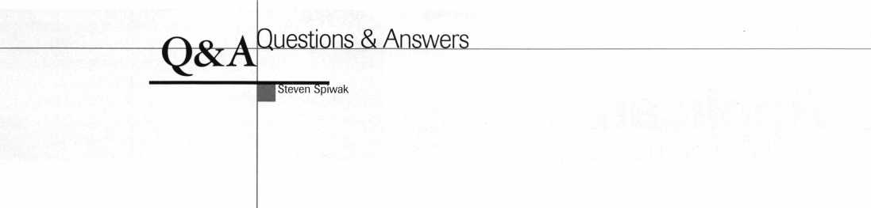

Q: A customer came into my store with a key labeled WIND. Which is the correct key blank for this brand?

A: The correct key blank for WIND should be the ILCO 1041E.

Q: What is the difference between lock picking and raking? I hear the two terms being used interchangeably all the time.

A: Both terms are used in reference to finesse opening techniques. Lock picking refers to the act of manipulating all the tumblers in a lock, one by one. Raking refers to manipu­lating all the tumblers in a lock all at once.

Q: What is an AR cam?

A: The “AR” in “AR cam” are the initials for Adams-Right, a major manufacturer of aluminum storefront door locks - the most popular of which is the “MS” lock, which has been copied by several other manufacturers.

An AR cam is a mortise cylinder cam uniquely designed to operate this style of lock.

Q: I remember that you wrote an article about the different ways in which a locksmith could improve his business.

Could you list the ways that you suggested improving your retail business?

A: The article that I wrote several years ago referred to 16 ways in which you could improve your current business. These 16 methods have become the principles of a popular marketing seminar that I give around the country throughout the year.

In fact, this question has given me a good idea for a marketing article, which will appear in one of the next few issues. For now, let it suffice to list these following methods.

1. Start a quarterly newsletter to mail to your existing accounts as well as other businesses in your immediate area or areas as defines by zip code.
2. Prospect for new customers by direct mail. This can be done by geographical proximity (i.e. zip codes, towns, etc.) or by common occupations (i.e. doctors, lawyers, etc.). Often you can encourage a response by offering these potential customers a free security survey where you make suggestions to improve their existing security.
3. Offer incentives for those existing customers who frequently refer new customers to you.
4. Produce a quality business brochure. It not only explains what you do, but gives prospective customers a more professional image of you and your business.

3. If you have given someone an estimate and they did not call you back, do not be afraid to call them again. Even if you do not get the job, you will know why. This will help enormously in future endeavors.

1. Signage is essential. Everything from outdoor electrical signs to indoor shop signs should be neat and colorful.
2. Yellow pages advertising must be approached carefully. This is an important subject that I will deal with at length in that future article. Just remember that it is not for everyone.
3. Advertise with the welcome wagons and chamber of commerce groups that are the first to be informed of new people and new businesses moving into your area.
4. Newspaper advertising can be important, but often is expensive. Be sure to include both local and citywide publications before you make a decision.
5. Shoppers’ coupons can be a real benefit when advertising such things as two keys for one dollar.
6. Be sure to see if you have qualified for cooperative advertising or coupons. This method gets the word out for two or more companies. It is significantly more cost-effective than advertising alone.
7. Cold calling and cold direct mail is a bigger gamble, but if you mail in the bulk, it can be a real bargain with even minimal results.
8. Radio advertising, particularly ethnic stations, can be quite effective and

a real bargain.

1. Television advertising does not have to mean half-time at the Superbowl. It can mean local programming or cable shows at off-peak hours. A lot less money than you might think.

13. Get out and walk around your

neighborhood. Meet the people both residential and commercial. The effect is unforgettable.

16. Think about structuring guarantees in terms of both products and services. Most people are more inclined to do business with a person or a company that has enough confidence to guarantee their work.

Q: What is meant by a stand-alone unit? A: A stand-alone unit is generally used in reference to an access control device. It is a device, which is usually self-contained, battery operated and easy-to-install or retrofit into an existing installation.

Q: What does the term non-volatile mean? A: Non-volatile is usually used when talking about an electronic item that possesses memory. For example, this device will not lose its memory even when the power is turned off.

About the Q&A Man: Steven B.

Spiwak, CRL is a fourth generation locksmith  
who specializes in a variety of variety of areas  
including crime prevention and institutional  
security. His broad experience in the security field  
spans 20 years of writing, teaching and  
consulting. Spiwak’s lengthy client list includes  
Ford Motor Company, Exxon, The Chicago  
Tribune, Sears, Westin Hotels, the U.S. Treasury  
Department and the Federal Bureau of  
Investigation. Most recently he formed Lockport,  
Inc.—a security consulting company for industrial,  
commercial, institutional and governmental clients.  
Readers with article suggestions or requests for him  
can contact ALOA at email [publ@anet-dfw.com](mailto:publ@anet-dfw.com)  
or fax to (214) 827-1810.

April 1998

Keynotes 1

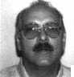

Applicants

For Membership

Dept

^ ***The following applicants are scheduled for clearance as members of  
ALOA. The names are published for member review and comment prior to  
May I, 1998, to ensure applicants meet standards of ALOA’s Code of Ethics.  
Protests, if any, should be addressed to the Membership Department and  
must be signed. Active Membership applicants (A) have worked in the  
industry two or more years. Allied Membership (ALJ applicants are not  
locksmiths, but work in a security-related field. Apprentice Membership  
(AP) applicants have worked in the industry less than two years. A***

ALABAMA

Arab

027905, Donald T White, AP

ARKANSAS

Melbourne

027876, Marion J Mizner, A Sponsor: Ronald Willhoite

ARIZONA

Sierra Vista

027878, Jewell Crippen, A

COLORADO

Broomfield

027894, Anthony L Wright, AP

Pueblo

027853, Bruce E Mooney, A Sponsor: James Burton

DISTRICT OF COLUMBIA

Washington

027890, Ernest R Williams, AL Sponsor: Philip Rovenolt

GEORGIA

Savannah

027851, Ray Groover, AP

IOWA

Altoona

027893, David L Schafer, A Sponsor: Eric Veal

Ames

027865, Mark E Reimer, A Sponsor: Eric Veal

Des Moines

027873, Eric M Asher, A SPONSOR: Eric Veal 027866, Robert T Broyles, A SPONSOR: Eric Veal 027874, Wm T Dupuy, A SPONSOR: Eric Veal 027870, Robert M Jensen, A SPONSOR: Eric Veal 027868, David D Morelock, A SPONSOR: Eric Veal 027867, Thomas D O'Neill, A Sponsor: Eric Veal 027872, Clayton D Selzer, A Sponsor: Eric Veal 027875, R Stickels, A Sponsor: Eric Veal

027869, James T Wicker, A Sponsor: Eric Veal 027871, Nathan J Woodard, A Sponsor: Eric Veal

Waterloo

027884, Brett A Heath, A Sponsor: Philip Heath

ILLINOIS

Elk Grove Village

027860, Brian M Curry, A 027861, James C Curry, A

INDIANA

Lafayette

027914, Paul George, AP Sponsor: Monte Salway 027913, Michael Thistlethwaite, AP Sponsor: Monte Salway

KANSAS

Topeka

027888, Tim J Wietharn, A

LOUISIANA

Maurice

027883, Joel KVizena, A

Slidell

027887, Vincent G Ducre, A Sponsor: James Portie

MASSACHUSETTS

Gloucester

027885, Steven Pinkham, A

MARYLAND

Glen Burnie

027891, John F Spivey, A

MICHIGAN

Detroit

027862, Christopher F Tellerico, A Sponsor: Frank Tellerico

Midland

027856, Brian S Blevins, AP Sponsor: Chris Fiebke

MINNESOTA

Brainerd

027858, David M Mahady, A

Pine City

027879, Joel D Yesenko, AP Sponsor: John Heckman

MISSOURI

St Louis

027850, Keith L Brown, A

NORTH CAROLINA

Charlotte

027904, Michael G Parker, A

Winston-Salem

027908, Mark E Flinchum, A Sponsor: Keith Wood

NEBRASKA

Elgin

027855, Brian L Moser, AP Sponsor: John Heckman

NEW JERSEY

Lodi

027892, John D Ayer, A

NEW MEXICO

Albuquerque

027906, John L Demmon, A

Moriarty

027857, Jeff L Miller, AP

OHIO

Cincinnati

027897, Joseph D Higdon, A 027900, Robert F Mitchell, A 027901, Joseph R Norton, A 027896, Michael E Underwood, A 027898, Michael A Wells, A 027899, David A Wilburn, A

OKLAHOMA

Mustang

027886, Lynne L Collins, AP Sponsor: Jean Shuford

SOUTH DAKOTA

Sioux Falls

027863, Owen J McKittrick, A Sponsor: Chic Pyper

TENNESSEE

Knoxville

027902, Mark Hinkle, AP 027854, Richard A Little, A 027903, Adam W Wilson, AP

TEXAS

Dallas

027880, Ernie W Cecil, AP

Fort Worth

027911, Jerry K Lucas, A

Irving

027881, Stephanie Durocher, A 027882, Barbara Fett, A

Leakey

027910, Henry Rabon, A

Waxahachie

027912, Mike B Moore, A

VIRGINIA

Norfolk

027889, George N Brewster, AP

WASHINGTON

Deer Harbor

027895, John C Conant, A

CANADA

Gloucester

027907, John R Starrett, A

JAPAN

Kochishi Kochi

027852, Toshitada Fujimoto, A Sponsor: Yoshiro Watanabe

Keynotes

April 1998



ASSOCIATED LOCKSMITHS OF AMERICA, INC.  
MEMBERSHIP APPLICATION

Welcome to the Associated Locksmiths of America, Inc., an association for persons involved in the security industry as ocksmiths, security consultants, educators, manufacturers, or distributors.

fo apply for membership, please complete this application and submit it with the application fee, dues for the current year, ind your business card, company letterhead, or suitable proof of employment.

\ll of the following questions MUST be answered before this application may be processed: (Please Print)

PERSONAL INFORMATION

i/lr. Mrs. Ms. (circle one)

Business Mailing Address Home/Other Mailing Address



|  |  |  |  |  |  |
| --- | --- | --- | --- | --- | --- |
| Last Name) | (First] | (Middle) |  |  |  |
| business Name |  |  | Address-Street and Number |  |  |
| flailing Address-Street and Number | |  | City and State |  | Zip Code |
| )ity | State | Zip Code | Phone | FAX |  |
| 'hone  dail: Bus.D | FAX  Home D |  | Social Security No.  Directory Listing: Bus. L] | Date of Birth  Home Q None 0 | |

PROFESSIONAL INFORMATION

\re you a sole owner?, Partner, Corp. officer, Employee, Student?

\re you currently engaged in the security industry? Yes No If yes, how long?

Vhat percent of your work time is spent in locksmithing?

How did you learn locksmithing or security work?

\re you a member of a local locksmith association? Yes No If yes, please provide name, city, and

itate of association(s):

\LOA Member sponsor ALOA #

’lease note: If you are sponsored by an ALOA member, your application will be immediately processed with a 90-day probation >eriod. Otherwise, final processing will take 120 days.

aive names and addresses of two industry-related references (required):

HTPES OF MEMBERSHIP - Please check only one:

**) ACTIVE MEMBERSHIP** - Individuals actively engaged in supplying, servicing, or installing security hardware for a period of not less than two years.

**^ APPRENTICE MEMBERSHIP** -- Individuals who are in initial training and meet all the requirements for Active Membership except for length of time in the security industry. **) ALLIED MEMBERSHIP** - Individuals whose position in the security industry relates to the aims, policies and promotion of the locksmith and his or her craft.

2/27/97

APPLICATION AND FEES

A $40 application fee, appropriate annual dues, and your business card, company letterhead or suitable proof of employment must accompany this application.

ANNUAL DUES: ACTIVE/ALLIED MEMBER $125 APPRENTICE MEMBER $75

* Dues include $25 subscription to monthly magazine. **Keynotes**

NOTE: Your second year's dues will be prorated based on the date your application was received by ALOA.

Have you ever been convicted of a felony? Yes No

If yes, please give details on a separate sheet. All felonies are reported to the Membership Committee for review.

I certify that all statements are true and if accepted as a member, I agree to abide by the rules, regulations, and Bylaws of ALOA and further agree to adopt the Code of Ethics of ALOA as my own and adhere to it to the best of my ability. Should my membership be discontinued, I agree to return my membership card and cease use of all ALOA insignia.

SignatureDate

METHOD OF PAYMENT

* CHECK (Payable to ALOA in US funds)
* CREDIT CARD

□ American Express □ VISA □ MasterCard □ Discover Card Number Expiration Date

Please print name as appears on card

Cardholder Signature

FINAL CHECKLIST:

|  |  |  |
| --- | --- | --- |
| □ | $40 Application Fee |  |
| □ | $125 Active/Allied Membership dues | □ Letterhead or Business |
| □ | $75 Apprentice Membership dues | Card or Proof of |
| □ | $15.40 for Canadian Air Mail | Employment |
| □ | $37.40 for Overseas Air Mail |  |
|  | TOTAL ENCLOSED $ |  |

Return to: Associated Locksmiths of America, Inc.

3003 Live Oak Street; Dallas, TX 75204 Phone: (214) 827-1701; FAX (214) 827-1810

|  |  |
| --- | --- |
| Received $ | For office use only  Number |
| Appl. Fee | Dues Date Rec'd. |
| Bv | Date App'd. |
| Apprentice transfe | jr Applicant listed |
| in Keynotes |

|  |  |
| --- | --- |
|  | On Education |
| Focus |  |
|  | | David Lowell, CML, CMS  PRP/Education Manager |

Spring is here! For many of you, that means its time to go out to the ballpark and enjoy America’s pastime. For others it probably means taking some well-deserved time off to relax and soak up some sun.

For us here in the education sector of ALOA, it means gearing up for classes at convention as well as letting all of you in on new and important things that are going on.

For example, there’s me! Yes, me, ALOA’s current PRP/Education manager here at the corporate headquarters in Dallas, Texas. Then there’s a new face on the team, Ashley Spenser, education assistant.

We’ll both be working to continue the growth of education within our association as times change. From expanding the scope of classes to keeping up with the increased technology in our industry, it’s always been ALOA’s mission to further all of our education programs.

I’ll be on-hand to answer any technical questions or inquiries regarding testing, materials, etc. Presently, I’m trying to return as many calls as I can, so please bear in mind that I am here to help. So don’t write me off if I’m not immediately available.

With that, here are some items that we’ve recently been working on.

At the moment, all ALOA classes are ACE certified, but soon we’ll be offering classes that are PRP certified as well. When someone enrolls and completes a PRP certified class, they’ll be able to receive all the information needed to pass a PRP exam within the class. At the end of these classes, students will be given the test booklet for the particular elective that they are studying. If they pass the test, then the students will receive credit for the PRP class and the PRP elective.

For example, this year ALOA is offering a brand new class on motorcycle locks (available at this year’s convention in Nashville, Tenn.). For years, there’s been a PRP ‘motorcycle lock’ test, yet we’ve never offered a class for it. At the conclusion of this class, students will be given the PRP test booklet for the motorcycle lock elective and given the opportunity to then be tested. Whoever receives a passing grade (70 percent

or higher) will receive credit for both the class and the PRP elective. Please note that the ‘class’ is not teaching the actual test but rather material that will be helpful on it.

So far, this idea has been met with favorable response and hopefully will serve to benefit everyone.

We’ll also be trying to reach members who are not able to make the trip to Nashville by holding classes at the ISC shows. We’ll be offering 14 classes at the Chicago show May 29-June 1 and also at the New York show August 31-September 2.

With that, members who can’t make the ALOA show can still learn in a convention­like atmosphere. You’ll receive information on both of these ISC shows (if you haven’t already) in the mail. If you don’t, contact me at the ALOA headquarters.

We’re still actively conducting ACE classes at major conventions this year including several three-day training courses with multiple instructors. You’ll see those classes and dates listed in this column’s sidebar.

We’ve made a lot of progress this year, and the best part is that this year’s just beginning.

Don’t forget to check your convention brochure as well as this very issue for a list of courses (full-day, half-day and evening) at this year’s convention. See you there.



About the Manager: David Lowell,

CML, CMS, is ALOA’s immediate past president  
and an ALOA Trustee. David has served on the

ALOA board for 10 years. He owns and operates Phoenix Lock & Key in Arizona, and has been an ALOA member since 1981.



Upcoming ACE Classes

Grand Canyon Chapter of ALOA

April 18-19,1998 Phoenix, Ariz.

(602) 921-0123; (602) 921-0524 fax Contact: John Ilk, CRL Closed Circuit Television

Alabama Chapter

April 25-26,1998 Montgomery, Ala.

(334) 793-5060; (334) 671-1405 fax Contact: Jim Turner, CPL Safe Lock Servicing Safe Deposit Lock Service

Gateway Locksmith Association

May 17, 1998 St. Louis, Mo.

Contact: James R. Arnold Tricks of the Trade

ISC Central

ALOA

May 29-31

Navy Pier, Chicago, 111.

ISC Central

Contact: David Lowell, CML, CMS (214) 827-1701; (214) 827-1810 fax

ALOA ’98 Security Expo

June 14-20 Nashville, Tenn.

Contact: David Lowell, CML, CMS (214) 827-1701; (214) 827-1810 fax 59 full-day classes; 34 half-day classes;

Six evening seminars

New Mexico Chapter-ALOA

August 7-8,1998

Las Cruces, New Mexico

Contact: Stephen W. Smith

(505) 281-8777; (505) 292-7993 fax

Basic Locksmithing, Tricks of the Trade,

Shop Management and Pricing, Exit Devices, Servicing Aluminum Storefront Doors, Door Closers, S&G Group 2 Certification and Electronic Safe Lock Servicing.

ISC East

ALOA

August 31-September 2

New York, NY

Contact: David Lowell

(214) 827-1701; (214) 827-1810 fax

Lou-Miss. Locksmith Association

August 23-26 Alabama

Contact: Thomas L. Hunt (205) 833-3333; (205) 836-3333 Nine classes TBA

MINK

October 15-18 Omaha, Neb.

Contact: Elmer Howard (420) 330-4758; (420) 330-8701 fax Basic Electricity Access Control

Servicing Aluminum Storefront Doors

PRP



April 1998

Keynotes

Legislative

Comment

■ Tim McMullen-Legislative Manager

Grassroots Lobbying is S

parting

to Pay Off.

In recent weeks, members in Arizona, Hawaii, Maryland, Missouri and Tennessee received letters from ALOA asking for help in a grassroots letter writing campaign. Alarm licensing bills were introduced in each of these states, and defined “alarm systems” or “security systems” in such a way that our members who are involved in access control would be required to have an alarm license. As previously reported to you, ALOA is working with the National Burglar and Fire Alarm Association (NBFAA) to come up with definitions that are acceptable to both groups. Unfortunately, these have not been formulated yet, so the legislative train still moves down the track - for the alarm industry, its “full steam ahead.”

The biggest difference between paid lobbying and grassroots lobbying is the obvious: it’s all about money. NBFAA works primarily at the direction of its state organi­zations. These state chapters raise money and hire lobbyists to do one thing: get an alarm bill passed - no matter what the cost. At $1,000 to $2,000 a month, these lobbyists are determined to do just that. Grassroots phone and letter writing campaigns, however, can sometimes slow down, amend or derail those bills.

In Maryland, ALOA coordinated a grassroots letter writing campaign and worked with Legislative Action Network (LAN) members to voice our concerns over a bill that tied locksmiths to an existing electronic security law. The thrust of the letters was to convey to the legislators that locksmiths should have input on the legislation being presented. The committee voted against passing the bill onto the Senate floor, thereby defeating the bill. Their reason: the Maryland State Police (who introduced the bill) should have consulted with locksmiths before they tried to introduce the legislation!

In Missouri, two LAN members appeared at a House committee hearing to voice their opposition. The bill, which was on a fast- track to becoming law, would have required anyone installing “security devices” to be regulated by a board consisting of six

members chosen from a list submitted by the Missouri Burglar and Fire Alarm Association (MBFAA). A security system was defined as “any device or collection of devices which is designed to record unlawful acts or provide surveillance for the protection of life or property.” Clearly this is a CCTV system, something locksmiths install. They were able to convince the House committee that locksmiths should have a voice in this piece of legislation. Consequently, ALOA has been in constant contact with the MBFAA.

ALOA’s experienced the same results in Arizona, Tennessee and Hawaii. The point is this: members CAN make a difference. For our members that sent letters and made phone calls to their legislators, you can have the satisfaction of knowing that your voices are being heard. Grassroots lobbying is starting to pay off, and ALOA member’s involvement is the key.

ALOA is getting ready to have the first meeting of the Electronic and Physical Security Industry Coalition on March 23, 1998. This column will keep you informed on the outcome.

LEGISLATIVE UPDATE

Arizona HB 2479

Relates to alarm businesses and agents; requires alarm agents to be registered with the state. Working with AZBFAA to exempt locksmiths from this law.

Kansas HB 2647

Relates to the licensing and regulation of locksmiths. Bill was withdrawn by sponsor for lack of support.

Maiyland SB 61

Defines “security system” (in a provision of law relating to the licensure of security system technicians) as a lock, dead bolt, or other mechanical, electromechanical, or electronic device or system operated by a key combination, keycard, or pass code used for securing a door or window. Bill did not pass out of committee because locksmiths

were not involved from the beginning of the process.

Missouri HB 1720

Defines “security system” as any device or collection of devices which is designed to record unlawful acts or provide surveillance for the protection of life or property. Working with MBFAA on this law.

New York AB 5315

Establishes security requirements to be fulfilled by owners of multiple dwelling units including deadbolt locks, window pins, adequate lighting, solid core door and optical viewers. No movement to date.

Rhode Island HB 7376 and SB 2303

Creates a board to regulate the profession of locksmithing. Moving through House Labor committee.

South Dakota HB 1131

Exempts locksmiths, locksmith shops, and locks made to individual order from the contractor’s excise tax; makes them subject to sales and use tax. To Governor for signature.

Tennessee SB 2780 and HB 2454

Committee deleted all language in the original bill, and substituted the following: “A company whose business is the sale or installation of delayed egress locks which are used to detect and monitor the wandering of residents of a nursing home.” Moving through committees. Working with the ALOA Smokey Mountain Chapter, ALOA West Tennessee Chapter and Tennessee Organization of Locksmiths (TOOLS) to exempt locksmiths from this bill.

Tennessee SB 2391

Prohibits person with prior felony record from installing, modifying or servicing burglar alarm systems.

Moving through committees.

Tennessee HB 2251 and SB 2294

Establishes certification, licensure and/or registration requirements for any person

12 | Keynotes

April 1998

Legislative

comment

who provides or offers to provide security services and/or investigative services to the general public by creating the Tennessee Security Commission. Moving through committees. Working with the ALOA Smokey Mountain Chapter, ALOA West Tennessee Chapter and Tennessee Organization of Locksmiths (TOOLS) to exempt locksmiths from this bill.

Vermont HB 671

Prohibits electrical installation work to be performed by electrician’s helpers and to permit only journeymen and register apprentice electricians to perform electrical installations under the supervision of a master electrician and only registered apprentice electricians to perform electrical installations under the supervision of a journeyman electrician. No movement.

Virginia HB 509

Places electronic security contractors and electronic security employees in equal status regarding registration. Moving through committees.

Virginia HB 865

Grants to the Department of Criminal Justice Services the authority to certify private security training schools and instructors, unarmed security officers and electronic security personnel; authorizes the Criminal Justice Service Board to enter into reciprocal agreements with other states; clarifies the definitions of certain private security personnel; authorizes the recovery of costs of investigation and adjudication for violations. Moving through committees.

I About the Manager: Tim

McMullen oversees legislative affairs for ALOA.  
He is a graduate of the District of Columbia  
School of Law and has an extensive background in  
legislative work. If you have information for Tim  
concerning federal or state legislation affecting the  
locksmithing industry, contact him at: ALOA;  
3003 Live Oak Street; Dallas TX 73204;  
(214) 827-1701; (214) 827-1810; email:  
[tim@aloa.iofiice.com](mailto:tim@aloa.iofiice.com)

Recently Enacted New Jersey Law

ALOA has received many calls regarding the recently enacted locksmith law in New Jersey. The following is designed to clear up some of the questions:

Q. Will a New York state license be reciprocal?

Ab The law states that if the Board of Examiners of Electrical Contractors after consultation with the Fire Alarm, Burglar Alarm and Locksmith Advisory Committee, determines that an applicant holds a valid license from another jurisdiction that requires equal or greater experience and knowledge requirements, the board may accept evidence of that license as meeting the experience and knowledge requirement of the act for a person engaged in the alarm business or in the proactive of locksmithing services. The Board of Examiners has yet to name an advisory committee!

Q. Can I be grandfathered in?

Ab Under the law, there will be no examination requirement for any person engaged in locksmithing services who has practiced locksmithing services for at least one year prior to the effective date of the act and who files an application within 120 days following the effective date of the act. But you will still have to register and pay a background check fee. The act was signed into law on Jan. 8, 1998. This means that you must have been a locksmith from Jan. 8, 1997 to date of application in order to qualify. Also, you have until May 8, 1998 to get in your application.

Qb How do I apply?

Ab Call the Board of Examiners of Electrical Contractors to get on their mailing list (973-504-6410).

April 1998

Keynotes 1

Industry

News

High Road to China

Security China ’98, the international exhi­bition on public safety, security, fire control and police equipment will be held at China International Exhibition Center in Beijing. The dates are Nov. 10-13, 1998. Exhibits will include anti-explosion and security inspection, alarm systems, access control,

TV surveillance, anti-burglar door locks, police-used security equipment, fire-related alarm systems and control facilities, financial security systems, GPS systems, cash-in­transit vehicles and more.

I LA Endorses ISC

It was announced recently that the Institutional Locksmiths Association (ILA) will participate in all three ISC events to be held in 1998. The endorsement is the latest addition to the numerous industry associa­tions and organizations aligned with the event, including ALOA Ace classes. The agreement between the two organizations will also include a joint effort to produce a symposium geared towards institutional (in-house) locksmiths and end-users. The symposium will be included as part of the ISC EXPO Conference Program. The ILA is considered by many to be the “In-House” Locksmith Association since it was founded (in 1983) as a forum wherein institutional locksmiths could share and solve common problems and concerns. Included among the approximately 800 ILA members are lock­smiths from colleges, universities, hospitals governmental agencies, businesses and corporations, as well as distributors, manu­facturers and representatives from lock- related industries and schools.

Gradient Lens Corp.

Gradient Lens Corporation announced today that it has been appointed exclusive North American distributor for technical endoscopes, including rigid borescopes and flexible fiberscopes, produced by Karl Storz Endoskope of Germany. The announcement was made at Advanced Productivity Exposition, which is organized by the Society of Manufacturing Engineers and focuses on the automotive industry.

The Karl Storz line complements the Hawkeye Precision Borescope line already being manufactured and sold by the Rochester, New York-based company.



New Name

Best Lock has changed its name to Best Access Systems, a move company says reflects their evolution from a mechanical lock manufacturer to a premier provider in security solutions. The new name and new identity coincide with Best’s 75 th anniversary. Best will communicate more information about its programs and policies as it transitions its documents and materials to the new identity.

New Acquisition for Chamberlin

The Chamberlin Group, Inc. has acquired Sentex Systems, Inc. of Chatsworth, Calif. The acquisition, which was formalized on Dec. 5, 1997, was announced by Robert Baker, chief executive officer of The Chamberlain Group, Inc. The Chamberlin Group, Inc. is the world’s largest manufac­turer of residential garage door openers, commercial and gate operators, and waxers/ polishers for automobiles, boats and airplanes. Sentex Systems, Inc. is a manufacturer of telephone entry systems, and also sells gate operators, card readers and other access control devices.

Dorma Expands

Spurred by continued business growth and the addition of three new product lines, Dorma Door controls has expanded its Reamstown manufacturing facility with a 25,000 square- foot addition. The $1 million dollar, two-story addition allowed Dorma to reorganize its cur­rent manufacturing operations and begin pro­duction of three new product lines that will be introduced in 1998: the 7900/8900 Series nar­row projection surface closer and ED600 Series low-energy operator - both manufactured at the expanded Reamstown facility - and the 9000 Series exit device, which will be made at the company’s Steeleville, 111. plant. To manu­facture the new products and support the com­pany’s continued growth, Dorma plans to increase its workforce five to 10 percent this year with additional full-time employees from the Berks and Lancaster county areas. As part of the expansion,

Dorma invested $4.5 million dollars in machinery upgrades and new equipment - such as a state-of-the-art, Diedsheim unit that automates body machining for the new door closers.

Whoa, Philly!

The Greater Philadelphia Locksmith Association recently installed their new slate of officers for a two year term. ALOA President Dallas Brooks was on-hand for the formal installation. The officers are as follows: President Robert Mock, Vice President John Magee III, Corres. Secretary Lou Gildenberg, Recording Secretary Edward Fitzgerald, Sergeant at Arms Edward Palwick, Treasurer Martin Arnold. Directors for the GPLA are William Young, Nelson Dayton, Ronald Blevins, Ronald Marcinkowski, William Neff, Fred Radich, Robert Schuetrumpf, Clifford Shafer and Barry Wilensky. ILCO UNICAN presented incoming and outgoing presidents with gifts. The event took place during a dinner meeting at the Woodbine Inn in Pennsauken, NJ. Also present were ALOA directors Dana Barnum and Barry Leas.

Things Are Happening at ASD

American Security Distribution, which is a national distributor of locks and other security hardware to locksmiths, security dealers, end users and retailers, said today that as a result of the ongoing consolidation in the commercial security industry, it has implemented a series of initiatives aimed at enhancing service to customers, strength-

Keynotes

April 1998

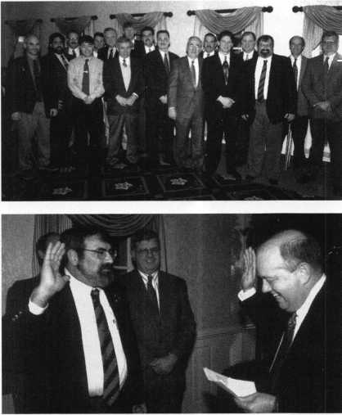

Industry

News

ening its vendor distribution programs and improving productivity. The company said that it has successfully negotiated a $26 million credit facility with its existing lender, Wells Fargo Bank, that will provide adequate operating capital to purchase merchandise and fund all other aspects of the business. It also announced that Sean DeForrest who has been president and chief executive officer since 1987, would become chairman and that David L. Auctherlonie, founder and principal of The Scotland Group, Inc., a Los Angeles-based manage­ment consulting firm, has been named chief executive officer and president.

25 Years Young

Marlee Electronics announced the celebra­tion of their 25 th anniversary in business throughout 1998. Marlee began its opera­tions in Southern California and quickly established itself as a market leader in the telephone entry business. Many of Marlee’s designs have been adopted by the industry and now represent the standard. Marlee begins the anniversary with the introduction if their latest development, the VF Series.

Executive News

Viva Branagan

After serving for a number of years as a technical products specialist at Security Lock Distributors, James Branagan has been

appointed manager of Security Lock’s new  
Las Vegas warehouse. Branagan has worked  
in the security industry for over 20 years,  
having hands-on experience as a locksmith,  
installer and a security products service  
manager before joining Security Lock. He  
will supervise Security Lock’s extensive new  
facility, which will house in-depth inventory  
of the nation’s leading life safety and security  
products. This new location will provide  
the same array of services offered by other

Security Lock centers.

Yeah, Greenlaw!

Robert Greenlaw has been  
appointed to a post in Security  
Lock Distributors’ expanding  
customer service department.

He is a specialist in the application, installa­tion and maintenance of electrical and mechanical access control products, with over 12 years of hands-on experience. In addition, he is an ALOA certified registered locksmith.

You Go, Gloecker!

Yale Security Group announces the appointment of Mark A. Gloecker, CDT to the position of northeast regional sales manager. He will be responsible for sales of Yale, Norton, Rixson and Corbin Russwin products in that area. Mark is a graduate of the University of Connecticut and a Certified Document Technician. He has seven years

field sales and managerial experience in the door and hardware industry.

Welcome Aboard, Tim!

Detection Systems, Inc. is pleased to announce the arrival of Tim Tracy. Tim has five years of security industry experience with C&K Systems, Inc. He began his career as a junior technical representative. Most recently, Tim held the position of sr. inside sales representative and technical trainer. Tim will be Detection’s Western Region Sales coordinator and will be reporting to the Western Area Sales director, Scott Crown.

He will be based out of Auburn, Calif.

Welcome Back!

Radionics, Inc. is pleased to welcome back Roy Thurston, who has returned to Radionics as Eastern Area sales director.

Roy has many years of experience in the security industry. Most recently he held the position of vice president of Sales and Marketing in UPLINK Security. Having been with Radionics previously, Roy is familiar with Radionics products and cus­tomers. Located in Marietta, Ga., he will be overseeing Radionics’ Eastern regional managers, including: Dennis Calvey, Andy Aylesworth, Dave Heinen and Scott Lozier.

In addition, Roy will also oversee the Detection Systems’ Eastern regional sales managers.

Detex

Philip N. Haselton recently announced that Gary Hackney has been named director of Marketing and Sales for the Detex Corporation. Hackney will be responsible for managing sales and marketing for all Detex domestic product lines. He has been with Detex since 1986 and served as a product manager for the security hardware division since 1991. Haselton advises that Hackney will be relied upon to uphold Detex’s position in the industrial security and security hardware marketplace. The Detex Corporation is a manufacturer and world wide marketer of security, life safety, and asset protection products and services with general offices and manufacturing facilities in New Braunfels, Texas.

Dedicated

Dedicated Micros  
USA, a subsidiary of  
Dedicated Micros UK,  
has received ISO  
9002:BS EN ISO: 1994  
certification. Lloyd’s  
Register Quality Assur-  
ance Ltd. presented this  
globally recognized qual-  
ity award to Dedicated  
Micros in November  
1997. This certification  
recognizes DM’s standards

for the distribution and service of multiplexers, digital storage and video transmission  
products. Detailed Micros UK has ISO 9001 certification which covers the manufacture of  
Dedicated Micros’ multiplexer products.

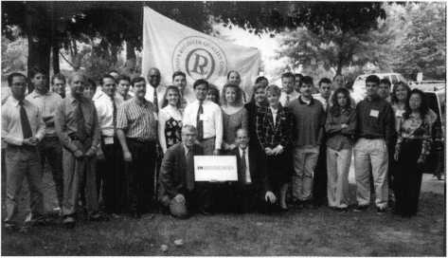

The Dedicated Micros team celebrate ISO 9002 certification.



Trimec Electric Strikes

Australian Trimec is introducing their line of electric strikes to the U.S. market. The ESI00, ES200, ES2000 and the new ES3000 Series were produced to pass and exceed the highest levels of the revised UL standard- UL1034. This standard includes static and dynamic strength testing, cycle testing, manipulation and safety checks. In addition to UL testing, the ES range of electric strikes have recently undergone thermal testing by a NADA approved testing authority, resulting in full operational functions at temperatures from -13 degrees Fahrenheit to +122 degrees Fahrenheit.

Trimec U.S.

(800) 987-4632 (414) 375-6712 fax [sales@trimec-usa.com](mailto:sales@trimec-usa.com) ***Reader Service #12***

Yale

Yale is expanding its 7,000 Series to include surface and concealed vertical rod devices for doors up to 4' x 10", with and without a bottom rod, in doors carrying up to 1 1/2 hour UL “B” fire ratings. The new range is available in both wide and narrow stile configurations and is approved for use in a variety of wood and hollow metal door applications. The 7,000 Series Exit Devices are fully compliant with ANSI and ADA standards. Damage to the exit devices with surface rods is eliminated with application of the Less Bottom Rod (LBR devices) where the door is subject to equipment traffic and security is not a major concern. The 7,000 Series Exit Device is also available with an alarm kit option. The exit device fitted with the alarm features an automatic reset after five minutes, a nine volt power source, an audible low battery indicator, a nuisance alarm option, and a 10 second actuating delay for authorized egress. A red LED indicator illuminators every 30 seconds when the alarm is armed, The alarm can be ordered with the exit device or ordered as an optional kit for field installation.

Yale Security, Inc.

1902 Airport Rd.

Monroe, N.C. 28110 (704) 283-2101 (704) 282-2346fax

Reader Service #13

Lockmasters

Out now is the newest Lockmasters Tool Catalog. It features over 180 new products. This new catalog features automotive opening tools, wire and installation tools, a variety of LAB pin kits and accessories, picking tools, and a broad selection of quality locksmithing tools. Just as Lockmasters has been committed to providing the necessary classes and technical support for safe and vault tools, it will also continue the commitment for its newly expanded product base.

Lockmasters 5085 Danville Road Nicholasville, KY 40356 (800) 654-0637 (606) 885-7093 fax ***Reader Service #14***

Corbin Russwin

Corbin Russwin has introduced the CL3900 Series Grade 2 Key-in-Lever Cylindrical Lockset. The CL3900 is a full featured lockset offering anti-rotation through bolts, independent lever return springs, a 3 1/2 rose to cover the new ANSI hollow metal foot cutout, and a patented lever release mechanism that allows the outside lever to disengage when pressure is applied in the locked condition. A complete range of finish, functions and design options are available including six architectural finished, three lever designs and 10 lock functions. The CL3900 Series carries a three hour UL fire rating and is available in the complete range of Corbin Russwin six pin key systems. It is well suited for light commercial applications including interior offices, closets, multi-family housing, restaurant and retail companies.

Corbin Russwin (800) 543-3658 (800) 447-6714 fax ***Reader Service #15***

Detection Systems, Inc.

Detection Systems, Inc. has announced the release of its Digital Fire Alarm Control/Communicator Panel- the DS9400- a panel which is 100 percent compatible with all DS smoke detection devices, and a wide range of industry-standard fire alarm accessories. The four-zone panel supports up to 20 conventional detectors per zone, and can be expanded to eight zones for a total of

160 two-wire smoke detectors. Two Notifi­cation Appliance circuits provide up to four amps of 24-volt power to operate horns, strobes, bells and other notification appliances. The system is provided with a viewing window for the front panel display. It also has restricted access function keys to allow silencing of alarm and trouble conditions, zone bypassing, detector resetting, testing and other fire functions. **Detection Systems, Inc.**

130 Per inton Parkway Fairport, N.Y. 14450 (716)223-4060 (716) 223-9180fax ***Reader Service #16***

Moniteq Research Laboratories, Inc.

Moniteq Research Laboratories, Inc. has recently published a new catalog describing their complete line of stand-alone access control systems. The new catalog offers in- depth descriptions of their “Crypto Code” systems, key pads, card readers memory chip readers and accessories. A leading supplier to industry and government since 1969, Moniteq has time tested expertise in the design and manufacture of electronic security systems. Through an aggressive, continuous R&D program, Moniteq’s Crypto Code systems have set the standard in stand-alone access control system for small to medium industrial, commercial, educational and government facilities. Crypto Code Systems are extremely versatile, offering virtually all of the features available in much larger, complex computer controlled systems. They enable full control and recording of access to a facility, providing both reliable security and convenient access to authorized personnel. The new catalog includes detailed descrip­tions and specifications on both single and multiple door systems, keypads, card readers (magnetic, proximity, Wiegland and barcode) and touch key readers.

Moniteq

7640 Fullerton Road Springfield, VA 22153 (800) 989-9891 (703) 569-0196fax

Reader Service #17

161 ***Keynotes***

April 1998

Security

Marketplace

NAPCO Security Systems, Inc.

NAPCO Security Group is introducing the GEM-PI632 Intro-Pak, consisting of one GEM-P1632 Hybrid eight-to-32-zone Hybrid Control/Communicator, a GEM- RPICAe2 keypad and a transformer. This all- in-one pak is now available at a distributor near you and is being offered at an intro­ductory price. The GEM-PI632 features eight zones that instantly double to 16 zones and, with the addition of an expansion module such as GEN-EZM8, is further expandable to 32 zones with multiplexing. This new Gemini control features the user- friendly “Self-Programming Plus,” which includes new alpha keypad question- prompts-even for selecting fire support. The panel supports all reliable, crystal-control Gemini transmitters and uses advanced helically filtered receivers. Its keypad, the GEM-RPICAe2, features a built-in four-zone expansion module and a 32 character custom alphanumeric backlit display.

NAPCO Security Systems, Inc.

333 Bayview Avenue Amityville, New York 11701 (800) 643-9443 (316) 842-9137 fax ***Reader Service #18***

Continental Instruments

Continental Instruments LLC announces the availability of its Microterm® controller, the most recent addition to its family of one-, two-, four- or eight-door smart controllers. Microterm may be used as a cost-effective, intelligent, stand-alone one-door access control system, or it can be used as a standard door controller utilized in a large integrated access control security system. Microterm s plug and play capability allows for simple installation with virtually no tweaking or lost time. Microterm s single door design also eliminates the waste created by excess door controller capability in larger systems. With a combination of door controllers, exact system size can be configured without spending extra money. Systems can be easily expanded by simply adding another controller of any size.

Continental Instruments LLC (316) 234-0044 (316) 234-3043 fax ***Reader Service #19***

Texcel Technology

British Texcel Technology has developed the RMS 4,000, a user configurable remote management system for site monitoring and control in local or remote installations of varying sensors and equipment. The RMS unit includes a microprocessor-controlled remote monitoring system for managing power and ancillary equipment, including the ability to communicate and alarm conditions or receive new operational parameters. The RMS 4000 is able to manage the operational requirements of its own location without involving external communication. The system only communicates when an exception occurs, as defined by user setting, so that the transmission of irrelevant information and the danger of false alarms are minimized.

The system can be controlled locally from a simple terminal or remotely via a modem or X2 5/frame relay option. The level of intelligence and decision-making built into the system is variable, depending on the application. For many applications-including intruder, flood, fire, temperature alarms and power condition monitoring-integrated solutions are available.

Texcel Technology Thames Road Crayford\ Kent DAI 4SB 011-44-1322-337722 011-44-1322-337733 fax ***Reader Service #20***

Secuvitron

The Magnalock installation kit is available from Securitron. The IK includes a drilling template for the models 32 and 62 Magnalocks, a blind nut placement tool, drill bits for all types of door frames, and a stock of additional fasteners housed in a single tool box. The installation kit may be helpful for volume installers who want to install the Magnalock faster with more accuracy. **Securitron (702) 333-3623 (702) 333-3636fax [info@securitron.com](mailto:info@securitron.com) email Reader Service #21**

Marray Enterprises

Marray recently introduced the DOR- COR Drilling Fixture, a tool to aid the installation of electrified access hardware. DOR-COR is designed to drill a 3/8"

raceway within a 1/8" of center for easy, safe and consistent electrified hardware installa­tions. DOR-COR mounts to hanging doors and drills from the hinge mortise to the lock prep to wire power transfer hinges and electrified access hardware on 36" commercial grade wood and composite doors. Marray Enterprises’ full product line includes power transfer hinges, electrified locks and panic devices, universal micro-switches, the DOR-COR Drilling Fixture and training courses.

Marray Enterprises 1128 Walsh Avenue Santa Clara, CA 93030 (800) 300-1449 (408) 970-8767 fax http:11[www.marray.com](http://www.marray.com) [ray@marray.com](mailto:ray@marray.com) ***Reader Service #22***

Crow Electronic Engineering

In March, Crow Electronic Engineering introduced their latest video product at the International Security Conference in Las Vegas, Nev. Crow Jet is a new integrated remote video monitoring technology can be sold to residential and commercial customers of large and small security companies. This technology was designed to provide the user the ability to monitor events “live” and on-site at their home or businesses during the day, and directly over their existing phones lines at night. Business owners will be alerted to alarming situations while on the work site or from a remote location) such as their homes in the evening). Parents could view events within their homes while at work, at play or on vacation. The technology will be able to capture events live on automatic monitor screens without the need for expensive multi-plexing technology required on older systems. While utilizing Windows 95 multitasking software, users will be able to switch between up to six cameras on each video board and up to six boards can be installed on the basic software. In other words, 36 cameras can repackaged into one complete system.

For more information, contact:

Crow Electronic Engineering 2160 North Central Road Fort Lee, NJ 07024 (800) GET CROW (201) 944-1199fax ***Reader Service #23***

April 1998

***Keynotes*** In



“Coming from a third world country, my family and I were taking a very big step into a new world,” he says. “We had to get used to American standards and American customs, but in the end it was a good experience. There were few bad experiences to tell about. We did, however, have to go through some difficult changes because we lost just about everything we had in Uganda. My family had to totally readjust to what had happened and take what items we had left and move forward.”

It’s little surprise then that Bhimji is so at home within the insti­tution known as The World Bank. After all, it is an internationally- funded institution dedicated to allotting money to third world countries that have been financially or physically damaged by natural disaster, war, or any other devastating force.

“Basically, The World Bank’s mission is to assist the third world nations redevelop and help get them out of poverty,” says Bhimji. “It was created after the second World War in an attempt to help the countries that had been destroyed or sent under the poverty level.”

Since he can certainly relate to the cause of The World Bank, Bhimji’s role in maintaining the headquarters’ locks and security is all the more rewarding.

He’s actually worked for The World Bank since 1976 through contracting, but was hired on as its official locksmith in 1981. While working on a contract basis, Bhimji began talking to The World Bank’s security chief, who informed him of his plan to start an internal lock and key task force. Before long, Bhimji’s hard work as a contract locksmith had paid off and he was placed in charge of The World Bank’s initial lock and key shop, pioneering its operating procedures.

“Before everything was done by the building engineers,” he says. “They were just rekeying and issuing keys. They were not really too good with master keying and how master keying worked, or key control.”

He’s proud of his status as The World Bank’s premiere locksmith and carries these feelings of accomplishment into his day-to-day tasks and projects. In addition to maintaining the basic lock duties, he also provides hardware for renovated sections of the complex and computer security (laptops, desk units, etc).

But as one could imagine, being part of the security team at an institution like The World Bank, can put some added pressure on Bhimji. Through it all, his experience and product knowledge help him stay a step up on any unexpected situations. His secret is no different than most of his institutional brethren or even retail locksmiths. Attending trade shows and membership in associations like the Institutional Locksmiths Association (ILA) where he serves as national chairman of Education and president of its international chapter. He’s also an ALOA member (#14633).

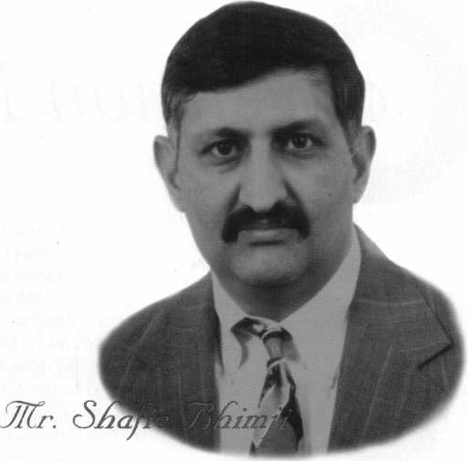

“There’s always pressure when you have to provide service to any  
kind of the staff of The World Bank,” he says. “They expect you to be  
there the minute they hang up the phone and sometimes that’s kind  
of tough. However, we need to respond to our work orders in a timely  
manner. An ‘emergency’ work order should be responded to within  
an hour. Others should be addressed in 24 hours or when any special  
parts come in. The pressure will always be there, but it serves as  
motivation for the lock shop to provide quality service.”

Aside from his delight in being part of an organization that  
benefits causes so close to his heart, Bhimji enjoys his status as an  
institutional locksmith.

With all the urgent requests and emergency work orders he  
handles daily, working at one lone location (although the complex is  
quite extensive, housing 4,500 staff members in addition to other a  
few other buildings) provides a degree of convenience to an otherwise  
busy job.

“The best part about being the locksmith at The World Bank is  
that I’m going to work at one place instead of servicing different  
accounts,” he says. “I come to my job and all the work is in one place.  
I don’t have to fight rush hour going from one place to another.  
Everything is internal.”

The World Bank is the only place Bhimji’s ever worked at as a  
locksmith and he hopes to retire there. More than likely he’ll get his  
wish, but not without many more years of service to the place he feels

so closely aligned with.

“I have a great appreciation of The World Bank’s

the third world countries especially because I’m

says. “So I feel that whatever I do in

computers anc  
that mission.”

About the Author: Mike Emery is a freelance music writer.

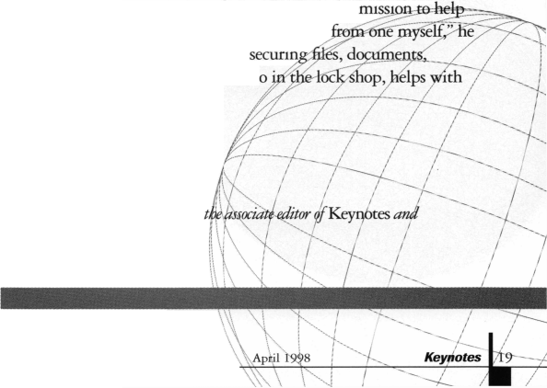

onvention News

By Charles W. Gibson

ALOA members have often asked for more ALOA classes to be offered in additional locations throughout the year.

In response, ALOA taught classes in conjunction with the International Security Expo (ISC) held in Las Vegas in March, and will also offer classes May 29-31 at the ISC Expo in Chicago. About the same time this issue arrived, you should have gotten a brochure in the mail that describes the entire ISC event. Our classes are listed in an insert in the middle of this brochure.

This event does not take the place at the ALOA convention. But the quality of the classes will be the same as if you were taking them at the convention. We have attempted to choose classes that fit well with the ISC event, which features many security tech­nologies—part icularly electronic.

Please take a few minutes to look through this brochure, the ALOA classes in particular. You may very well find it convenient to take advantage of this educa­tional opportunity.

If you have questions about the program, please contact the ALOA Education Manager, David Lowell, at (800) 532-2562.

We hope to see you in Chicago.

**INTERNATIONAL COUNTRY MUSIC FAN FAIR**

While visiting Nashville, Tenn. during the ALOA convention, you may want to visit this special music event, June 15-20. It’s sponsored by the folks who know their country music, The Grand Ole Opry and the Country Music Association. Fan Fair offers over 35 hours of stage shows and other musical events, picture and autograph sessions with country music stars as well as the grand Masters Fiddling Championship.

Your admission into the event includes the scheduled activities and concerts, two meals and tickets to the Ryman and Country Music Flail of Fame. Registration does not include your Grand Ole Opry ticket. For pricing and registration information, write:

Fan Fair

2804 Opryland Drive Nashville, TN 37214 or call (615)889-7503

**CLASSES AND SEMINARS AT ALOA '98**

**FULL DAY (8 AM - 5 PM)**

**SUNDAY, JUNE 14**

* Instructor Training
* Basic Interchangeable Core and Corbin Russwin Removable Core with Hands-On Pinning
* Professional Bypass Techniques
* Basic Electricity
* Domestic Automotive
* Electronic Safe Lock Serving
* LCN and Glynn Johnson Installation and Servicing
* Introduction to Combination
* Key Blank Identification
* Basic Locksmithing I

**MONDAY, JUNE 15**

* Instructor Training II
* Master Keying Methods and Formats I
* Science of Impressioning
* Access Control
* Import Automotive
* Safe Deposit Lock Servicing
* Installing, Maintaining and Servicing Von Duprin Products
* Combination Lock Manipulation
* Professional Automotive Opening
* Fort Multi-Function Cabinet Lock Certification
* Basic Locksmithing II
* Servicing Aluminum Storefront Doors
* Life Safety Codes with ADA
* Studying for and Passing the PRP

**TUESDAY, JUNE 16**

* Certified Alarm Technician Training I
* Instructor Training III
* Master Keying Methods and Formats II
* The Art of Picking
* Closed Circuit Television for Locksmiths
* Single Door Access Control



**MEMBERSHIP MEETING BULLETIN**

* S&G Group II Certification
* Servicing Schlage Commercial Product
* Combination Lock Manipulation II
* VATS and Airbag Service
* National Cabinet Lock Certification
* Master Keying for Dummies
* Complete Door and Door Closers
* Advanced Shop Management
* High Security Import Automotive
* Simplex/Unican Certification
* Strattec 98/99 Update

**WEDNESDAY, 17**

* Certified Alarm Technician Training (Level 1) II
* Successful Security Retailing -

How to Increase Your Sales in both the Shop and on the Job Site

* Advanced Topics in Master Keying
* Simplex/Unican Manipulation
* Forensic Locksmithing
* Advanced Access Control
* S&G Electronic Safe Lock Certifications
* Jail and Prison Locks
* Alarm Design and Development
* Tesa Access Control Certification
* All-Lock Auto Update 98/99
* System 800 Stand-Alone Electronic Access Control
* Exit Devices
* Mas-Hamilton Auditcon 2100 System Certification
* Motorcycle Locksmithing
* Winfield Micro key Electronic Lock Certification

**THURSDAY, JUNE 18**

* Certified Alarm Technician (Level 1)

Training III

* Instructor Refresher
* Meilink/Hayman Safe Certification,

Selling and Servicing I

* Affordable Access Control with Wireless Capabilities
* Peaks® Factory Certification
* American Lock Company Padlock Certification
* Opening the New Vehicles
* High Security Key Copying and Code Cutting
* Starting Your Own Business
* Medeco New Product Update
* Simplify Your Business with Software
* Everything You Need to Know About Key Machines
* Installing, Servicing and Trouble Shooting Electrified Products
* Sargent’s Signature Cylinder &

Master Key Systems Tracking Software

* Mas-Hamilton Auditcon Series Overview

**HALF-DAY CLASSES {8 AM - 11 AM}**

**THURSDAY, JUNE 18**

* Installing Electrified Access Hardware
* Mortise Lock Lock Technology

**FRIDAY, JUNE 19**

* Introduction to Range of Mul-T-Lock Products
* Access Control with Audio and Video Systems
* Servicing and Master Keying Bi-Lock
* Meilink/Hayman Safe Certification,

Selling and Servicing II

* Are you Adequately Covered?
* Framon Key Machine Technology
* Safe Sales and Choosing Quality in a Safe Line
* MIWA Tri-Point High Security Lock System
* Transponder Key Technology
* Codes on Computer
* Medeco Key Mark Certification
* Access Control for the Locksmith
* The 13 Methods of Car Opening
* The Locksmith’s Secret Weapon
* Schlage Primus Certification
* Yale Mastering Keying
* Pro-Lock 1998

Professional Auto Entry Techniques

**EVENING CLASSES/SEMINARS (7 PM- 9 PM) MONDAY, JUNE 15**

* Automated Concepts for the Locksmith Shop
* Mas-Hamilton Auditcon Family Overview
* Marketing That Should Hit Home(s)

**TUESDAY, JUNE 16**

* Know Your Insurance Needs
* Locking Down Profits Through the Yellow Pages
* Getting What You Want from the Government: Lobbying 101

We're starting the June 20 membership meeting at 8:00 a.m. However, breakfast (FOOD!) will be served from 6:30-8. There's been some confusion about the meeting actually starting at 6:30 before some of us (no names) can form complete sentences.

He y - be sure to attend this year. This is your chance to vote in your right to vote- by-mail and your right to pick the directors from your region. A bunch of you have been waiting for this a long time - make it happen, people.

**GET YOUR ROOM IN NASHVILLE BEFORE MAY 20!**

Yes, it's terrific that Fan Fair is in Nashville the same week as ALOA '98. We'll just have that much more fun. But there is a downside - hotel rooms are impossible to get that week unless you call the convention hotel and identify yourself as an ALOA '98 attendee. And, this is important, we have to release that room block by May 20. DO IT NOW.



*mmm*

VwhenJdflnl first decided to his Dallas locks business, he lai very importqjH

“Everyone ij| afraid of gOM

bank and gel

**aCMLv**

“They’re scifireoby  
bankers. But they’ri  
not the biggest  
problem. Landlords  
are. As long as you  
make your payma it  
you’ll never hear t rtj  
your bank again. Bu  
your landlord is  
always around.”

This is not to say, Dickherber adds with a  
laugh, that he likes dealing with bankers. But  
he has learned it is possible to successfully  
navigate the ins and outs of financing a business  
expansion, whether at a bank or out of his own  
cash flow. In addition, there are a host of other  
sources, including finance companies, private  
investors and partners.

Along the way, he discovered that an ordeal  
that intimidates too many locksmiths-often to  
the point where they won’t even consider  
expanding-doesn’t have to be that way. Shop  
owners who are prepared, confident, and  
knowledgeable can make the process work for  
them. It may not be painless, but it is a far cry  
from taking hat in hand and going begging.

“What too many small business owners  
forget is that the only way lenders make money  
is by lending,” says Paul Lapides, who teaches  
management and entrepreneurship at Kenesaw  
State University in Kenesaw, Ga., when he isn’t  
helping small businesses raise money. “What  
they don’t like to do is to lend money to people  
who won’t be able to pay it back. As long as  
you can demonstrate to a lender that you can  
pay it back, they’re going to lend you money.”

Laying the groundwork



WZl

One of the most important decisions locksmiths will make (especially ones who have been through the process) is not where to borrow the money, how much money to borrow, or how many times you’ll listen to

By Jeff Siegel

lenders say ‘no,’ but deciding why you need to borrow the money. In other words, they say, be absolutely, positively sure you want to expand or renovate.

Not only will it make you feel better, but every lender (even the fellows with the well­muscled business associates) is going to be especially reluctant to give money to someone who isn’t quite sure why they need it.

“They have to know you’re watching your business,” says Dickherber. “It gets back to the standard old business things.”

Unfortunately, there is no magical formula to help you decide if it’s time to expand.

There are any number of reasons why-to take advantage of a better shop location, because you are operating at capacity, to forestall a competitor’s move into your area, or to upgrade your facilities.

But in the end, you’re going to have to decide if you want to take on the added respon­sibility. That’s because any decision to borrow money for expansion or renovation must take into account the following factors, or no lender will let you in the door. They insist on seeing reasoned, thoughtful answers to these questions:

Whether to renovate or expand. Sometimes, there’s no need to open a second shop. Adding to or reconfiguring an existing shop may do the trick. Lenders frown on advancing money to people who want to expand when all they need to do is renovate.

Finding a site. Where do you want to open your next shop? You don’t necessarily have to have a location signed and sealed when you talk to a lender, but you’ll need a firm idea of where you want to go and how much it will cost (and whether you will buy or lease the site) to get there.

Staffing requirements. Who is going to work in the new shop? Who is going to manage the new shop? This is an important, and often overlooked, consideration. If you have staffing problems at your current shop, what makes you think you won’t have them at the new shop?

Choosing a lender

Banks, especially in this day and age of deregulation, are far from the only source of money. There are almost a dozen different kinds of lenders, and who you choose will depend on what you need, what the lender offers, and whether there’s a match between the two.

“What you have to remember,” says Lapides, “is that the loan officer who makes you a successful loan looks good. It helps his career. That’s why you shouldn’t be afraid of not only asking for the money, but of asking questions.”

That’s why you should ask prospective lenders as many questions as they ask you. What’s the lender’s procedure for making a loan? How long will it take? What are the interest rates? Does the loan officer have the ability to OK a loan, or does it have to go before the institution’s loan committee? How much lending authority does the officer have before your proposal gets sent to the committee? What formula does the bank use to figure out how much to lend you?

“Keep in mind that all lenders, regardless of category, follow several general rules,” says Jerry White, the director of the Caruth Institute of Owner-Managed Business at Southern Methodist University in Dallas. First, they don’t like to lend money to businesses in industries they aren’t familiar with. Second, they tend to focus on businesses in certain stages of development, with some specializing in start-up loans, others in expansion loans, and still others lending only to companies that are fully mature. Business size can also figure into it. Third, and most frustratingly, they don’t like to lend money to people who aren’t good risks to pay it back.

“There is absolutely no payoff in getting upset with the lending process,” says Lapides. “If that was true, then I’d show all my students how to be upset. If you focus on that, you’ll never succeed.”

What you should do instead, small business experts say, is to try to find a lender whose objectives meet your needs. If you check ahead of time, you’ll save yourself the embarrassment

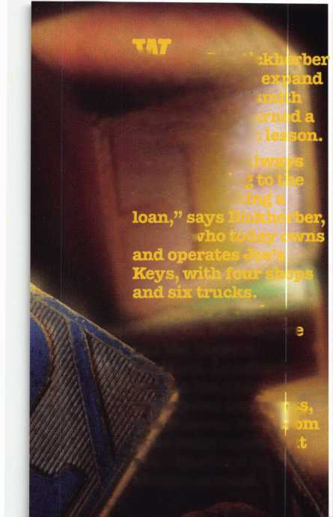

when the loan officer tells you his or her bank would never, ever think of lending to something as chancy as a locksmith shop.

Ask colleagues, other shop owners, and members of trade groups for the names of lenders who do locksmith loans, and of those who look more favorably on small and medium-sized businesses.

Know, too, that some lenders will turn you down even if they seem perfect for your business and you have met every objection. Generally, say operators who have been through the process, count on at least three or four rejections for every acceptance.

And don’t expect miracles. If your credit is lousy, few people are going to lend you money. That’s just a fact, and you’ll have to figure out another way to finance your expansion or renovation. After all, do you extend credit to customers who have shown the ability to neglect to pay you back?

Making the proposal

You have a vision for your new shop. You know who you’re going to ask for the money. Now, all that’s left to do is to ask for it.

The key to your presentation is your business plan. In it, you must state your case, and you must do it practically, forcefully and positively. The business plan must be hard- nosed, business-oriented, and ready to stand up to the scrutiny of someone who doesn’t have to lend you money. You cannot, as so many shop owners have learned the hard way, walk into the bank and say, “I’ve got this great idea.”

“It’s just penciling numbers on a piece of paper,” says Joe Esposito of Liberty Lock &

Keys in Las Vegas, who used a Small Business Administration loan to consolidate three shops into one, larger, 5,000-square foot showroom. “If you think of it that way, you won’t be scared by the process.”

Your business plan should include:

Mission statement. This explains what you do now, what you want to do, and why the lender should help you do it. It should outline your management stmcture, including who will supervise the new shop, and who will be responsible for the loan. It should also take into account your potential market, and how you tell the new market you’re there. All of this may seem obvious to you, but remember that the loan officer knows little, if anything, about your business, and can say ‘no’ if something doesn’t seem obvious to him or her.

“You have to have a real respect for your competition in this part,” says Bob Rubin, the president of Investaid, a Birmingham, Mich., company that makes collateral-based loans to small businesses. “You also have to explain why you’re going to succeed in the face of that competition, that you have a unique niche.”

Financial projections. What your costs will be (for equipment, employees, advertising, and supplies), and how you’re going to cover them. The latter should include some idea of your pricing stmcture, and why you have

chosen that stmcture. Don’t just say you’re going to have $250,000 in sales the first year; rather, break it down so it doesn’t seem like wild boasting whose only goal is to impress someone. If that’s the case, it won’t. Lenders say you should be extremely conservative in this section, and try to take into account everything that can go wrong-since something always does.

Three years of financial statements.

This includes tax returns (personal and business), business profit and loss statements, and the like.

And don’t worry if putting together the business plan for your new shop seems daunting. You can usually do it yourself without too much trouble for smaller loans, using your existing business plan as a guide.

For larger loans, or if you have a number of shops in the mix, your accountant or lawyer can help put it together. Some accounting firms also specialize in putting together business plans for expansion.

“It’s less of a hassle than refinancing a new house,” says Esposito. “I’ll be honest with you-I didn’t think I’d qualify. But the bank and the SBA put together the deal, and all I had to do was come up with 10 percent down. It’s the best move I’ve ever made.”

That’s the kind of success story that will happen sooner, rather than later, if you take control of the process instead instead of letting the process take control of you-or not trying at all. Says White: “If you are naive about it,

I can see where it will be disappointing and you’ll get discouraged. But if you’re sophisticated about it, you’ll realize it’s just a part of doing business.”

Banks no longer have a monopoly on lending money to small businesses. The past two decades of financial deregulation has made money available from a variety of sources. Each has its particular advantages and disadvantages, which may fit your business.”

Banks

The cliche -“they only lend money to people who don’t need it”—still has some tmth to it.

On the other hand, the business expansion in the mid-1990s has been good to banks, and many are more interested than ever in making small business loans.

What you need: A strong track record, probably some sort of corporate setup, and collateral.

What you get: The best interest rates, a minimum of paperwork, and absolutely no interference as long as you make the payments.

Non-bank lenders

Insurance companies, finance companies, firms like GE Capital, and asset-based lenders are an increasingly popular alternative to banks since they’re generally willing to take more chances than banks.

What you need: A good track record, but not necessarily collateral (unless you’re using an asset-based lender, which will ask you to put up your building or equipment).

What you get: Generally higher interest rates than a bank, and absolutely no interfer­ence as long as you make the payments.

SBA lenders

It’s hard to beat a Small Business Adminis­tration loan, in which the federal government guarantees up to 80 percent of the obligation.

That’s also why they’re more difficult to obtain.

What you need: You must meet a number of specific SBA guidelines, which any SBA approved lender can explain to you.

What you get: Competitive interest rates, no-hassle acceptance if you meet the SBA criteria, and the usual amount of government paperwork.

Suppliers

One option that’s often overlooked is to ask your vendors for financing. They get a chance to make sales they wouldn’t make if you didn’t expand, and you get equipment and trucks on credit.

What you need: Suppliers who are used to this sort of thing, and the time to put the deal together.

What you get: Higher interest rates than a bank, and someone who is probably going to pay more attention to your business than a bank.

Friends and family

The thought may turn your stomach, but some lenders insist on participation from your relatives. Their reasoning: If your mother isn’t going to invest, why should they?

What you need: Enough equity to hand out, and relatives with deep pockets.

What you get: A favorable interest rate, easy acceptance, and lots of problems if you don’t structure the deal carefully.

Partners

This is an option if you don’t mind giving up a certain amount of control and work well with others.

What you need: Someone willing to come into business with you who you can work with.

What you get: Money without paying interest, but a potential for serious problems as well as the time and expense of setting up the partnership.

Self-financing

Paying for expansion out of your cash flow or with credit cards is always possible. But it carries its own unique problems.

What you need: A strong, consistent cash flow, and lots of good luck. One business downturn, and all your calculations no longer apply.

What you get: No outside interference, and absolutely no margin for error. Plus, if you use your credit cards, very high interest rates.

About the author. Jeff Siegel is a freelance writer and editor in Dallas, Texas.

April 1998Keynotes \ 23

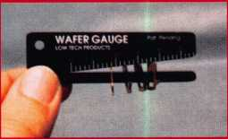

With all the high tech changes are taking place in our industry, still the need to deal with a lot of ordinary every day mechanical tasks. A company called Low Tech Products makes some rather interesting and useful tools and devices to help make some of those ordinary tasks a little quicker and easier.

Many companies make lock installation jigs for installing residen­tial or commercial locks on ordinary walk through doors. Low Tech Products has some interesting jigs for installing locks on drawers, cabinets and so on. The Super Desk Lock Jig (#LT-1()02A) is shown in Photo 3. It is a multi-part jig, which is adjustable to a variety of drawer (and door) thicknesses and configurations. An additional spacer block is just to the right of the assembled jig. A separate set of longer bolts is used when adding the spacer.

Photo 4 shows the tool in a front view with the assortment of different diameter drill guide sleeves. They can be used with the jig to drill holes of the following sizes: 3/4 inch, 7/8 inch, 1 inch, 1 1/8 inch and 11/4 inch.

Forstner wood bits are recommended for drilling the holes in wooden drawers or cabinet doors. A Forstner bit is a specialty auger

in the gauge in Photo 1. The  
Pin Gauge is identified as stock

number LT1001.

Another gauge is available for measuring and decoding disc  
tumblers. The Wafer Gauge (stock #LT1000) is shown in Photo 2.

There are calibrated markings on  
the gauge that could be used to  
record the measurements of disc  
tumbler sizes for specific brand  
locks. Later, the information could  
be used to decode tumblers for  
locks of those brands. The gauge  
could also be useful to approximate

a tumbler size on a lock brand for which you don’t carry a tumbler kit.

Some very practical tumbler gauges are available from Low Tech Products. A gauge for pin tumblers is shown in Photo 1. Three sets of tapered slots on the gauge are calibrated with measurements in thousandths of an inch. By sliding a pin tumbler into one of the slots

|  |  |  |  |  |
| --- | --- | --- | --- | --- |
| temtcwHseMO*  Lr.T.TiTi | T«T i T, T. | PIN GAUGE  T.T.T.T J.T | , T, T. T. T, T | . T. T>. T 7\ |
| T, T, i, T. T, | T.T.T.T, | T.^.T.T.T.T | . T i T. T. T. T | .T.T.T.T |
| T, T. i, i. i, | T.T.T.T, | T, T. T, T. T. T | .T.T.T.T.T | ••T.T.T.T |
|  | mmmmrn |  |  |  |

until it stops, you can quickly gauge the length of some of the shortest of master pins to the longest of bottom pins. It will not precisely measure to an exact thousandth, but with the color coding of the pins you can quickly identify the exact length. This gauge can be especially useful if you have the misfortune of tipping over a pin kit, or at least accidentally dumping a goodly number of pin tumblers. It is much faster than a dial caliper, not to mention that you can measure more than one pin at a time. Three different pins are



Photo 3

Photo 4

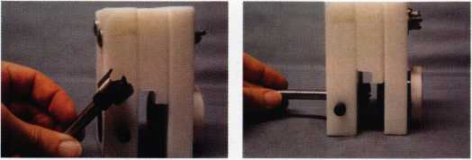

Photo 5

Photo 6

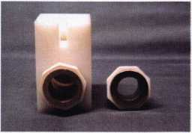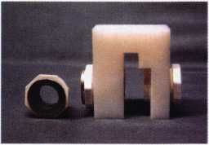

type bit that creates a very shallow depth pilot hole. A 7/8 inch  
Forstner bit (stock #LT1012) is shown in Photo 5. Photo 6 shows  
how the bit fits through the 7/8 inch sleeve installed in the jig.

This type of jig can make an  
otherwise long and tedious job of  
installing many drawer or cabinet  
locks into a relatively quick one.

Plus the lock installations will  
probably be cleaner and more  
accurate.

Another more basic jig called  
the Combination Jig (#LT1003A)  
is shown in Photo 7. This one  
has two different sleeves: 7/8  
inch sleeve for desk locks and  
3/4 inch sleeve for cam locks.

Photo 8 shows a side view of  
the jig. All you need to do is  
measure for the center of the

drawer, clamp on the jig, and Photo 8

you’re ready to drill your hole. Unusual drawer or door configurations  
may require the use of the Super Jig, shown previously.

gurus

Two different style “Goof Rings” are shown in Photo 9- These  
can be purely decorative or can be used to cover damage or scarring  
around the lock installation hole. Stacked on top of each other at  
the left side of the photo, the bottom one (with the round hole) is  
a Desk Lock Goof Ring (#LT1008). It measures 1 1/4 inch by 2  
inches. It is designed to fit over the nose of a 7/8 inch face desk lock.  
The plate is adhesive backed, with a back view of the same type  
of plate immediately to its right. When the paper backing is  
peeled off, the glue will hold the plate to the surface of the  
drawer. They are available in US3, US26D, aluminum and white.

The plate at the top with  
flats on each side of the hole  
opening is a Cam Lock Goof  
Ring (#LT1010). The outside  
measurements are the same  
as the other goof ring. It is  
designed for use with cam  
locks, and with the strong  
adhesive backing can

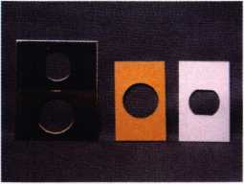

Photo 9

sometimes act as a lock reinforcement. A view of the backing of this plate is at the far right.

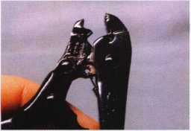

Photo 10

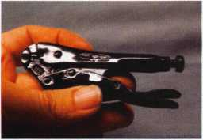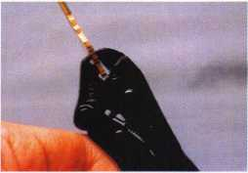

Photo 11

Photo 12



Another interesting tool from  
Low Tech Products is the Imp  
Grip, shown in Photo 10. It is a  
specially modified pair of vise  
grips designed for impressioning.  
Photo 11 shows a closer view of  
the gripping surfaces. When  
clamped shut in Photo 12, you  
can see that one part of the  
gripping surface is designed to  
go through the key ring hole of a  
key blank. It is intended to get a  
more solid grip and minimize  
slippage while applying binding  
and bumping pressure during the

process of impressioning. Photo  
13 shows a key clamped securely

by the Imp Grip. The one shown  
here is 4 inch (stock #LT1004),  
but it is also available in 5 inch  
(#LT1005) and 6 inch (LT1006)

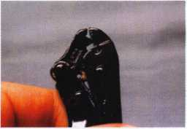

versions.

None of these products  
requires batteries or program-  
ming. Even though more and  
more things are going hi tech and  
will continue even further in that  
direction, there is still the need  
for a little bit of low tech. A lot  
of what we do is still mechanical,  
and clever and well crafted tools  
are always helpful to getting the  
job done.

If your local distributor does  
not stock these items, contact:

Low Tech Products, 3434 N.E. 130th, Portland, OR 97230-1535.  
Phone: 503/253-0424. FAX: 503/251-5839.

' About the Author: Sal Dulcamaro, CML has been in the

locksmith business for over 23 years. He is president of All Pro Security, Inc. in  
Michigan and has been an ALOA member for 16 years. A past president of the  
Locksmith Security Association of Michigan, Sal currently serves as editor of the  
association newsletter. He was named “Keynotes Author of the Year’ for both

1996 and 1997.

April 1998

Keynotes

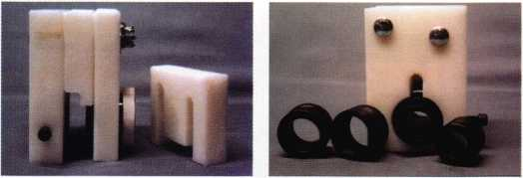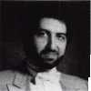

Institutional locksmithing is coming to the forefront of our profession as we locksmiths enter the 21st century. These men and women represent some of the largest and most influ­ential corporations in the world. Through their dedication and enthusiasm, they have gained access to the latest in physical and electronic security as well as the technical education necessary to enable them to choose the best and the brightest of the new security products becoming available in today's marketplace. These are truly security profes­sionals on the cutting edge of technology.

While it is taie that institutional locksmiths are still locksmiths in every sense of the word, traditional locksmiths have always considered them to be “outsiders,” unconcerned with the traditional field of locksmithing because their interests, pressures and concerns were so far removed from those of traditional retail locksmiths. Yet now, as we approach the new millennium, we find that something unique and wonderful is happening.

No longer are locksmiths and the lock­smithing industry becoming more fragmented. Rather, I find that locksmiths as a whole are finally coming to the realization that we should welcome each other. We are finding that there is strength in numbers and the whole is greater than the sum of its parts. With this new attitude being embraced by ALOA as well as individual locksmiths everywhere, we are welcoming all locksmiths and security professionals from every walk of life to join us in sharing our knowledge of security. This will make each of us individu­ally - and our national association in general - all the better for it. Congratulations... and welcome to the 21st century.

Institutional locksmiths have long been the best source of understanding the next phase in the evolution of our industry since many of them work for those corporate giants who have the wherewithal and the vision borne of necessity to seek out the newest in security technology. Just as surely as a new security innovation hits a waiting market, so do those would-be thieves in our society seek to compromise their efforts. We can learn all about the cutting edge of technology by welcoming these professionals who have to deal with high tech problems on a daily basis. After all, access control was not borne of resi­dential needs, but of commercial, industrial and institutional needs!

The importance of ADA legislation was news to most of us in the retail trade, but was an ongoing battle for many years for those in public institutional settings. Insurance regula­tions are something that is uppermost on the mind of every institutional locksmith, but sometimes only a passing concern for us as

retailers. Two of the most common tejxns in the Vocabulary of the institutional locksmith are “risk management” and “loss prevention,” \ yet to many of us they are new concepts.

Believe me, no one makes a move at that level without considering them both.

So come with me now as we visit with a security professional who can shed some light on this segment of our profession, and see why ] I believe we have so very much to learn from each other.

I have chosen one of the finest security professionals who I am privileged to call a close personal friend tg/iaterview. He is a man who has deep roots in the locksmithing profession.

He will provide us with insight into the emerging pivotal role of the institutional locksmith, as well as the ever-changing role of the traditional retail locksmith,|This gentleman is responsible for the security at one of the most influential companies in America, the 3M Corporation.

INSTITUTIONAL LOCKSMITHING:

m WBm n % w

&

In Minnesota, where its corporate head­quarters are located, 3M has made significant changes in the way they have chosen to approach security. Many of these innovations were the result of the gentleman that I am about to introduce you to through this interview. His name is Doug Rude.

My wish is to analyze the current state of the security industry from his point of view.

In this way, we can draw the conclusions about where we are now and where we intend to go in the near and distant future. Now, let us turn our attention to the remarks of Doug Rude.

Keynotes: What was it like, making the change from retail locksmithing to institu­tional locksmithing?

Doug: Steve, first and foremost, I feel that I am truly lucky to be working in the field of security in general and the field of lock- smithing in particular. The biggest change for me as I made the transition from retail locksmith to institutional locksmith was the decision making process itself. Before, I was able to make a decision solely on my own. Now, I am required to be part of a giant corporation where all decisions are made by committees. The reason for this is that decisions made by corporations of this size

affect hundreds, if not thousands of employees of our company as well as many companies around the country. That is to say nothing of the effect such decisions have on consumers. My decisions made on my own in my lock shop affected a much, much smaller number of people. Do not get me wrong, I am not saying that one method of decision making is better than another. I am saying that the processes are vastly different.

Another significant difference between my role as a retail locksmith and my role as an institutional locksmith lies in the fact that the primary business motivation for the retailer is to make money. Hopefully, he does this by providing customer service and quality products at fair prices. Whereas the primary motivation for the institutional locksmith is to save money - to accomplish the most in terms of providing internal services and purchasing quality products for the least amount of time and money. As a result,

I have become innovative. I have learned to understand the internal politics of a major corporation just as politicians learn how to operate in the outside world to get bills passed. The buzz word here is downsizing. The effects of downsizing in terms of prof­itability and corporate survival cannot be overemphasized. Especially in relation to responsibility to the stockholders. Remember, if the corporation is generating less prof­itability than the stockholders could obtain by investing their money in other areas, then they will no longer invest their money in the corporation.

Keynotes: Are there similar skills and knowledge requiredfor institutional?

Doug: Another significant difference between retail locksmithing and institutional lock­smithing is the transition I made from being a hands-on practitioner who knows a good deal about most every lock to a manager who is an expert in a couple of brands of locks and locksmithing systems. By nature, I am an entrepreneur who is a hands-on guy.

However, in this environment, I have learned to delegate my authority to others. Much of my time is spent training.

The training I do is internal training for employees of the corporation.

One of the biggest changes that I see is in master keying. For more years than I care to remember, the most important part of a security system was for the corporate leaders to have a single master key that operated on every one of 100,000 locks within our company. The disastrous results that occurred when that master key was lost were monumental. The staggering costs and the lost man hours were unacceptable. Yet this was a job that I dreamt of as a retail locksmith. Both because it was high profile

Keynotes

April 1998

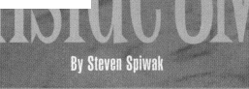

and because of the enormous amount of money this highly profitable job would bring into the company Now, with the advent of access control, such a change can often be accomplished in the biggest companies for virtually no cost and in very, very little time. We are talking about minutes, instead of days.

Keynotes: What are some other areas you have found yourself spending more time on nmv?

Doug: Most of all, I must always consider the single most important preoccupation of the corporate or institutional security professional — liability. I have become an expert on Life Safety codes, ADA (Americans with Disabili­ties), internal company security procedures, applicable local, state and federal ordinances and laws. I have even become an expert on many Environmental Protection Agency (EPA) ordinances as well as customizing existing installations to meet new legal, ethical and moral criteria.

So how do I keep all this information together? I have learned to become a computer expert as well as an access control expert. By this, I mean that I have all my keys and locks bar coded, so that I can obtain accurate information quickly and easily by swiping the key past the stationary reader or swiping the lock with the portable reader.

This complete program of door, key and hardware identification through bar coding is one of the ways in which I keep my sanity given the number of responsibilities that I now have.

Keynotes: Do you ever miss retail?

Doug: Do I long for the good old days when I was a retail locksmith? The answer is “yes” and “no.” By this, I mean that I truly loved working in the shop. The variety of people, and locks and problems was downright exciting. I also loved the unbounded freedom of going out on service calls to everywhere in our city. However, I have never been so challenged as I am here. Each day brings some new technology to my door that I would have waited forever to see and evaluate if I was not working for one of the largest corporations in the world. The compensation packages for medical, disability and retirement are more than I could have ever dreamt of in a standard retail shop. In fact, I am the chairman of the Facilities Access Control Steering Committee that is meeting shortly. This committee is the driving force behind many of the innovative solutions to the security challenges that we face every day. I am glad that I have been on both sides of the locksmithing fence. Having been so, I can truly say that both traditional retail locksmithing and institutional lock- smithing each have their strengths and weaknesses, and I would not have given up

either experience for any other job in the world. Maybe that is why I told you that I feel so lucky to be part of this exciting and dynamic industry



About the author: Steven B.

Spiwak,CRL is a fourth generation locksmith who  
specializes in a variety of variety of areas including  
crime prevention and institutional security. His broad

experience in the security field spans 20 years of writing, teaching and consulting. Spiwak’s lengthy client list includes Ford Motor Company, Exxon, The Chicago Tribune, Sears, Westin Hotels, the U.S. Treasury Department and the Federal Bureau of Investigation. Most recently he formed Lockport, Inc.-a security consulting company for industrial, commercial, institutional and governmental clients. Readers with article suggestions or requests for him can contact ALOA at email [publ@anet-dfw.com](mailto:publ@anet-dfw.com) orfax to (214) 827-1810.

Do you need Electrified

Trim  
Locks  
Hinges

Panic Devices  
Access Hardware  
Custom Modifications?

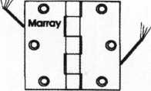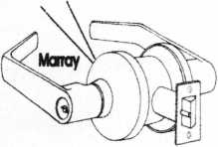

You Need To Call Marray  
1-800-500-1449

Marray Enterprises, Inc., is an after-market modifier of locks, hinges, and panic devices. Located in the Silicon Valley of California, Marray uses precise computer controlled machin­ing to modify name brand hardware like Schlage, Von Duprin, Arrow, Baldwin, Bommer, PBB hinges and more! If you are looking for superior products with the best warranty, pricing, delivery and availability, call Marray. Your first source for UL listed & modified hardware.

ME

**Marray *enterprises, inc.***

At Marray, we’re not just modifiers, we’re Master Hardware Modifiers™  
1128 Walsh Ave., Santa Clara, CA 95050. [www.marray.com](http://www.marray.com)

Reader Service #2

April 1998

Keynotes L_

*"You've probably seen him. Maybe you’ve  
chatted with him. He a at aii the big trade*shows, *ALOA, PHI, ISC, etc. He a the quiet,  
unaaauming guy in the blue blazer with aome*

*aort of creat on the pocket. And hep a man  
with a miaaion.*

*He a Phillip A. Povenolt, but call h\n  
“Povey.” Sy day, he a the aole lookamith for  
the Waahington D.C. Waiter and Sewer  
Authority. In hia free time he teachea look-  
amith ing at Prince George a College in Largo,  
Md. and partioipatea in the Cheaapeake  
Chapter of ALOA in addition to other local  
and national organizationa. And to pop it all  
off, he a the preaident of the Inatitutional*

*Lockamith’a Aaaociation. In caaeydu  
haven’t noticed, Povey and aeveral df hia  
fellow “in-houae” lockamitha are quietly  
building a aucceaaful trade aaaociation  
and breaking aome new ground.* j

*I’ve known Povey for a couple ofyeara  
now and, aa a former inatitutional* j  
*lookamith myaelf, I’ve watched with intereat  
aathia organization haa grown. I thought it  
would be intereating to aak Povey a few  
queationa about hia aaaociation and about*

*the role of inatitutional lockamitha*

*in general.*

*Povey: The ILA waa formed in 1933 in the doaton, Maaa. area by 17 men and women who wanted a forum to meet their apecific needa aa inatitutional lockamitha From that humble beginning we have grown to be an international group with aeveral local chaptera. We have a number of hard working membera, not leaat of who ia our editor and webmaater Sill Kiae,*

**Keynotes: What kind of membership do you have today?**

Povey: Our membership today is growing at a very fast pace. We’ve gone from the original 17 members in 1933 to nearly two thousand today. We foresee continued growth because there are a lot of institutional locksmiths seeking an association that can help them to better their job situations and improve pay scales.

**Keynotes: What sort of bene members receive?**

Kovey: We provide educational classes at our annual conference, as well as at other times during the year. For instance, we are offering a number of classes in connection with the 15C conventions in Las Vegas, Chicago and New York this year. Our own annual conference and symposium will be hosted by Sargent Lock Company in July 1993. In addition to classes we have a newsletter, called KEY ISSUES and a website. Our Web address is <http://www.mindspring.com/~inhouse/startil> a.htm

**Keynotes: Why did**

**your own o**

**the existing**

Kovey: Well, speaking for myself, I felt that I needed an organization that would connect me with people who have common interests and where I could improve in my skills as a locksmith. I’ve discovered that most super­visors and managers are very sincere but woefully uneducated about the locksmith trade. Of course other locksmith associa-

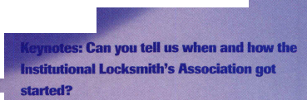

NOW SHIPPING

tions, such ae ALOA, offer some of these benefits. f3ut they also focus a lot of energy on issues that just don’t concern in-house locksmiths - issues related to business ownership, for example. I feel that ILA addresses our unique interests in a special way. Many ILA members, including myself, belong to and participate in other locksmith associations as well. We don’t see see ILA as “instead of” other associations, but rather“in addition to.”

**Keynotes: When I was an institutional locksmith attending trade association classes and events I used to feel resentment and conde­scension from some of the commercial locksmiths. Is this a problem today. If so, how can we address it?**

Rovey: I think there may always be some resentment and conde­scension, on both sides of the fence. We need to realize, though, how much we all have in common. The world needs both the commercial locksmith and the institutional locksmith, and there’s plenty of work for us all. Dallas Drooks and I have had several good conversa­tions about promoting the common bond between all locksmiths.

**Keynotes: What would you say are the unique issues, circumstances and needs of institutional locksmiths?**

Rovey: Training is foremost. We need complete and detailed technical instruction on the specific commercial hardware that we work on daily. Heavy duty hardware and large master key systems require exacting and precise service procedures.

**Keynotes: What are the advantages of being an institutional locksmith?**

Rovey: Locksmiths who are employed by large institutions enjoy steady employment, regular paychecks and usually a pretty good benefit plan. Some employers are good about paying for additional training, too.

**Keynotes: From your perspective what are the trends in our industry, good and bad?**

Rovey: Certainly electronics is becoming a major factor in our work. Electronic security is taking much of the emphasis off mechanical locking devices. The entire locksmith industry is experiencing these rapid and challenging changes. Institutional locksmiths also need to stay up-to-date on the American With Disabilities Act and all Life Safety Code issues.

**Keynotes: What would you like to see happen in our industry as we enter the 21st century?**

Rovey: I would personally like to see more unity among us and less personal grudges. The next millennium is upon us and moving very fast.

**Keynotes: How can our readers find out more about the Institutional Locksmith’s Association?**

Rovey: Anyone interested can write to us at EO.Dox 1275 Waldorf MD. 20604 or email us at inhouse(^mindspring.com. We would be happy to send you information, an application and a flier about our symposium which will be held from July 22 through 25 in New Haven, Ct. at the Omni Hotel and at Sargent Lock Company.

About the Author: Paul Chandler, CRL, is the manager of the Electronic Security Department for I.D.N.- ACME in Houston, TX.

A Smarter  
Safe In Minutes  
For Only $219

AVL® Activity Verification Lock is the first truly affordable Smart Safe Lock. It is quality crafted with features not

available in products  
costing twice as  
much, yet AVL®  
is easy to install,  
program and use.

With AVL? you  
can generate new  
revenue from old  
safes and continuous  
income from

replacement keys.

® ® © ® ® ® (D ©

°®00



I Standard foot print replacement. All you need is a screwdriver to replace that old mechanical lock.

I Features include duress interface, door condition monitoring, armor car (dual) key, programmable time delay, and more.

l 500 lines of audit trail identified by user, date, time, and activity type. Audit trail can be viewed or printed without special proprietary software.

I AVL® accepts all Dallas Semiconductor keys, such as those used by Vindicator, MAS Hamilton, AuditLok® and others, allowing for easy integration into existing systems.

I 9V batteries last 3,000 + safe openings.

Call NKL Industries today for complete details  
on the AVL® Retrofit Program.

1-800-528-9900

NKL|NDUSTRIES' *-td-

GW

**[SAFE INTERNATIONAL]**

Corporate Office: 1111-13 Cavalier Blvd. Chesapeake, VA 23323

nklindustries.com

AVL® Activity Verification Lock, and NKL are registered trademarks of NKL industries, Ltd.

The following are trademarks of their respective companies: Dallas Semiconductor, Vindicator, MAS Hamilton.

Reader Service #3  
 April 1998

Keynotes

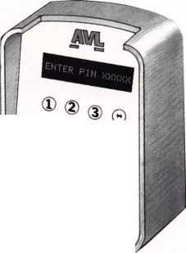

I he field of security can be broken down into three areas, namely: physical security, electronic security and human security. This month, the emphasis will be within the category of electronic security. In particular, the area of electronic card access control will be examined.

Many locksmiths are presently considering whether or not they should enter into the field of electronic security, but are hesitating for a wide variety of reasons. The main reason among even the most highly skilled physical security specialists is fear of the unknown, in this case, a fear of electricity.The best way to combat this fear is to educate yourself thoroughly about this new subject area. Education, both in terms of written materials (technical magazines, manuals, texts, etc.) and participatory involvement (seminars, workshops, correspondence courses, etc.) are excellent methods for increasing one’s knowledge to a point where he/she is confident to master a new service in order to offer it to paying customers.

There is another option, however, which should also be considered. That option is subcon­tracting. Subcontracting with a highly qualified, experienced and skilled technician (or technical firm) can be a legitimate shortcut to being able to add income from specialized services to your profits as well as to dramatically increase the breadth of services that you can offer your customers!

Moreover, it will enhance the image of both you as an individual, and your overall company image - an essential element of any successful businessman and business.

The cards most commonly used in electronic card access systems are generally grouped into seven major categories (in approximate order of cost and complexity): Hollerith (hole punch cards), Bar Coded Cards (optical reader cards), Magnetic Stripe Cards (sometimes referred to as “swipe cards”), Barium Ferite Cards (named for the magnetic material used), Wiegand Cards (a thin type of binary wire system is characteristic of this card), Proximity Cards (often referred to as tuned circuit or electro-static cards) and lastly Smart Cards (often used in conjunction with the security term “biometrics”).

**Hollerith Cards**

Hollerith or hole punch cards are most commonly manufactured from paper or paper-like substances. Punch cards are therefore the least expensive of the seven major categories of cards to produce. These cards generally cost between 20 cents and $1.75 per card. Historically speaking, these cards have been, as you would expect, in the marketplace the longest amount of time.

30 I KeynotesApril 1998

Records indicate that in the early years of the industrial revolution (circa 1890), paper punch cards were used to clock-in and clock-out seamstresses in the rapidly growing New York garment industry. Hole punch cards, however, did not really achieve widespread popularity in the United States until the 1930s when they were used almost exclusively to record an employee’s actual working hours and attendance.

The basic operation of this type of card is not difficult to understand. The earlier punch cards were “read” mechanically by metal pins, which resembled fingers. These “fingers” would be inserted into the specified hole to identify and record, most often in conjunction with a clock, the most basic types of information, namely attendance and punctuality. The more advanced punch card systems operate by producing light, which is then used to illuminate the card. The card blocks all of the light except the portion that passes through the holes, which are then read by a photo sensitive plate on the opposite side of the light source.

Despite the attractiveness of the price of punch cards, there are many drawbacks that can occur due to the primitive design and the fact that damage can occur so easily because they are constructed from a relatively flimsy material (i.e. paper). Furthermore, these cards can be easily altered or tampered with to enable entry of unauthorized personnel. Even the basic positioning of the punch holes is rather simplistic and easy to decode. Perhaps, worst of all, is the fact that punch card machines used to originate new cards are available for as little as $200!

Overall, it must be stated that Hollerith or hole punch cards should only be used in the most minimum security situations - employee attendance cards and parking lot time cards where the low cost of the cards is a higher priority than the level of security. This is particularly true when both these areas may already be monitored by a trained guard or a closed circuit television camera.

**Bar Code Cards**

The second type of card used in electronic card access systems is the Bar Code Card (label). Bar codes have been in existence since the 1960s, gaining steady popularity as the method of choice for tracking inventory in retail, wholesale, institu­tional and manufacturing settings. They are the tracking method of choice due to their high relia­bility and low cost (as little as 10 cents).

Lately, bar codes have been gaining popularity in the security industry because they are so easy to manufacture particularly in conjunction with the easily scanned bar code labels used almost univer­sally these days in the supermarket industry.

Another important reason for their growing popularity in the security industry is the fact that bar codes can be “masked.” Infrared masking provides a significant level of security by making it difficult to decode the cards or labels that are protected in this manner. As you would expect, bar codes protected in this manner are considerably more expensive to produce, costing as much as $5 per bar code.

Technically speaking, there are generally considered to be about 10 different types of bar codes. They are not easily distinguishable from each other using the naked eye.

This is because bar codes in their most basic form are no more than a series of light and dark areas spaced a specific distance apart from one another for the purpose of forming a unique patterned code that can then be read by the appro­priate optical scanner to analyze the information.

In their most basic form, bar codes are placed directly on a card or label for quick and easy scanning. Visible bar codes are inexpensive to manufacture, but easy to alter or forge. Masked bar codes offer a greater degree of security, because the masking not only makes the bar code difficult to interpret without specialized sophisticated equipment, but difficult to alter as well. Furthermore, masking protects the bar coded cards or labels from the harmful effects of abrasion, dirt, and electrical or magnetic fields.

Perhaps the greatest concern associated with bar coded cards and labels is the ease with which a card originating or altering machine can be obtained and used. Currently, a bar coding machine sells virtually everywhere for about $400. Unauthorized bar coding machine users can even add an individu­alized infrared mask of their own to conceal their identity and any part they may have had in the unauthorized alterations of cards or labels.

Bar coded cards or labels are classified as “swipe,” meaning that a card or label must merely be brushed by the optical reader to be analyzed, and not carefully inserted and held in place to be read. Despite the lack of need for closely held tolerances for effective optical analysis, bar code readers that are installed outdoors must, of necessity, be carefully sealed since their lifespan and their accuracy are directly affected by the outside elements.

**Magnetic Swipe Card**

The most popular of all electronic card access systems is the magnetic stripe card. These cards are used by virtually everyone on a daily basis. Magnetic stripe cards form the basis for all our credit cards, ATM (automatic teller machine) cards, etc.



This type of card relies on fundamental manufacturing technology. Magnetic stripe cards can cost as little as 75 cents per card to as much as $2.75 per card.

Unfortunately, these cards can be altered or forged with little or no trouble in the field by a qualified user, utilizing a magnetic stripe programmer! Currently the going rate for this type of programmer will run between $1,000 and $2,500 depending upon the sophistication



By Steven Spiwak

and the amount of use for the individual unit in question. Security can be improved upon by adding special tape to prevent accidental or intentional erasure or alteration.

Currently, the most accepted cost effective methods for enhancing the security of these cards are identification photographs of the card holder permanently affixed to the card (although it must be pointed out that such photos can be altered or forged with a minimum of effort in most cases), and the use of alphabetical or alphanumeric security cross­checks such an PINs (personal identification numbers) in addition to the card itself.

These cards are best utilized when read by insertion; however, they are frequently used in conjunction with swipe machines. When these magnetic stripe cards are used in an outdoor application, it is important that both the card and the reader remain dry and free from harmful elements to ensure the best possible

results. It is important to note that magnetism (or electromagnetism) can have deleterious effects on both the card and the reader, but the card itself is especially vulnerable to magnetism. This is made evident by the fact that even a weak magnetic force found in a small magnet used to secure a woman’s change purse or handbag can, after a short time, effectively alter or erase all the information contained in the magnetic stripe.

There is one problem that must be mentioned. The average life expectancy of the magnetic stripe card under normal use is only about 18 months. While this short duration is highly unacceptable for security applications, a newer polyester based card is now available that more than doubles the current lifespan for a modest increase in price.

**Barium Ferite Cards**

Barium ferite cards have found a widespread acceptance among the security community within a very narrow application band. Barium ferite cards are used almost exclusively for minimum security applications such as parking lot surveillance.

The actual construction of the cards is accomplished by carefully compressing the compound barium ferite between two thin outer layers of plastic. By magnetizing these specific areas to correspond to a reader preset to sense these critical positions one is able to accept authorized barium ferite cards while rejecting unauthorized versions.

Each specific magnetically encoded area of barium ferite compound is referred to as a “magnetic spot.” Each magnetic spot of barium ferite compound contains one single bit of information. There are usually two dozen to four dozen bits of information per card.

Barium ferite cards can be manufactured in such a way as to vary not only the degree (strength) of magnetism, but the specific type of magnetism as well. These more sophisticated versions (approximate cost $3.50) of the standard barium ferite cards (approximate cost $1.00) are significantly more effective against alteration and forgery than the standard versions. In either case, it must be remembered that the code is located within the card itself, between the two layers of plastic, within the magnetized barium ferite spots, making any attempts at vandalism or tampering more difficult than any of the other cards that have been discussed so far.

April 1998

Keynotes 111

The type of reader used in conjunction with the barium ferite cards { must be of the insertion type, rather than of the swipe variety. The reason | for this lies in the construction of this type of unit. Alignment in the case of a magnetically encoded card of this type is critical. The swipe type of | reader which does not rely on critical alignment and therefore often proves faulty and provides inconsistent readings.

It is important to note that recent advances in card reader technology | have given rise to the touch action reader. This type of reader is similar to j the insertion readers now being used However the touch action readers | are more convenient and easy-to-use since alignment criticality is not as I much an issue as with the insertion readers. Both insertion and touch action readers utilize non-moving (stationary) coils to enable the card j to be read easily, even through dirt, environmental debris, and other visual detractors or inhibitors.

**Wiegand Cards**

Wiegand cards are ingeniously constructed. Each Wiegand card is comprised of a series of infinitely small diameter wires. These wires are then assembled in strips which are positioned throughout various locations on the card itself.

Wiegand cards are often compared to a computer oriented binary system since each wire strip has two information tracks. When the Wiegand card is moved through a set of magnetic fields, each Wiegand wire will send an impulse that is interpreted as a 0 or a 1 by the j computer (having only one of two choices in this manner virtually defines the binary systems). Depending on the number of wires contained within the Wiegand card, there is the capability of having literally l hundreds of millions of different codes!

Despite all the advantages of the Wiegand cards and the fact that they | are held in high regard in most security circles, there are two major drawbacks. The first concern is the cost of the individual cards, which run on an average in the neighborhood of $4 to $7 each. Secondly, since | the Wiegand card contains so many small diameter wires within its interior, through ordinary use (and especially through abuse or misuse)

| the tiny wires can be broken through the normal flexing of the card. If you add the element of extreme heat or cold, the incidence of broken wires resulting in faulty or scrambled messages increases dramatically!

Most Wiegand cards are now using swipe readers, which are generally accepted to be effective under all but the most extreme conditions, j However, uses for the Wiegand cards in the security industry have j generally been limited to use in product identification situations and employee attendance. The reason for this limited use is a result of the fact that on average only 20 to 40 bits of information can be transmitted on time effectively.

**Proximity Cards**

Proximity, Tuned Circuit, and Electrostatic type cards all provide | excellent security, because these types of cards are nearly impossible to 1 duplicate, forge or alter, even under the most optimum of conditions.

I However, all these types of cards can be damaged or destroyed through vandalism or tampering.

These three types of cards all feature complex and sophisticated technology, maintenance that on average is routine, and upkeep that is I greatly considered inexpensive. However, despite all the positive factors there are basic drawbacks. Blocked messages can occur on occasion creating an annoyance for the system users. In addition, the frequency of blocked messages in this type of system can be a genuine problem - even to the point of being a security concern.

A Keynotes April 1998

There are a number of clearly defined factors that will increase the incidence of blocked messages in these types of cards. Most common is the extreme pressure exerted on the conductive materials between the card and the reader. This system must also contend with the continual disruption of ongoing activities caused by electrical radiation emanating from the reader itself.

There are many varied uses for the proximity type cards even though the price per card is quite costly, ranging on average from $7.50 to $15.00. These cards are used extensively to track everything from clothing in department stores to migrating animals in the wild.

Proximity cards never wear out under normal conditions because, as their name implies, these cards are held in close proximity to the reader to transmit data, and do not have to be either swiped or inserted to be read. In fact, it is unnecessary for this system to provide any direct physical contact between the card and the reader for the proximity card to be read.

Proximity cards are available in two versions: active and passive. The active version of these cards is declining in popularity due to the fact that they rely on a battery for power and therefore have a relatively limited lifespan. In addition, batteries always seem to quickly weaken and become inoperative at the most inopportune times. It is true that the battery problem has been solved to a degree in some of the newer systems. The batteries are often guaranteed for three to five years, and feature a visually arresting red LED (light emitting diode) and an inter­mittent high decibel audio warning signal to indicate when the battery is nearing the point when it must be replaced.

The passive version of the proximity system has been increasing in popularity as of late and gaining a widespread acceptance among those in the security community. The passive version, which relies on a tuned circuit, has an indefinitely long lifespan. This system utilizes a chip that is energized by the force exerted by the radio frequency emanating from the reader.

Proximity cards feature internal circuitry that transmits 30 and 60 bits of information. These cards are characteristically thick and rigid to protect the delicate internal mechanism, which can be affected adversely by environmental extremes (frigid cold or intense heat).

As a result, these cards are bonded together using a manufacturing technique called ultrasonic welding. Ultrasonic welding uses ultrahigh frequency sound waves to bond substances together where the substances themselves or the internal circuitry or components are adversely affected by more tradition welding techniques using extreme heat. One common example of a security item with which we are all familiar that utilizes ultrasonic welding techniques are VATS (Vehicle Anti-Theft System) keys. VATS keys utilize ultrasonic welding techniques to bond the resistor chip into the throat of the key blank, because heat directly affects resistance and the values of resistance components.

**Smart Cards**

The seventh and final category of electronic access cards is the smart card. Smart cards provide the state-of-the-art in security technology. Prices for smart cards begin at $25 per card and can go much higher depending on the levels of sophistication and complexity involved.

Smart cards utilize individualized statistics such as an individual’s social security number, which can be updated on a regular or irregular basis, as well as personal characteristics such as voice print, finger/palm prints, or retina scans to obtain positive identification.

It is interesting to note that in a recent movie some potential thieves were successful in compromising a voiceprint identification system by obtaining a cleverly edited tape recording of an authorized user’s voice.

In actuality, this would not have worked with a sophisticated system, because such a system would have picked up the tape on the recording heads as distortion, no matter how faint, and rejected it. However, the new laser disc recording technology does give one pause to think about the possibilities of using that type of equipment to accomplish the same ends.

Smart cards utilize microprocessors to create encryption algorithms to generate unique, one-of-a-kind personal identification requirements from detailed physical descriptions to esoteric passwords. General data, specific descriptions and complex passwords can be added, deleted or upgraded at any time. These same encryption algorithms can be used to create communications links between the card and the reader. This is the same type of futuristic technology that is described in such movies as the Terminator and Star Wars when the characters speak of “machines communicating with other machines.”

While it is true that smart cards are expensive, forgery can not be even attempted for the amount of money needed to try unauthorized duplication. To say the least, unauthorized duplication is very difficult.

Smart cards are generally available in two versions: laser cards and microprocessor cards. Both versions contain a powerful miniaturized memory chip.

This miniaturized memory chip found in the microprocessor card is either embedded in the plastic or it is written into the plastic using a laser. This type of smart card can store up to several million bits of information! Just compare that to the other cards that we have discussed that provide only 30 to 60 bits of information on the average. The microprocessor cards are directly affected by over flexing, improper alignment, electrical and magnetic fields

The laser version of the smart card is, in actuality, a series of microdots that are placed under a cover sheet. This type of smart card does not need to be in direct physical contact, by swipe or by insertion, to be accurately read. Laser type smart cards are not affected adversely by electrical or magnetic fields.

**Play Your Cards Right**

Familiarize yourself with the uses for these seven types of electronic access cards. Understand their strengths and weaknesses. Seek the best source to obtain the best pricing for you and your customers. Seek further information about those particular types of cards that appeal most to you. Learn to apply them in the proper situation to obtain maximum security and optimum results for your customers, and you will be well on your way to entering the security business as it will be performed in the 21st century.

The 21st century sounds so distant, so futuristic. Remember- the 21st century is just around the corner.

WFW* About the author: Steven B. Spiwak, CRL is a fourth

generation locksmith who specializes in a variety of variety of areas including  
crime prevention and institutional security. His broad experience in the security  
field spans 20 years of writing, teaching and consulting. Spiwak’s lengthy  
client list includes Ford Motor Company, Exxon, The Chicago Tribune,  
Sears, Westin Hotels, the U.S. Treasury Department and the Federal Bureau  
of Investigation. Most recently he formed Lockport, Inc.—a security consulting  
company for industrial, commercial, institutional and governmental clients.  
Readers with article suggestions or requests for him can contact ALOA at  
email [publ@anet-dfw.com](mailto:publ@anet-dfw.com) or fax to (214) 827-1810.

INTERCHANGEABLE  
COREPRODUCTS

Interchangeable

with:

•BEST

* ARROW
* FALCON

Quality • Price  
Delivery

KSP

KILLEEN SECURITY  
PRODUCTS

That's what KSP is all about!

***33 Hermon* St.**

Ask your wholesaler about  
our drop shipping**.**



**Worcester, *HIA 01610  
Phone (508) 798-3200***

***Fax (508) 753-2183***

Reader Service #4

**What's In A Name?**

**Sometimes Everything!**

ALL-LOCK

Is

Newer - Bigger - Better

And Now Serving You As

*BWD*

Automotive - Alabama

Automotive Locks, Keys & Kits For The Professional Locksmith

(800) 647-4926

**Catch Us At [www.alllock.com](http://www.alllock.com)**

Reader Service #5

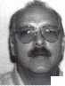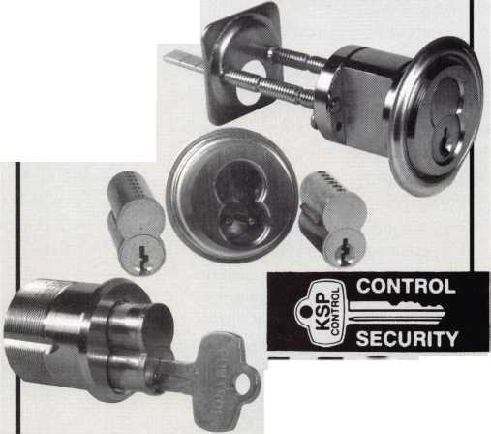

Mul-T-Lock makes some rather heavy and physically imposing padlocks. The internal construction of the padlocks is somewhat unique, with a number of different layers of metal inside of each other. The disassembly and servicing procedure is not readily apparent just by quickly looking over the padlock. Trying to disassemble this type of padlock, a careless service technician could end up with an assortment of parts with no obvious way to put them all back together. When done properly, however, disassembly and reassembly is not that difficult. You must pay close attention to what you are doing.

Photo 1 shows the assembled padlock with two keys and an ID card for ordering additional keys. The nearly flat key is tip gauged, and has inside and outside dimple type key cuts in five pin chamber positions (a

**total of 10 guts); which ■■■mteraec with 1-0**

bottom tumblers. Each pin chamber contains a smaller diameter solid inner pin and a larger diameter hollow outer pin. Two drilled and tapped holes (between the shackle legs) on the top of the lock case are designed to allow attachment of a shackle guard to reduce the possibility of cutting the shackle.

**- - i#fN€HT I E-SHACKfcC** 1

This padlock has a “pop-open” style shackle. Turning the key unlocks the shackle, and a shackle spring pushes the shackle outward causing it to pop open.

Most heavy duty Mul-T-Lock padlocks can be converted to a fully removable shackle or back to pop-open style. The shackle must be removed in order to access the lock cylinder inside the lock case. In the demonstration to follow, the shackle is removed for that purpose. If rekeying is not desired, further disassembly past the shackle removal is not normally necessary when just switching shackles.

In Photo 2, a 2.5 mm Allen wrench is used on the lock on the left to remove the set screw. With the set screw removed, the needle roller pin behind it can be tipped out of the hole as shown with the lock on the right. That pin secured by the set screw is what prevents the shackle from completely coming of the shackle body when the key is turned and the shackle is released.

Looking at the bottom of the padlock body in Photo 3, the keyway is obstructed by a spring loaded shutter-type device. It is designed to protect the tumblers and internal parts of the lock cylinder from the elements (dirt, etc...). The tip of the key is tapered and

The core has been pulled out of the shell in Photo 6. Between the two shackle holes, at the top of the core is a part called the thrust plate. This plate conceals the two latch pieces and the latch spring. After removing the thrust plate in Photo 7, the latches and latch spring are now exposed to view.

The latches and latch spring have been removed in Photo 8. The back side of the lock cylinder components can now be viewed. The Mul-T-Lock key is tip stopped. With the latches removed, it is apparent that the inside surface of the latch had acted as the stop surface for the tip of the key. The raised surfaces on the back of the plug fit into slots

allows it to smoothly enter the keyway (moving aside the shutter at the keyway opening).

After the proper operating key is inserted and turned, the lock is unlocked and the shackle is released. Photo 4 shows the shackle completely out of the padlock body. The only reason the shackle has come out completely is that the set screw and needle roller pin had been previously removed. Otherwise (for normal lock operation) the shackle would have unlocked, but would have remained attached to the padlock body.

With the shackle out and the key removed, in Photo 5, the padlock can be disassembled further. The outer layer of the padlock, with its reflective chrome-like finish, is called the shell. The inner assembly (in a mostly matte black finish) is called the core. The core can now slide sideways out of the shell.

on the inside surfaces of the latches, and they  
(when the plug was rotated) acted to draw in  
the latches to release the shackle.

Turning the core upside down, in Photo 9,  
reveals a spring loaded shutter type device at  
the entrance to the keyway. This shutter  
device is called the “slider.” With the slider  
and spring removed in Photo 10, the keyway  
is now apparent. To the right of the slider  
and spring is a large diameter hardened pin  
that had previously filled the toe side shackle  
hole. This pin can only come out from the  
bottom side of the core. It is this hardened  
pin (along with the needle roller pin) that  
prevents a Mul-T-Lock removable shackle  
from being fully inserted into the shackle  
holes of the padlock.

If switching the shackle had been the only  
intention, removal of the slider and spring  
would not have been required. Neither

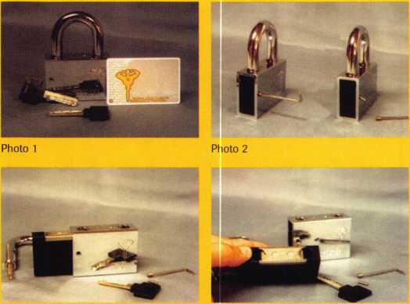

Photo 5 Photo 6

Keynotes April 1998

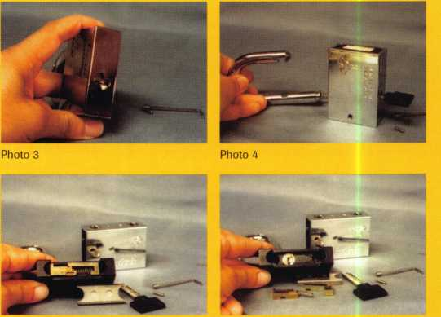

Photo 7 Photo 8



would one have had to remove the latches, latch spring and thrust plate. Once the hardened pin had been removed, the rest of the padlock could have been reassembled. The set screw would reconnect the shell to the core to complete reassembly. The needle roller pin would be omitted because that is only needed with a pop-open shackle. It acts to retain the shackle and keep it from coming completely out of the shackle body when the key is turned. A fully removable shackle could then be inserted into the two shackle holes.

When fully inserted, the removable shackle would latch and lock into place. Without a shackle spring, turning the key would release the shackle, but the removable shackle would not pop out of the padlock. The shackle would have to be pulled out of the lock body.

Removing

the lock cylinder

The lock cylinder inside the Mul-T-Lock padlock is of very unique constmction. The parts that make up and contain the upper and lower pin chambers in the lock cylinder are in contact, but they are not connected. Photo 11 shows the lock cylinder partially withdrawn from the cavity within the padlock core that contains it. The bible (the part that contains the upper pin chambers) remains in contact with the cylinder plug (which contains the lower pin chambers) as long as the two parts are held together within the cavity of the padlock core. If the lock cylinder was pulled out completely, the two parts would separate and cause the contents of all the pin chambers to spill and likely become lost.

To remove the lock cylinder safely, a special plastic holding device called a “catch” must be used to hold the two main parts of

the lock cylinder together. The catch is being slipped into place on the lock cylinder in Photo 12. After the catch is properly snapped onto the lock cylinder in Photo 13, the lock cylinder can be safely and completely removed from inside the cavity of the padlock core.

Photo 14 shows the lock cylinder after it had been removed. Although the bible and plug are not permanently attached to each other, they still act as any other type of lock cylinder. The plug will not rotate until the pins are at the shear line, which means the operating key must be inserted first. We are dealing with a tipped stopped key without a backing plate at the back end of the plug. It might be a good idea to use a finger tip as a stop when inserting the key, so as to position the key cuts under the correct tumblers to allow plug rotation. After the key was inserted, Photo 15 shows the plug rotated to expose the five pin chambers in the plug. Each of the five chambers has two pins: a solid inner pin and a hollow outer pin.

The contents of the first pin chamber have been dumped in Photo 16. The inner and outer pins are just below the lock cylinder and key. A series of inner and outer key cuts, coinciding with each of the five chamber positions, interact with inner and outer pins in each pin chamber. For the plug to rotate, all the pins (both inner and outer) must be at the shear line. All it takes is one pin out of position, and the plug won’t turn.

If the lock cylinder is to be rekeyed, all the bottom pins (called plug pins) can be dumped. A new key can then be inserted, and the proper inner and outer pins can be matched to the key cuts so that they all line up at the shear line. The plug would be rotated back so that the upper and lower pin chambers were back in alignment, and the key would be removed. With the lock

cylinder successfully rekeyed, the padlock could be reassembled.

Reassembly would be almost the exact opposite of disassembly. The lock cylinder would be partially reloaded into the cavity of the padlock core, until the catch could be safely removed. Then the cylinder would be inserted the rest of the way. The slider and spring would be reattached to recreate the keyway shutter. If the shackle was not being changed, the hardened pin would be reinserted into the toe end shackle hole. The latches, latch spring and thrust plate would be reattached on the top surface of the padlock core. The core would slide back into the padlock shell. Before reinstalling the shackle make sure the key works properly and rotates the plug smoothly. The shackle spring and shackle would be reinserted, and the needle roller pin would be reinserted into the hole that accepts the set screw. Reat­taching and tightening the set screw would complete the reassembly process.

For additional information about their padlocks or any other lock or security products, contact Mul-T-Lock at (800) 562-3511.

'About the Author: Sal Dulcamaro,

CML has been in the locksmith business for over 23 years. He is president of All Pro Security, Inc. in Michigan and has been an ALOA member for 16 years. A past president of the Locksmith Security Association of Michigan, Sal currently serves as editor of the association newsletter. He was named "Keynotes Author of the YeaY for both

1996 and 1997.

Photo 16

Photo 9

Photo 13

Photo 10

Photo 14

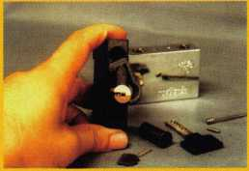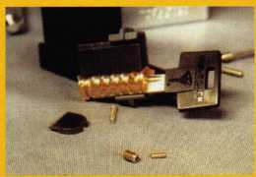

Photo 12

April 1998

Keynotes

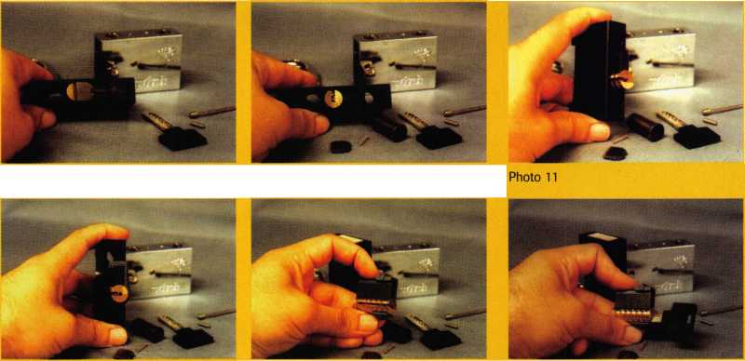

**Professionalism Through  
Education"**

CO *GNfg*

CEL

• Technical Reference Manuals

• Instructional Videos

Computer Software

**to provide you, the security**

**information that is both**

**accurate and relevant to your**

**ever-changing role in the**

**marketplace. In addition to**

**serving you each month**

**through the pages of**

**Locksmstf Leo**

**published** *Uis **v i**

**educational and refe\***

**material to help you prosper**

Free Information - Reader Service Card #6



Sometimes you find unusual or interesting tools in unexpected places. Recently when shopping for something else, I discovered a rather impressive screwdriver—the Viper 6-in-l screwdriver.

At first glance, it looks like any other multi-tip screwdriver. When you look again, you’ll see that it has an extended length shaft.

The screwdriver has been removed from its package in Photo 1 so that you can see the extended shaft. Six different screwdriver tips are stored in the handle. They include two slotted tips (1/4 inch and 3/16 inch), two Phillips tips (size 2 and size 1), and two Torx tips (size T- 20 and size T-15). I compared the tips to other screwdriver tips that I have for a battery powered screwdriver, and they seem to be standard size. You should probably be able to use other tips of other size and design with this tool. If other tips would be used more often than those stored in the handle, you could probably substitute and store the other tips in place of the original screwdriver tips included with the tool.

The main shaft of the screwdriver is rigid metal, but it is hollow and contains the flexible shaft inside. Although you could use the extended shaft for gaining additional length, I think that this tool becomes very versatile when used in awkward or very tight spaces. The flexible shaft can bend back nearly 180 degrees (Photo 2) and can get into some very hard to reach spots. A gripper piece near the tip end of the shaft (Photo 3) allows you to position the screwdriver tip securely into the head of a hard-to-reach screw. As you rotate the handle to drive the screw, the flexible shaft spins freely within the gripper piece.

The large flourescent orange handle is easy to grip and should allow you to apply ample torque either tightening or loosening screws. I’m sure many of us have been in spots where we could have used a screwdriver that could work around corners or get into tight or awkward spots.

I purchased this tool at a Meijers store, and I’m not sure how widely spread outside the state of Michigan that their store locations might be. The package label indicates the manufacturer of the tool, and it may be available from other retail outlets or maybe even for direct purchase from the company. If this tool is not available in your area, you could write to: Michigan Industrial Tools, PO. Box 88245, Kentwood, MI 49518.

I About the Author: Sal Dulcamaro, CML has been in the

locksmith business for over 23 years. He is president of All Pro Security, Inc. in  
Michigan and has been an ALOA member for 16 years. A past president of the  
Locksmith Security Association of Michigan, Sal currently serves as editor of the  
association newsletter. He was named "Keynotes Author of the Yead’ for both  
1996 and 1991.

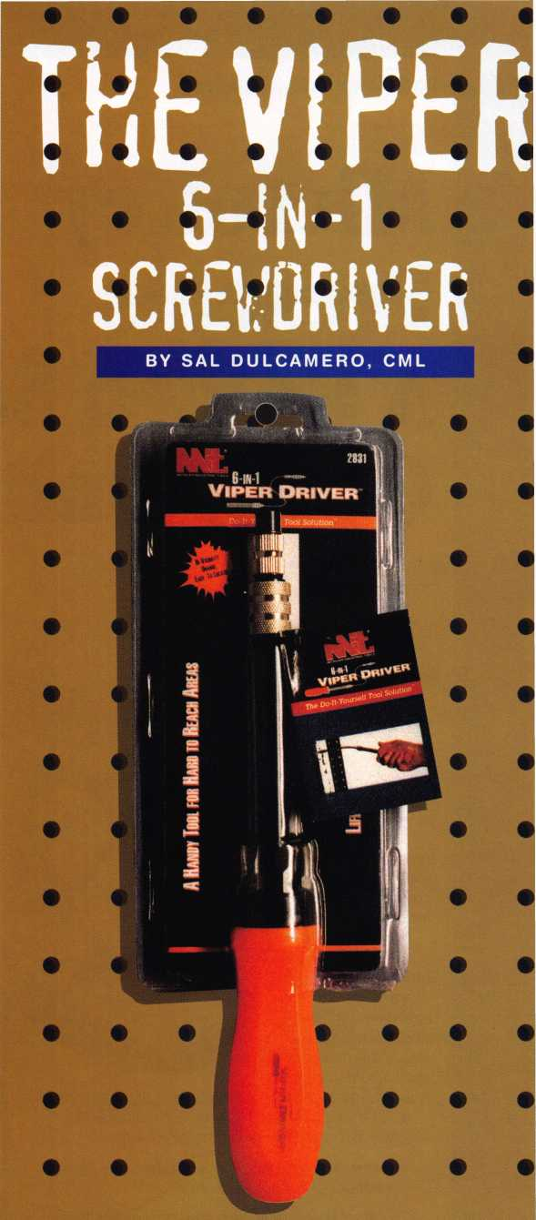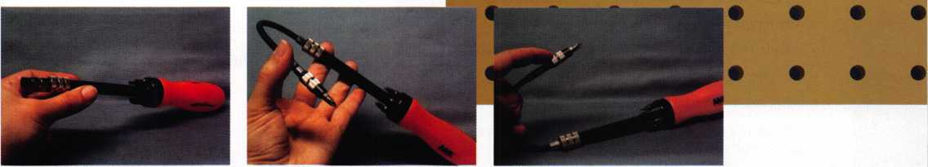

Photo 1

Photo 2

Photo 3

April 1998

Keynotes

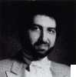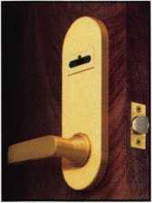

MicroKey

**Presents**

**A Golden Sales**

**Opportunity.**

I ake good care of your  
customers with high

security technology that  
creates repeat business  
for you.

The computerized

MicroKey Series is  
easily installed in new  
or retrofit construction  
applications without  
electrical wiring. Easily

expandable, it is adaptable to  
small or mid-size projects.

It accommodates mortise or cylindrical door prep conditions.

Winfield's sophisticated engineering has instilled the  
MicroKey System with these state-of-the-art features:

* Audit trail records date, time, authorized user names, unauthorized attempts (1200 entries)
* Five-level keying capabilities (also construction keying)
* System capable of controlling more than 60,000 users
* Instantaneous re-keying capabilities following installation
* Time zone keying control
* Smart, reusable micro-chip key blanks

Don't miss this golden opportunity for increased sales from  
one source. Call Winfield today for complete information.

A Division of CSS  
1020 West 17th Street, Dept. C-6  
Costa Mesa, California 92627  
Phone: 800-562-5733 (ask for ext. 407)  
(or) 714-722-5400  
Fax: 714-722-0129

Free Information - Reader Service Card #7

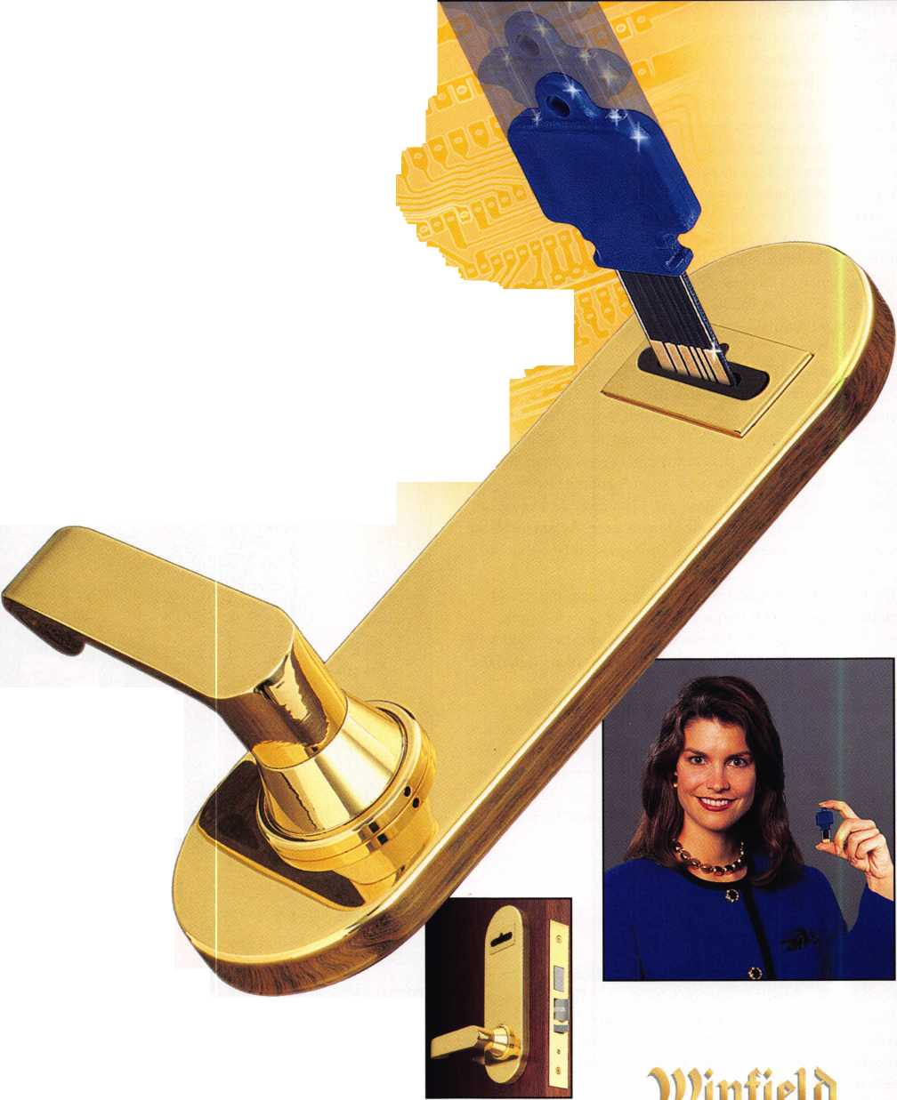

Fire at will. But aim well.

Before you terminate an  
employee, be aware of a changing  
legal environment that makes the  
procedure more hazardous than  
ever. You are within your rights to  
fire anyone. Misfire, though, and  
the unexpected recoil can be  
deadly: An expensive lawsuit for  
wrongful discharge.

“Unfortunately for employers,  
employment litigation matters are  
a growing part of the American  
legal scene,” says Lawrence C.  
Winger, partner at the Portland,  
Maine employment law firm of I  
Kraft & Winger. 1

Wrongful discharge lawsuits g  
can devastate your bottom line. 1  
Even a small employer can |  
easily spend $50,000 or more  
defending these cases, says 1

Herbert E. Gerson, a partner in j  
the Memphis, Tenn., office of  
McKnight, Hudson, Lewis, Ford |  
& Harrison. And the costs escalate  
if you lose a case brought under  
federal or state anti-discrimination  
laws. You can pay up to $300,000  
in punitive damages, as well as the  
fees of the plaintiffs lawyer.

Not a pretty picture. So how  
can you stay out of it?

Here are the most common  
mistakes made by employers, as  
revealed by seven employment law  
attorneys who have defended  
hundreds of businesses against  
wrongful discharge lawsuits. Then  
these attorneys tell how you can  
avoid making these errors.

Legal or not, extracting performance by brute force can land you on the losing end of a wrongful discharge claim. Here’s why: Smart plaintiff lawyers can easily translate brutish behavior into an actionable case of workplace discrimination.

“Juries don’t like to see an abuse of power, whether illegal or not,” says James. “Many of the large verdicts you hear about are not because of the actual sex, racial or age discrimination, but because the juries don’t like unfairness.

“Attorneys can often defend successfully against such claims,” says James. But it’s an expensive proposition. And you are likely to settle out of court for a large sum to avoid months of protracted - and costly - discovery proceedings.

Make sure all of your supervi­sors are trained in coaching styles that bring out the best in employees.

4 Mistake # 2:

V Communicating poorly

about employee performance.

Employers who fail to clearly communicate their disapproval of employee performance open themselves to wrongful discharge claims. In contrast, those who communicate clearly, through a combination of on-the-spot corrections and formal perfor­mance reviews, documenting all the way, are more protected.

This fact comes home when a wrongful discharge lawsuit hits. Hames reports that during depositions, plaintiffs will make statements such as:

“I was never told I was not doing my job.”

“I realized there was a problem, but I didn’t realize it was so serious I would lose my job.”

“All he did was scream at me and I didn’t know why.”

“I couldn’t get my boss to listen to me.”

In may cases, this mistake goes hand in glove

Mistake #1:

Managing employees in an autocratic manner;

The results are in:

Overbearing supervisors are the main reason for wrongful discharge lawsuits.

“Most lawsuits come about because of an autocratic management style,” says Ronald J.

James, an employment law attorney at Cleveland, Ohio’s Squire, Sanders & Dempsey. We’re not talking about illegal harassment, but a person who is a brute when dealing with subordinates Terminated workers figure they

can get back at months or years of abuse by dragging the employer to court.

“Tough,” you say. Maybe it’s not great management style, but autocratic management isn’t illegal.

Keynotes

|  |  |  |
| --- | --- | --- |
|  |  | iiiiiiii&k mm |
|  |  | il ITm |
|  | ■IfKk | . ■ |
|  | si m | BP- |

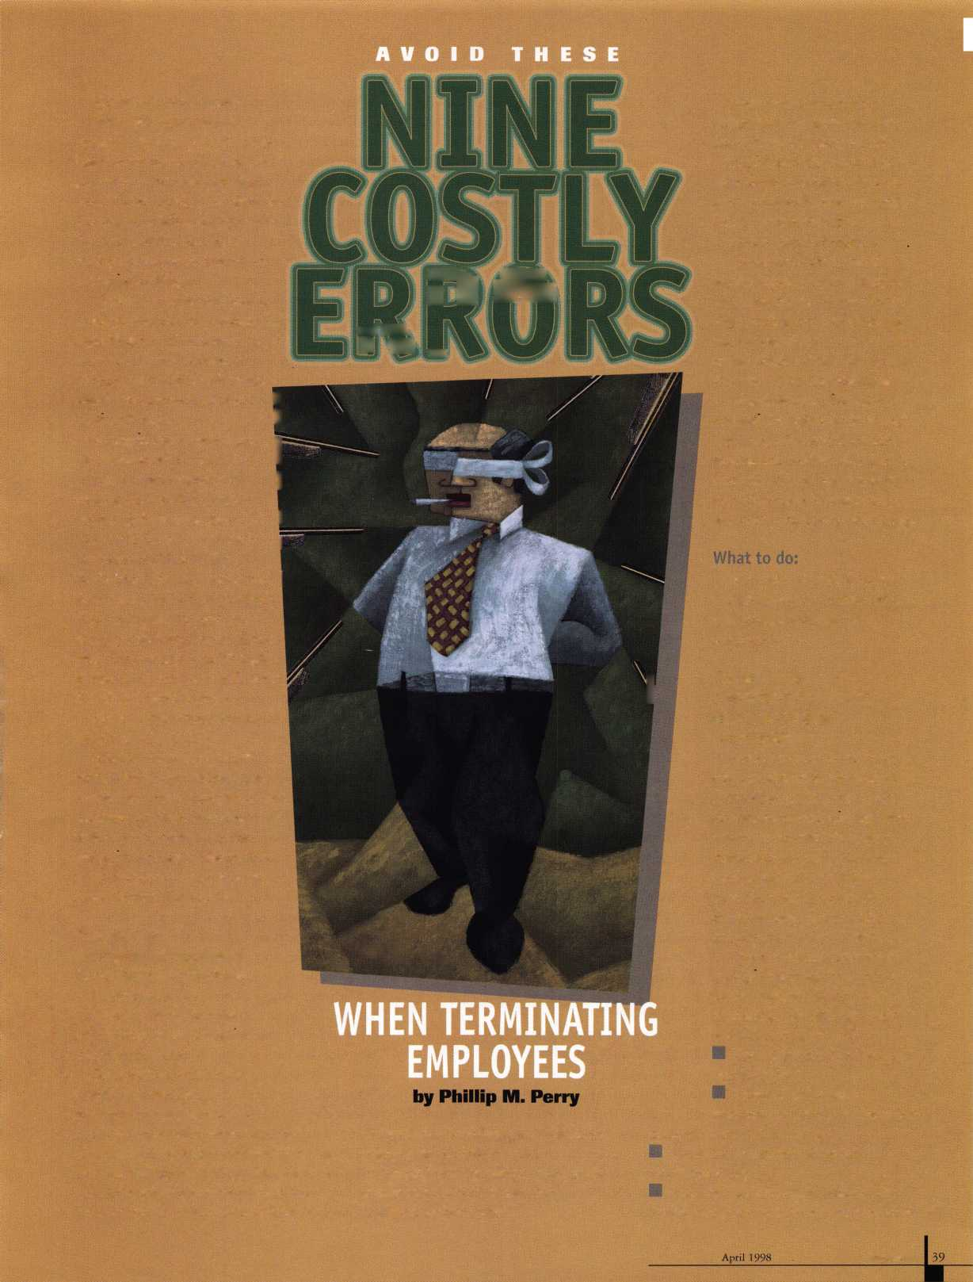

ner.

MISTAKES THAT  
SPARK WRONGFUL  
DISCHARGE LAWSUITS

1. Managing employees in an autocratic mam
2. Communicating poorly about an  
   employee performance.
3. Ignorance of employment law and  
   personnel policies.
4. Creating unintentional contracts when hiring.
5. Evaluating performance honestly.
6. Making working conditions intolerable to  
   force a resignation.
7. Treating employee problems inconsistently.
8. Retaliating for acts protected by  
   public policy.
9. Mistreating the employee during the termination process.

THE TWO TYPES OF  
DISCHARGE LAWSUITS

Although this article lumps them  
together, there are really two types of  
lawsuits that discharged employees may  
bring.

Wrongful discharge lawsuits can succeed  
if the employee can show you violated  
the terms of a written or oral contract,  
if you violate public policy by firing  
the employee for a protected act such  
as a jury service, or for other specific  
reasons designated by state law.

Discrimination lawsuits are far more  
common - and more costly - because  
losing employers are subject to huge  
punitive damages. Both federal and

state law outline discrimination for  
age, sex, race, religion, national origin  
and disability.

FIRE BY COMMITTEE

No one person should have the  
power to discharge an individual.

"There should always be a review  
process," says John Myers, chair of  
the labor and employment law  
department at Eckert, Seamans,

Cherin & Mellott, Pittsburgh, Pa.

"This way, you'll avoid decisions made in anger, or not well thought out, or because of a personality conflict that led to wrongful discharge suits."

with Mistake #1. Bosses who bark at  
cowering subordinates usually lack the  
required communication skills to  
clearly express what they want  
subordinates to do.

Here’s a real world example:

Ann spent too much time talking  
on the telephone. Joe, her boss, saw  
the problem but did not communicate

disapproval.

Instead, Joe barked out obnoxious  
orders, such as “Get off your duff and get  
those documents copied. And have them  
in my office in 20 minutes.”

Joe figured Ann would translate “get off  
your duff’ to “stop spending so much time

on the phone.” That never happened. Ann  
just saw a rude offensive boss who was  
treating her like dirt. When Joe finally fired  
Ann for performance problems, it came as a  
big surprise. That’s not good. Ann discovered  
that Joe has replaced her with a younger  
woman. That was worse. Ann sued for age  
discrimination.

When Joe’s attorney reviewed the case, he  
found his client had never explicitly told Ann  
about her performance failings. There was not  
written documentation of formal counseling  
sessions. A jury would likely conclude that Joe  
has discriminated against Ann. Further, plenty  
of employees could testify about Joe’s

workplace behavior, which would be enough to  
convince a jury to award the plaintiff heavy

punitive damages.

Joe settled out of court for a large sum.

What to do:

These problems can be solved partly by on-  
the-spot corrections. James suggests using this  
formula: “When you [...] it [...] so [...]” For  
example, Joe could have told Ann:

“When you talk so much on the phone you  
don’t get your work done, so please stop doing  
that.” These informal corrections must be backed

up with documented performance reviews.

Mistake #3:

Ignorance of employment law and personnel policies.

Lawsuits often arise when supervisors are unfamiliar with employment law. “You must train supervisors so they know what the law is regarding discrimination,” says Geron.

The same applies to company policies, which often look good on paper but are forgotten by supervisors who are caught up in the demands of the workday.

Supervisors need to stick to the company’s guidelines whenever they hear of a possible discrimination problem.

Sometimes, this is a challenge. Suppose an employee reports harassment or discrimination of some kind, but asks that the supervisor do nothing? Even if the employee is just looking to let off steam, says James, you must take note and follow company procedures.

“If you find out someone is polluting the river, you know there is a violation of the law,” says James. “You can’t say you’re not going to do anything. If you fail to take action, you put the company at significant risk.” If the employee quits or is fired later, the lack of action by the company will be damning evidence to a jury.

What to do:

Draw up formal procedures for handling reports of discrimination. Then go by the book.

Mistake #4:

Creating unintentional contracts when hiring.

A careless phrase by an overenthusiastic interviewer can create an implied contract of employment that will hold up in court.

“Promises don’t have to be written down to create an implied contract,” says James. He warns against common phrases such as:

H “You have a job here as long you get

good evaluations.”

* “I see you have a long term future here.”
* “As long as your sales are average, you will

have a job here.”

That’s not all. Promises made about compensation, work evaluation procedures, and working terms and conditions can also be binding.

How are oral contracts proven? Sometimes, there are witnesses to the actual promise. Other times, the supervisor will make the same promises to the other employees, who are brought in to testify.

One other thing-a promise of employment can be made unintentionally if an applicant gives up a lot to join your business. Suppose an individual has been working hundreds of miles away at a good job for 15 years. You hire the individual, inducing him to take his children out of their normal school and move across country. Then, 30 days later, you fire the individual.

The courts may very well state that you misrepresented your intentions to this person.

You may be liable for damages, even if no contact was involved.

Keynotes

April 1998

What to do:

Avoid misleading statements when discussing the job offer.

Mistake #5:

Evaluating performance dishonestly.

Nobody likes to rock the boat. That goes double for supervisors when annual performance review time rolls around.

Maybe they want to be liked. Or maybe they feel that a written negative review will further demoralize an employee with attitude problems.

Whatever the reason, your business ends up with documented reviews that do not adequately describe performance problems. That spells trouble after an employee is fired.

“One of the most common errors is not to document the performance problems that lead up to a discharge,” says Gerald E. Berendt, professor of law, John Marshall School, Chicago. “To prove that the employee was fired for performance reasons and not for discrimination, you have to have good records.”

Without detailed performance reviews, a jury may well decide that an individual was the victim of illegal discrimination.

Here’s an example from Harry A. Zinn, partner in the Santa Monica, Calif., office of Paul,

Hastings, Janofsky & Walker:

“I recently had a client who wanted to fire a person for poor attendance. They claimed it was well documented. It turned out that all they had were some hand written notes by a secretary working in a different department. The supervisors had asked the secretary to jot down notes describing when the employee arrived.

“That’s not going to do it for you,” says Zinn. “I advised the client not to terminate the employee.”

Instead, Zinn had his client call in the employee for counseling. Put the person on notice and document everything.

Finally, be honest when terminating a person. Don’t say you are downsizing if the discharge is for performance reasons. Reason: Once you replace the poor performer with a new candidate, you will have no defense against a charge that the termination was because of illegal discrimination.

What to do:

Provide honest evaluations, and document them.

Mistake # 6: Making work conditions so intolerable that someone resigns.

Faced with the task of wrongful discharge lawsuits, some employers try too take an easy way out: make things so miserable at the workplace that an unwanted employee will quit.

“Sometimes businesses get hung up on the idea  
‘he quit, so he can’t sue,’ ” says Winger. “That’s  
not tme if the employer or supervisors took  
deliberate actions to force the employee out of  
the workplace.”

Courts call this “constructive discharge,” and it’s

destmctive to your case.

What to do:

Prohibit supervisors from mistreating  
employees to force resignation.

Mistake # 7:

Treating employee problems  
inconsistently

Equal treatment to all. Once you have estab-  
lished policies for progressive discipline, make  
sure that all groups of individuals are planning  
under the same rule book. Be consistent in  
similar situations.

“Suppose a female employee is terminated  
because of attendance problems,” says Gerson.

“The question now becomes: did you treat the  
male employees with similar attendance records  
in the same fashion? It never ceases to amaze  
me that once you get into records you see that  
it is not the case.”

That’s costly in terms of credibility with  
the court system.

“When you have to go in and explain  
exceptions, that’s where the employer ends up

with exposure to state agencies and possibly  
to a jury,” says Gerson.

What to do:

Apply progressive discipline in which  
employees are given oral warnings, written  
warnings, suspension and ultimately termi-  
nation. Be consistent in applying this  
discipline in similar situations.

Mistake # 8:

Retaliating for acts  
protected by public policy.

Don’t discharge employees for taking  
actions that they are required to take under  
law, or which are protected by public  
policy. These include filing a workers’  
compensation claim, serving on a jury,  
participating in the military reserves,  
cooperating with law enforcement officers j  
in investigating another employee, or  
refusing a supervisor’s order to lie to a  
government agency.

These and other similar activities are §j  
protected under “the public policy  
exception” to the “employment at will”

HAVE AN OPEN  
DOOR POLICY

Suppose an employee feels  
unfairly treated. How can you head  
off a lawsuit down the road?

"I advocate an open door policy, so  
employees with complaints have a  
place to vent emotions," says Herbert

E. Gerson, a partner in the Memphis,  
Tenn., office of McKnight, Hudson,  
Lewis, Ford & Harrison. "This also  
allows management to spot problems  
and head them off early."

Post the details of your open door  
policy on your bulletin board. What  
hours may employees see you?

TIE SEVERANCE PAY  
TO A RELEASE FORM

Many employees now offer severance  
pay to terminated employees, if the  
individuals will sign a form releasing  
the employers from wrongful  
discharge claims.

"It's very important that this form be  
reviewed by an attorney, because every  
state has different rules," says Harry A.  
Zinn, partner in the Santa Monica, Calif.,  
office of Paul Hastings, Janofsky & Walker.  
"And you must also comply with certain  
provisions of the federal law protecting

older workers. If it's not done right, the  
document is worthless."

"This is a good way to cut back on

frivolous court cases where the employee  
has nothing to lose," says John Myers, chair  
of the labor and employment law  
department at Eckert Seamans, Cherin &  
Mellott, Pittsburgh, Pa. "The employee that  
has to make a choice of getting severance  
pay or having the right to sue, will consider  
more carefully what grounds they have  
to sue."

These forms can also help, says Zinn, when  
the employer is anxious to rid the workplace  
of an intolerable employee, but the company  
has not followed the book in terms of  
counseling the employee. Zinn says that the  
company may say something like: "It's just not  
working out. It appears we are not happy  
mutually. Before things get worse, let's come to  
an agreement about severance, so you can take  
time to find another job and allow us to part on  
good terms."

The forms are less useful when the employee  
has committed some wrongdoing and the  
employer is not about to award severance pay.

April 1998 Keynotes

EMPLOYMENT DOCUMENTS CAN HELP

Does each new hire know that employment is "at will?"

You can make sure that is the case with a document that spells it out.

"The most important thing you can do is make sure all new hires sign some form of integrated written employment document that includes 'employment at will' language/' says Harry A. Zinn, partner in the Santa Monica, Calif., office of Paul, Hastings, Janofsky & Walker.

This document can spike a good number of wrongful discharge lawsuits. It will not help, though, for discrimination suits.

WHY YOU DON'T WANT TO SAY "LET'EM SUE ME!"

Maybe you're mad. And you're not going to buckle under to any threat of a lawsuit from a disgruntled former employee who deserved to be terminated.

Got a strong defense? Okay. But if there are any weak spots in your termination procedures, you may be surprised to hear your attorney advise you to settle out of court.

The reason is that a good plaintiffs attorney can develop a strong case for discrimination for any number of grounds including age, sex, religion, national origin or disability.

"We now have so many laws that restrict discharge that in almost any case an employee will be able to raise some grounds," says Gerry Berendt, professor of law at John Marshall Law School in Chicago.

Don't blame the federal government. State and city laws can be more restrictive. Chicago, to give just one example, protects indi­viduals from terminations for sexual preference.

The kicker is that these cases look bad when presented to juries which are invariably composed of employees rather than employers.

CONSIDER ARBITRATION

Consider arbitration as a tool for settling employer/employee disputes. It's gaining ground as a way to get problems resolved quickly. Some employers require pre-employment arbitration agreements as a condition of employment.

"There is an increasing reliance on companies to rely on alterna­tive dispute resolution," says Richard Chern ck, a former business trial lawyer turned full time arbitrator in Los Angeles.

"Arbitration keeps companies away from juries and makes it much easier to focus on a dispute in a way that gets it resolved quickly. The downside is that you get more claims," says Chernick. "But their resolution rates go up as well as the cost goes down."

And does the lack of an appeal from arbitration box in the employer who loses?

"Arbitration does make employers nervous," says Chernick.

"But juries make them more so."

LA

Keynotes

April 1998

doctrine. Firing an employee for them is considered a “retaliatory discharge."

“Employers can really get gored badly,” says Berendt. “Many states allow for high punitive damages.”

What to do:

Instruct supervisors never to terminate workers as punishment for acts protected by law.

Mistake #9:

Mistreating employee during the termination process.

People remember the last thing that is said to them longer than anything else. If you or a supervisor insults the employee during the termination proceedings, this could spark a wrongful discharge action.

“Discharged employees often go to lawyers because something in the circumstances of their termination made then angry or seemed unfair,” says John Myers, chair of the Labor and Law department at Eckert Seamans Cherin & Mellot in Pittsburgh, Pa. “Treat the employee with dignity. I also counsel to give the employee a complete explanation as to why you are terminating as opposed to staying vague and elusive. Hopefully, they will then understand what you are doing what you have done, and reduce the likelihood off going to court.” Indeed, attorneys suggest going the extra mile and taking a proactive stance in helping the employee to move on.

“Consider arranging for outplacement,” says Zinn. “This gets the person focused on the future, and on getting on with their life. People who are unemployed are more likely to file a lawsuit, because their focus is still on what happened and they have the time.”

Whatever the circumstances of the discharge, keep the details confidential. “Avoid making general comments as to why a person is being terminated,” says Winger. “Keep it between the employee and the company.” This will avoid any charges of defamation by departed workers.

What to do:

Rehearse exactly what to say during the termination session. Then keep to the program.

If there is a common theme running through the advice from these attorneys, it is that an ounce of prevention is worth a pound of cure.

“The ultimate question that the discharged employee will ask is this: was I as a former employee treated fairly in the decision to terminate me?” says Gerson. “That’s what it all boils down to. You can argue the law to the judge and it may protect you. But if the plaintiff presents his case to a jury, the underlying concept the jury will deal with is fairness.”

H

■■ About the Author: Phillip M. Perry has been honored by the American Bar Association with its “Value to the Reader” Award for editorial achievement. His legal columns appear in Folio: The Magazine for Magazine Management and Editor & Publisher.

Get the best master keying textbook

around, written by one of the most

well- known locksmith instructors

in the profession. Just $44.00

(including shipping and handling),

Fundamentals of Master Keying

covers system structure and record

keeping; basic mechanical and

arithmetic concepts; and how to

write a system

*An Introduction to Split Pin Master Keying*

To order, write or FAX: Associated Locksmiths of America, Inc.

3003 Live Oak Street Dallas TX 75204 FAX (214) 827-1810

Credit card orders: Phone (214) 827-1701

**Jerome V. Andrews, CML**

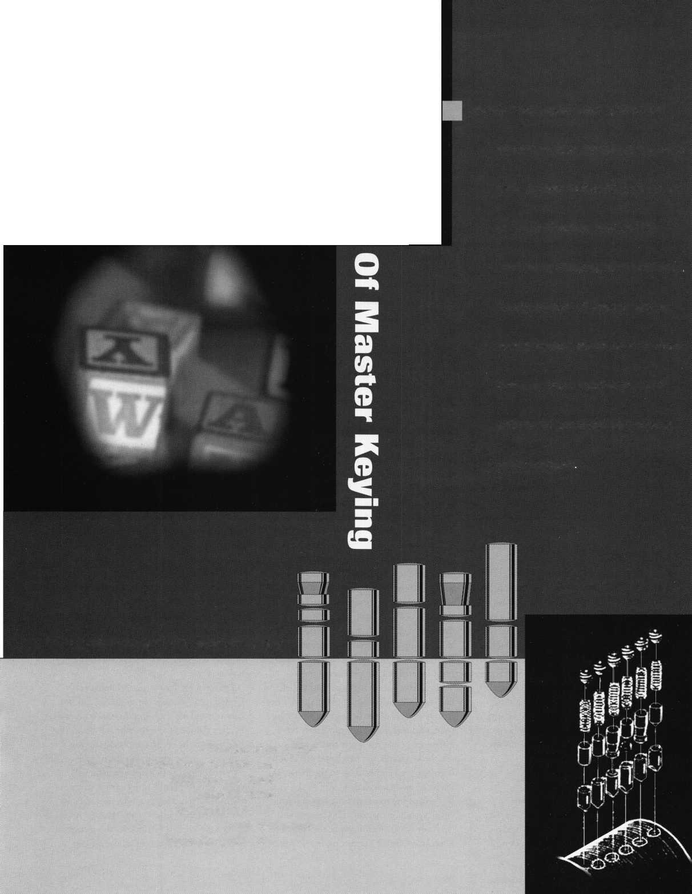

Biometrics is the science of using state-of-the-art technology devoted to positively identifying people through their own unique physical characteristics. At this time, the field of biometrics is divided into six different categories, namely: Fingerprint identification, palm (or hand) print characterization, facial recognition, retina scan, voice print verification, and signature evaluation (graphology).

Biometrics is not brand new technology, although it becomes increasingly sophisti­cated every day. This technology has been used for the last few years in conjunction with government agencies, military bases, and other institutions where only the highest security standards must be maintained on a continuing basis.

Where it's used

Until now the science of biometrics has been reserved for those precious few insti­tutions because of the cost of implementing such expensive systems was prohibitive.

These costs put such sophisticated technology well beyond the financial resources of most companies and virtually all consumers. However, this is all changing, as this technology becomes more affordable and more desirable as the need for greater security becomes a necessity and not a luxury for everyone around the world.

Why it's used

The primary motivating force behind this switch to biometric devices are the insurance companies. Obviously, these companies seek to adhere to the policy dictated by the two most common buzzwords in the security industry, namely: risk management and loss prevention. Minimizing risk to people and property, while at the same time preventing the loss of life or property are the two most important aspects of a successful security program. It should be noted that security is so important to people that it has become the second biggest industry in the world after travel and entertainment.

Types of technology

Let us now examine in detail the technology available today in each of the five categories that comprise the field of biometrics. Fingerprint identification is

certainly the oldest and best-known method for positively identifying an individual. Our earliest law enforcement personnel quickly realized that virtually every individual had a unique set of fingerprints.

It was this knowledge that led to the science of fingerprint identification with the countless characteristics such as loops and swirls as well as the unique and specific depth and space between them.

Wired

However, it is this myriad of information that lends itself so well to the computer.

Since this type of information can be catalogued, classified and cross-referenced so easily it has become the most expedient way in which to identify someone next door or across the country instantaneously.

Let ringers do tbe talking

The newest technology available is even more amazing. A new system introduced by a company called Veridicom, Inc. (A product of Lucent Technologies and U.S. Venture Partners) has developed a postage stamp sized fingerprint reader! This unique device has as many applications as the creative mind can conceive. For example, this miniaturized fingerprint reader can be used in conjunction with a computer keyboard or mouse. In this manner, the user can not only be identified, but given security clearance to enter and use specific programs as well as generate a permanent log, which will include time of usage. This feat is accomplished by the ability of the fingerprint reader to utilize its thousands of built in electronic sensors.

These sensors bounce signals off the user’s skin and create a digital fingerprint complete with special algorithms to match the original print kept in the computer’s memory.

By the way, contrary to popular beliefs held by the movie-going public, the discrim­inatory powers of the fingerprint reader are quite sophisticated. They can detect the difference between a finger that is still attached to someone’s hand, and one that has been removed and held up to the fingerprint reader to gain clearance.

Perhaps the most amazing aspect of this entire system is the cost. This system will cost only $300! Tom Rowley, the Chief Executive Offer of Veridicom, Inc. Predicts

that the cost for this system will eventually drop to $100! Convenience and low cost should give the impetus necessary to gain greater acceptance for this new area of security technology.

Live me five!

The second area of biometrics is palm (or hand) print characterization. This technology is preferred by many of the more hardcore security experts for two reasons. First, there are more characteristics to be counted, classified and catalogued if you choose to utilize the whole hand, rather than just the fingerprints alone. It is therefore a more exacting technique for identification. Second, there has been a trend among a select few individuals who participate in questionable activities on both sides of the law to remove their fingerprints by a number of nefarious methods. Few if any individuals would try one of these methods on these methods on their entire hand.

Face to face

The third category of biometric devices is facial recognition. The most common systems use thousand of stored images of authorized users, which can be scanned in less than second! Most of the technology centered around facial recognition seems to be concentrated around the identification of the user’s eyes.

The eyes have it

The fourth category of biometric devices seems not only to be the most popular category, but also the one category that is growing most rapidly in terms of consumer acceptance. Perhaps this is because this category of biometric devices may be the most accurate.

Eye scanning biometric technology is divided into two major areas, namely: retina scanning and iris scanning. Retinal scanning involves the use of a light, which is beamed directly into the eye of the person seeking authorization for identifying the unique pattern of blood vessels appearing on the retina. This technique is done from only a few millimeters away from the user and can be unpleasant. While it is true that each pattern of vessels is distinctive, the variations among individuals are not that great and

Keynotes

April 1998

By Steven Spiwak

thousands, if not, millions of years. This strategy of combining two or more security devices into a system is likely to gain more popularity in the future since it is so successful. In this case, the sum is truly greater than the sum of its parts.

may lead to false positives and identifica­tion problems. Other problems can occur when trying to ascertain a positive identifica­tion from a retina scan. This confusion is a direct result of the fact that the blood vessel patterns change overnight due to drinking alcohol, taking prescription medications or using illegal drugs.

On the other hand, there is iris identifica­tion technology. This is the technology of choice among discerning security profes­sionals. The scanners that read the iris are looking to examine and log the unique color and distinctive markings that each persons eyes feature. The characteristics being examined are less likely to change over time.

One of the main benefits of this technology is that these characteristics can be examined from several feet. The 1 results obtained are more accurate and the experience much less distasteful to the user who is being examined. In fact, according to Arcsine, one of the premier companies in this field, the likelihood of finding two identical irises at random is literally a gazillion to one!

Say "ftflHH!"

The fifth category of biometric devices is voice recognition. Voice recognition used to be the most likely area of biometrics to be fooled. This was due to the growing sophisti­cation of recording devices, and the ability to utilize them to duplicate verbal commands and instructions. However, as time has passed, the voice recognition devices have grown equally sophisticated and now reject these attempts at compromise by using duplicate voice patterns.

One of the primary reasons that such detection technology was successful in the beginning was due to sound of the sound

Service Association is an independent organization geared to the commercial side of the digital security industry. This association is based in Carlisle, Pennsylvania and has offices throughout the world.

The last category to be considered is electronic signature analysis. This technique seems to be gaining a great deal of popularity among retail merchants. The reason for this popularity is the use of existing credit card and an cross-referenced signature, working in combination, make the system quite a bit stronger than using each system independently. This system also prevents the unauthorized use of a credit card when the card being used does not have an integrated photograph.

A growing industry

The biometric technology has created an industry that is increasing in both technology and revenues at the speed of

the author: Steven B.

Spiwak, CRL is a fourth generation locksmith  
who specializes in a variety of variety of areas  
including crime prevention and institutional security.  
His broad experience in the security field spans 20  
years of writing, teaching and consulting. Spiwak’s  
lengthy client list includes Ford Motor Company,  
Exxon, The Chicago Tribune, Sears, Westin  
Hotels, the U.S. Treasury Department and the  
Federal Bureau of Investigation. Most recently he  
formedLockport, Inc.—a security consulting company  
for industrial, commercial, institutional and govern-  
mental clients. Readers with article suggestions or  
requests for him can contact ALOA at email  
[publ@anet-dfw.com](mailto:publ@anet-dfw.com) or fax to (214) 827-1810.

detection equipment to recognize the underlying hiss of a recording device no matter how quiet is seemed to be. With the advent of CD (compact disc) technology there is no longer an underlying hiss to be picked. Therefore, this technology was able to be circumvented in many cases. The results improve dramatically when such systems are now used in conjunction with PINs (personal identification numbers) or coded words. The reason for this Success is easily demonstrated by simple arithmetic. There are 15 or 16 numbers and/or letters in a typical bank or credit card. To determine the correct number by trial and error at the rate of one guess per second would take

light. Sales are predicted to double between the years 1996 and 2003. Because of this unprecedented growth, the biometrics industry has given birth to two separate organizations devoted to the betterment of . the industry by education, information and standardization. The two aforementioned organizations are the U.S. government- sponsored Biometric Consortium and the International Customer Service Association (ICSA) on the commercial side.

The Biometric Consortium is chartered by the National Security Policy Board. It has several technical working groups, and even a national test center based out of San Jose State University. The International Customer

April 1998

Keynotes



We’re Right Behind You

Locksmithing is at war with big business.

But you have more firepower than you realize.

Your fellow locksmiths joined forces more than 40 years ago, understanding the need to fight battles together. Today, benefits of membership in the Associated Locksmiths of America, Inc. have grown far beyond the early vision, but they still rest on one enduring truth: Strength in numbers.

Your best chance of surviving the struggle ahead is being a part of an organization with others like yourself. Through our common voice we will refuse to be legislated out of business.

As a united front, we can command technical advice from world-renowned instructors and authors who know how to make our business boom.

It starts with you.

It ends with all of us together.

Recruit a member today.

For a supply of membership applications, contact:

Associated Locksmiths of America, Inc.

3003 Live Oak Street, Dallas, Texas 75204 Voice: 214.827.1701 Fax: 214.827.1810

Email: [jackie@aloa.ioffice.com](mailto:jackie@aloa.ioffice.com)

TRAINING

**ADVERTISING**

**FRIENDSHIP**

**CERTIFICATIC**

**LOBBYING**

NETWORKING



Buyer’s

Guide

o

Alternative Tools

Here are new  
tools that  
address

problems from  
an alternative  
point of view.  
When the  
“usual” methods  
can’t get it done,  
try an alternative  
tool. “The  
Tool” tension

wrench is designed especially to allow more  
room for picks in SCI and KW1 keyways.  
“Lever Up” lifts vertical auto lock linkage  
without disconnect danger and without the  
tool entering the vehicle. “Paddle Pusher”  
operates paddles and crash bars like you were  
standing inside. $12.95 each (+$4.95 S/H).  
Allow four to six weeks for delivery. Send  
order on back of business card with check or  
m/o to: Alternative Tools, Inc.; 162 Robin  
Dr.; Loveland, CO 80537.

Reader Service #24

{Special Note: There has been a little confusion with  
a few of the buyers about the price of the opening tools  
offered by Alternative Tools. The tools are $12.95  
EACH. The manufacturer apologizes to anyone who  
thought all three tools were being offered at the single  
price. Whoa, what a deal...}

Every dollar  
counts, so let us  
help you keep  
your customers  
coming back.  
Key Tags are an  
inexpensive way  
to advertise and  
keep your  
customers  
coming back to  
you. Add a tag

to a set of new keys or key chain and the next  
time your customer needs a new key cut,  
they’re sure to remember you. We customize  
key tags to hold your store’s name or logo on  
one side and telephone number on the other.

Each key tag is made from buffed pewter and measures 3/8"x7/8" in size, and comes with its own ring. Our minimum order is 250 @ $1.20 each = $300.00 including set-up charge. Simply send us your store name and telephone number and we’ll do the rest: Milman Manufacturing, at either Commercial Street, Box 113, Roxboro, Quebec H8Y 3E8, Canada; or Champlain Mall Rd., P.O. Box 1641; Champlain, NY 12919; USA. Phone (514) 425-5794 or fax (514) 425-5793.

Reader Service #25

Door Controls International

Door Controls International announces our new champion lever trim. UL certified ANSI/BHMA 156.3—1994, grade 1. The 08L lever trim is to work in conjunction

with our fire  
rated security  
alarmed rim exit  
device, Pannex.

The vandal  
resistant lever is  
available for  
standard or  
narrow stile  
doors, and can

also be supplied with electric release. Phone  
(313) 426-0400.

Reader Service #26

The Most Locksmith-Friendly  
Rekeyable in the USA

Now Available With j**fr i • n l-^**a **Stainless Steel Shackle** l ^

and **Promax Shackle Guard**!

Enjoy "one key convenience" with the ggi g

ABUS 83/45 Z-Bar rekeyable pin  
tumbler padlock with solid brass

body. It quickly and easily adapts to

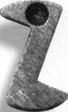

popular door locking systems,

quickly converts including Schlage,® Kwikset,®  
the 83/45 padlock Yale,® Arrow,® and more. Use it

as the basis for a totally new,  
totally flexible rekeyable pad-  
lock system!

The versatile 83/45 Z-bar offers  
eight easy-to-change shackle

options. It's the ultimate in security, convenience, and  
value for home, office, commercial, and industrial appli-  
cations. Precision made to German specifications, the  
83/45, manufactured in our ISO-9000 plant, is preferred  
by locksmiths nationwide because it's so easy to rekey.

ABUS is the industry leader. Call us today at 800-352-2287 to reduce your lock inventory!

Our clever "Z-Bar"

y converts

the 83/45 padlock  
mechanism to  
key-retaining or  
non-key-retaining.  
It's standard  
equipment with  
each 83/45.

ABUS Lock, USA 3555 Holly Lane North Plymouth, MN 55447-0507 800-352-2287

Contact any one of these full-line (1lm i i hT distributors for same-day shipment!

Accredited Lock & Supply

East Coast 800-652-2835

Clark Security Products

New England

Washington, DC  
Denver  
San Diego  
Chicago  
Seattle

Locks Company

Miami

800-746-5625

800-578-5625

800-282-5625

800-854-2088

800-755-5625

800-942-5275

800-288-2801

IDN - Acme

San Antonio Fort Worth Oklahoma City New Orleans Houston Dallas Phoenix

210-545-3396

800-859-2263

800-664-2263

800-788-2263

800-359-2263

800-372-2263

800-525-3131

IDN - Hardware Sales

Livonia 800-521-0955

IDN - H. Hoffman

Chicago Cincinnati Davenport Grand Rapids Indianapolis Kansas City St. Louis Stone & Berg New England

323-1918

457-3963

1. 4633 244-0777 428-9313 526-5897
2. 1303

Reader Service #8

April 1998

Keynotes

k

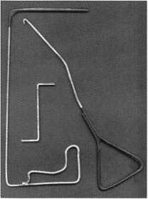

Custom Key Tags

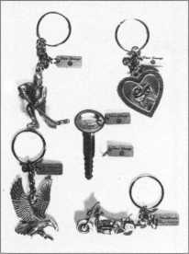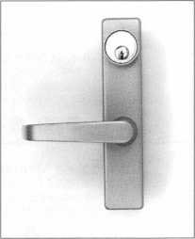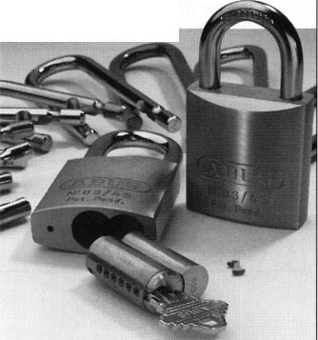

Associate

Members

|  |  |
| --- | --- |
| Manufacturers | Arrow Lock Company  10300 Foster Avenue  Brooklyn, NY 11236 (718) 257-4700; FAX (718) 649-9097 |
|  | esse |
| A & B Safe Corp.  171 S. Delsea Dr.  Glassboro, NJ 08028 (800) 253-1267; FAX (609) 863-1208 | Auto Security Products (A. S. P.)  P.O. Box 10  Redmond, WA 98073-0010 (425) 556-1900; FAX (425) 558-1205 |
| ^ ^ | • • |
| Adesco Safe Manufacturing Co.  16720 S. Garfield Ave.  Paramount, CA 90723 (800) 821-6803; FAX (310) 408-6427 | BWD Automotive  900 Raven wood Dr.  Selma, AL 36701  (334) 874-9001; FAX (334) 874-6011 |
| • | • • |
| ASSA Inc.  10300 Foster Ave.  Brooklyn, NY 11236 (800) 235-7482; FAX (718) 257-2772 | Baton Locks & Hardware Co.  14275 Commerce Dr.  Garden Grove, CA 92643 (714) 265-3636; FAX (714) 265-3630 |
| • | • ® |
| Abus Lock Company  3555 Holly Lane North  Plymouth, MN 55447-0507 (800) 352-2287; FAX (612) 509-9939 | Chicago Lock Company  10100 88th Ave.  Pleasant Prairie, Wl 53158-0069 (800) 445-3204; FAX (414) 947-7178 |
| • | ® |
| Adams Rite Manufacturing Co.  P.O. Box 1301  LaPuente.CA 91749-1301 (562) 699-0511; FAX (562) 699-5094 | Corbin Russwin Architectural Hardware  P.O. Box 25288  Charlotte, NC 28229 (800) 543-3658; FAX (800) 447-6714 |
| • • | • • • • |
| Adrian Steel Company  906 James St.  Adrian, Ml 49221  (800) 677-2726; FAX (517) 265-5834 | Curtis Industries  6140 Parkland Blvd. Ste. 300  Mayfield Heights, OH 44124-4103 (800) 555-5397 |
| • | • • |
| Alarm Lock Systems, Inc.  345 Bayview Ave.  Amityville, NY 11701 (800) ALA-LOCK; (516) 789-3383 | DETEX  302 Detex Dr.  New Braunfels, TX 78130 (800) 729-3839; FAX (210) 620-6711 |
| • | • • • • |
| Aiphone Intercom Systems  1700-130th Avenue, NE  Bellevue, WA 98005 (206) 455-0510; FAX (206) 455-0071 | Don-Jo Manufacturing, Inc.  P.O. Box 929  Sterling, MA 01564 (508)422-3377; FAX (508) 422-3467 |
| • • • | • • |
| American Lock Co.  3400 West Exchange Road  Crete, IL 60417-2099 (708) 534-2000; FAX (708) 534-0531 | Door Controls International  2362 Bishop Circle East  Dexter, Ml 48130  (800) 742-3634; FAX (800) 742-0410 |
| • • | • • • • |
| American Security Products  11925 Pacific Ave.  Fontana, CA 92337-6963 (800) 423-1881; FAX (909)685-9685 | Emtek Products, Inc.  15250 E. Stafford St.  City of Industry, CA 91744 (800) 356-2741; FAX (800) 577-5771 |
| • • | ® • |
|  |  |



Associate members of the Associated Locksmiths of America (ALOA) manu­facture or distribute materials or equip­ment, or provide services, for the securi­ty industry. Many have donated money, services and equipment to ALOA in addition to their annual dues. Their sup­port of ALOA projects enhances overall membership benefits and we encourage our members to patronize these firms. If you know of a potential candidate for associate membership, please contact the ALOA Sales staff at (214) 827-170L Associate member dues are $500 per year and entitle the payor to use the ALOA logo, and selected discounts on ALOA products and services.

® Alarms: Personal, vehicle, electronic, fire, burglar, and exit

9 Automotive: Lockout equipment, key chains/rings

9 Builders Hardwares Door closers, furniture/decorative hardware, viewers, emergency exit devices

Books, reference guides, publications, computer software

9 CCHf/Photo Imaging: Cameras, monitors, photo ID equipment, cables

9 Electric/Electronic Security: Card access control and readers, surveil­lance, electric/magnetic locks and strikes, keypads

9 Lock Devices: Auto locks, cylinders, emergency exit/entrance control, locks (various types), strikes

9 Tools & Supplies: Key blanks, cutters, picks, rings/hooks, custom van/truck supplies

Other

^ ***Keynotes***

April 1998

|  |  |  |
| --- | --- | --- |
| ESP Lock Products, Inc.  375 Harvard Street  Leominster, MA 01453 [508)537-6121; FAX [508) 537-1699 | Industries, C.L. Inc.  9730 Gouin Blvd. West  Pierrefonds (PQ) H8Y 1R5 (514)683-6282; FAX(514) 683-9015 | Lucky Line Products  7890 Dunbrook Rd.  San Diego, CA 92126 (619)549-6699; FAX (619) 549-0949 |
| • | • • | • |
| Federal Lock Company  14247 E. Don Julian Rd.  City of Industry, CA 91746 [800) 682-9851; FAX [708) 378-4767 | International Electronics, Inc. (I.E.I.)  427 Turnpike St.  Canton, MA 02021 (800)343-9502; FAX(617) 821-4443 | M.A.G. Engineering & Mfg. Inc.  15261 Transistor Lane  Huntington Beach, CA 92649 (714)891-5100; FAX (714) 892-6845 |
| m | • | • • • |
| Folger Adam Security, Inc.  16300 W. 103rd Street  Lemont, IL 60439  [630) 739-3900; FAX (630) 739-6138 | Jet Hardware Mfg. Co.  800 Hinsdale Street  Brooklyn, NY 11207 (718)257-9600; FAX(718) 257-0973 | MARKS USA  5300 New Horizons Blvd.  Amityville, NY 11701 (516) 225-5400; FAX (516) 225-6136 |
| • ® | • | • |
| Fort Lock Corp.  3000 N. River Rd.  River Grove, IL 60171 [708) 456-1100; FAX [708) 456-9476 | KABA High Security Locks  P.O. Box 490  Southington, CT 06489 (860)621-3601; FAX(860) 621-9727 | Master Lock Company  2600 North 32nd Street  Milwaukee, Wl 53211 (414) 444-2800; FAX (414) 449-3114 |
| • ••••• | • | • • |
| Gardall Safe Corporation  P.O. Box 30  Syracuse, NY 13206 (315) 432-9115; FAX (315) 434-9442 | Kenstan Lock Company  101 Commercial St  Plainveiw, NY 11803-2412 (516) 271 -2700; FAX(516) 271 -2759 | Medeco Security Locks  P.O. Box 3075  Salem, VA 24153  (540)380-5000; FAX (540) 380-5010 |
| • | e © | • • • |
| Grobet File Co. of America  750 Wasahington Ave.  Carlstadt, NJ 07072 (800) 962-7242; FAX (800) 243-2432 | KEY-BAK; Div. of W. Coast Chain Mfg. Co.  1460 S. Balboa Ave.  Ontario, CA 91762 (909) 923-7800; FAX0O9) 923-0024 | Meilink Safe Company  111 Security Parkway  New Albany, IN 47150 (800) 634-5465; FAX (800) 896-6606 |
| t | • • • • | • |
| H.E.S., Inc.  2040 W. Quail Ave.  Phoenix, AZ 85027 (602) 582-4626; FAX (602) 582-4641 | Knaack Manufacturing Co.  420 E. Terra Cotta Ave.  Crystal Lake, IL 60014 (800) 456-7865; FAX(815) 459-9097 | MUL-T-LOCK USA, Inc.  300-1 Route 17 South Suite A  Lodi, NJ 07644  (800) 562-3511; FAX (201) 778-4007 |
| • • • | e | • • • |
| Highland Glen Products, Inc.  218 Parkdale Ave.; P.O. Box 924  Buffalo, NY 14213 (716) 883-1110; (800) 248-KEYS | LCN Closers (Division of Ingersol)  121 W. Railroad Ave.  Princeton, IL 61356 (815)875-3311; FAX (815)875-3222 | National Cabinet Lock  200 Old Mill Road, P. 0. Box 200  Mauldin, SC 29662 (864) 297-6655; FAX (864) 297-9987 |
| ® • | • | • |
| Hill Security Products  711 East Walton Avenue  Spokane, WA 99207 (509) 487-1142; (800) 722-1142 | LAB Security  700 Emmett St.  Bristol, CT 06010  (800) 243-8242; FAX (203) 583-7838 | The National Locksmith Magazine  1533 Burgundy Parkway  Streamwood, IL 60107 (630) 837-2044; FAX (630) 837-1210 |
| e | • | • |
| HPC, Inc.  3999 N. 25th Avenue  Schiller Park, IL 60176 (847) 671 -6280; FAX(847) 671 -6343 | La Gard, Inc.  3330 Kashiwa Street  Torrance, CA 90505 (310)325-5670; FAX (310)325-5615 | Newman Tonks  805 N Buckman St  Shepardsville, KY 40165 (800) 826-5792; FAX (800) 777-8229 |
| <|^ ^ | • | e • |
| Hurd Corporation  503 Bohannon Rd.  Greeneville, TN 37744-1450 (423) 787-8800; (423) 787-8817 | Locksmith Publishing Corp.  850 Busse Hwy.  Park Ridge, IL 60068 (847) 692-5940; FAX (847)692-4604 | NKL Industries Ltd.  1111-13 Cavalier Blvd.  Chesapeake, VA 23323 (800) 528-9900; (757) 485-0271 |
| ^ ^ ^ | m | • • • • |
| llco Unican  400 Jeffreys Road  Rocky Mount, NC 27804 (919)446-3321; FAX (919) 446-4702 | Lori Lock  P.O. Box 1040  Southington, CT 06489 (860)621-3605; FAX (203) 621-5972 | Prime-Line Products Company  5405 Industrial Pkwy.  San Bernadino, CA 92407 (800) 255-3505; FAX (909) 880-8968 |
| ••••••• | • m | • # |
|  |  |  |
|  |  |  |

Keynotes



April 1998

|  |  |  |
| --- | --- | --- |
| ROFU International Corp.  2004-B 48th Ave.; Court E  Tacoma, WA 98424 (800) 255-7638; FAX (253) 922-1728  i | Vindicator Corp.  3001 Bee Caves Rd.  Austin, TX 78746-5561 (512)314-1200; FAX (512) 314-1270  • • • • | Cook’s Building Specialties  2441 Menaul Blvd. NE; P.O. Box 37320 Albuquerque, NM 87176-7320 (505)883-5701; FAX (505) 883-5704  ^ (0 (j^ (g| |
| Rutherford Controls Inc.  2697 Internal Pkwy, Bid 5 #100  Virginia Beach, VA 23452 (757)427-1230; FAX (804) 427-9549  • | Weiser Lock Company  6700 Weiser Lock Blvd.  Tucson, AZ 85746  (520)741-6338; FAX (520) 741-6363  • © | DiMark International  3117 Liberator St., Unit A  Santa Maria, CA 93455 (800) 235-2435; FAX (805) 928-8034  © © |
| Sargent & Greenleaf, Inc.  P.0. Box 930  Nicholasville, KY 40340-0930 (606) 885-9411; FAX (606) 887-2057  ^ @ (p ^ | Wilson Safe Company  3031 Island Avenue/P.O. Box 5310  Philadelphia, PA 19153 (215)492-7100; (800)345-8053  © | Dire’s Lock & Key Co.  2201 Broadway  Denver, CO 80205 (303) 294-0176 |
| Schlage Lock Co.  1915 Jamboree Suite 165  Colorado Springs, CO 80920 (800)847-1864; FAX (800) 452-0663  • • | Yale Security Inc.  P.O. Box 25288  Charlotte, NC 28229-8010 (800) 438-1951; (800) 338-0965  © © © © | Direct Security Supply, Inc.  36 Lincoln Street  Boston, MA 02135 (800) 252-5757; FAX (800) 452-8600  ^ ^ @ (|^ 10 (j^ ^ |
| Schwab Corporation  3000 Main St.  Lafayette, IN 47903-5088 (765) 447-9470; FAX (765) 447-8278  • | Distributors | Doyle Lock Supply  2211 W. River Road N.  Minneapolis, MN 55411 (800)333-6953; FAX (612) 521-0166 |
| Securitron Magnalock Corp.  550 Vista Blvd.  Sparks, NV 89434  (800) 624-5625; FAX (702) 355-5636  • $ | Accredited Lock Supply Co.  P.O. Box 1442  Secaucus, NJ 07096-1442 (800) 652-2835; FAX (201) 865-5031  ••©•••• | Dugmore & Duncan Inc.  30 Pond Park Rd.  Hingham, MA 02043 (800)225-1595; FAX (617) 740-4043  ••••••• |
| Security Door Controls  3580 Willow Lane  Westlake Village, CA 91361 (805) 494-0622; FAX (800) 959-4732  © | Ace Lock & Security Supply Co.  565 Rahway Ave.  Union, NJ 07083-6631 (800) ACE-LOCK; (800) ACE-FAX4 . | Ewert Wholesale Hardware  4709 W 120th St  Alsip II 60658 (800) 451-0200  © © © © © |
| Sentry Group  900 Linden Ave.  Rochester, NY 14625-2784 (716) 381-4900; FAX (716) 381-8559  • | Akron Hardware Consultants, Inc.  2579 South Arlington Road  Akron, OH 44319  (800) 321-9602; FAX (800) 328-6070  © © © | Fairway Supply, Inc.  2631 Lombardy Lane  Dallas, TX 75220  (214)350-0021; FAX (214) 352-4299  ^ @ (0 <j^ ^ |
| STRATTEC Security Corp.  3333 W. Good Hope Rd.  Milwaukee, Wl 53209 (414) 247-3333; FAX (414) 247-3329  • • • | American Security Distribution  4411 E. La Palma  Anaheim, CA 92807 (714) 996-0791; FAX (714) 579-3508  ••••••• | Foley-Belsaw Company  6301 Equitable Road  Kansas City, MO 64120 (800)821-3452; FAX (816) 483-5010  • © © © |
| Sully Tools Inc.  3515 Nodding Pine Ct.  Fairfax, VA 22033  (703)689-3416; FAX (703) 787-0869  • • • | Andrews Wholesale Lock Supply  544 S. 9th St.  Lebanon, PA 17042-6608 (717) 272-7422  © | Fried Brothers, Inc.  467 N. 7th St.  Philadelphia, PA 19123 (800) 523-2924; FAX (800) 541-3489 |
| Trine Products Corporation  1430 Ferris Place  Bronx, NY 10461  (718)829-4796; FAX (718) 792-9127  • • • | Boyle & Chase Inc.  P. O. Box 74  Accord, MA 02018-0074 (800) 325-2530; FAX (617) 335-5342  ^ <0 ® | HS&S Wholesale Distributors  12915 West 8 Mile Road  Detroit Ml 48235 (800) 521-2202  ^ <3^ ® hi |
| U-Change Lock Industries  1640 W. Hwy. 152  Mustang, OK 73064 (405) 376-1600; FAX (405) 376-6870  • • • | Clark Security Products, Inc.  4775 Viewridge Ave.  San Diego, CA 92123-1641 (800) 854-2088 | Hans Johnsen Company  8901 Chancellor Row  Dallas, TX 75247  (214)879-1550; FAX (214) 879-1530  •••••••• |
|  |  |  |
| :’ V ® Business/Tech & Ed. A t i a« !•« ''y‘-  © ccarv/piwtolnwgtog S  --- © Electric/ElectronScSecurity a  ^ r _; - - - ® Lock Devices ^ | | |

***Keynotes***

April 1998

Reader Service

•April 1998

.Title

.State .

.Country _FAX _

_ZIP_

|  |  |  |  |  |  |  |  |  |  |  |  |  |  |  |  |  |  |  |  |
| --- | --- | --- | --- | --- | --- | --- | --- | --- | --- | --- | --- | --- | --- | --- | --- | --- | --- | --- | --- |
| 1 | 6 | 11 | 16 | 21 | 26 | 31 | 36 | 41 | 46 | 51 | 56 | 61 | 66 | 71 | 76 | 81 | 86 | 91 | 96 |
| 2 | 7 | 12 | 17 | 22 | 27 | 32 | 37 | 42 | 47 | 52 | 57 | 62 | 67 | 72 | 77 | 82 | 87 | 92 | 97 |
| 3 | 8 | 13 | 18 | 23 | 28 | 33 | 38 | 43 | 48 | 53 | 58 | 63 | 68 | 73 | 78 | 83 | 88 | 93 | 98 |
| 4 | 9 | 14 | 19 | 24 | 29 | 34 | 39 | 44 | 49 | 54 | 59 | 64 | 69 | 74 | 79 | 84 | 89 | 94 | 99 |

15 20 25 30 35 40 45 50 55 60 65 70 75 80 85 90 95 100

Card valid until Aug. 1,1998.

Reader Service

‘April 1998

.Title

.State .

.Country .FAX _

-ZIP.

|  |  |  |  |  |  |  |  |  |  |  |  |  |  |  |  |  |  |  |  |
| --- | --- | --- | --- | --- | --- | --- | --- | --- | --- | --- | --- | --- | --- | --- | --- | --- | --- | --- | --- |
| 1 | 6 | 11 | 16 | 21 | 26 | 31 | 36 | 41 | 46 | 51 | 56 | 61 | 66 | 71 | 76 | 81 | 86 | 91 | 96 |
| 2 | 7 | 12 | 17 | 22 | 27 | 32 | 37 | 42 | 47 | 52 | 57 | 62 | 67 | 72 | 77 | 82 | 87 | 92 | 97 |
| 3 | 8 | 13 | 18 | 23 | 28 | 33 | 38 | 43 | 48 | 53 | 58 | 63 | 68 | 73 | 78 | 83 | 88 | 93 | 98 |
| 4 | 9 | 14 | 19 | 24 | 29 | 34 | 39 | 44 | 49 | 54 | 59 | 64 | 69 | 74 | 79 | 84 | 89 | 94 | 99 |
| 5 | 10 | 15 | 20 | 25 | 30 | 35 | 40 | 45 | 50 | 55 | 60 | 65 | 70 | 75 | 80 | 85 | 90 | 95 | 100 |

Card valid until Aug. 1, 1998.

ALQA Mentor

|  |  |  |  |
| --- | --- | --- | --- |
|  |  |  | |
|  |  |  |  |
| Name | PRP | ALOA# | |
|  |  |  |  |
| City | State | Zip | |

Years Experience

**Areas of Locksmithing that_you ar_e.pr.Qf.**

ODomestic Auto OForeign Auto OAuto Opening OCCTV

OCommercial OResidentia L OSafe Servicing OComputers

i-C-ient ini.

OMaster Keying OAccess Control OSafe Opening OBusi ness

Other

**AvaiLabLe** for ca L Ls;

**Phone numbers**

Weekdays

Saturday

Sunday

**am** to **am** to

AM to

PM

PM

PM

Days

Nights

Pager

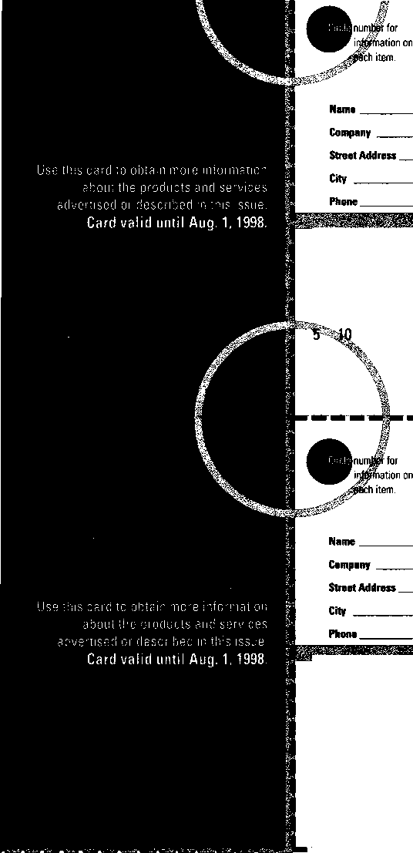

BUSINESS REPLY MAIL

FIRST-CLASS MAIL PERMIT NO 16501 DALLAS TX  
POSTAGE WILL BE PAID BY ADDRESSEE

NO POSTAGE  
NECESSARY  
IF MAILED  
IN THE

UNITED STATES

PO BOX 11602 RIVERTON NJ 08076-7202

I.II..1,1

BUSINESS REPLY MAIL

FIRST-CLASS MAIL PERMIT NO 16501 DALLAS TX  
POSTAGE WILL BE PAID BY ADDRESSEE

NO POSTAGE  
NECESSARY  
IF MAILED  
IN THE

UNITED STATES

PO BOX 11602 RIVERTON NJ 08076-7202

III...I..I.II...I...I.II..I...I..I.III I.II..1.1

Place

Stamp

Here

Robert DeWeese, CPL Bear Lock & Security, Inc. 205 Cleveland Ave. Baltimore, MD 21222-4237

|  |  |  |
| --- | --- | --- |
| Hardware Agencies, Ltd.  1220 Dundas Street East  Toronto, ON M4M 1 S3 (416) 462-1921 | McManus Locksmith Supply, Inc.  P.O. Box 9231,1309 Central Ave.  Charlotte, NC 28299 (702) 333-9112 | Turn 10  P. 0. Box 746  Marietta, OH m45750 (800) 848-9790; (800) 391-4553 |
|  | • • • | • • |
| Hardware Suppliers of America  P.O. Box 2208  Winterville, NC 28590 (800) 334-5625 | McMaster-Carr Supply Company  600 County Line Rd,  Elmhurst, IL 60126-2081 (630) 833-0300; FAX (630) 834-9427 | U.S. Lock Corporation  77 Rodeo Drive  Brentwood, NY 11717 (800) 925-5000; FAX (800) 338-5625 |
| • • | ••••ft | @ (Q 0 |
| IDN, Inc.  1000 S. Main, Suite 280  Grapevine, TX 76051 (817) 421-5470; FAX (817) 421-5468 | Monaco Lock Co.  339-345 Newark Ave.  Jersey City, NJ 07302 (800) 526-6094; FAX (800) 845-LOCK | Webster Safe & Lock Company, Inc.  3020 Millbranch  Memphis, TN 38116 (901) 332-2911; FAX (901) 332-2878 |
|  | ® • # | Q ^ ^ (0 (g) |
| Intermountain Lock & Supply Co  3106 South Main Street  Salt Lake City, Utah 84115 (800) 453-5386; FAX (801) 485-7205 | Omaha Wholesale Hardware  1201 Pacific Street, PO Box 3628  Omaha, NE 68108 (800) 238-4566 | Service |
|  | •••••••• |  |
| Jo-Van Distributors Inc.  929 Warden Ave.  Scarborough, Ontario MIL 4C6 (416) 752-7249; FAX (416) 752-3845 | E. L. Reinhardt Co., Inc.  3250 Fanum Road  Vadnais Heights, MN 55110 (800)328-1311; FAX (612) 481-0166 | Alarm Monitoring Service, Inc.  5021 Fairfield St.  Metairie, LA 70006 (504) 454-2163; (504) 456-8737 |
|  | •••••• | • |
| JLM Wholesale, Inc.  3095 Mullins Ct  Oxford, Ml 48371-1643 (800) 522-2940; FAX (800) 782-1160 | Security Lock Distributors  40 A Street  Needham Heights, MA 02194 (800) 847-5625; FAX (800) 878-6400 | Allstate Insurance Company  2775 Sanders Road, Suite A5  Northbrook, IL 60062 (847) 402-8196; FAX(847) 326-7509 |
| • • • | • • • | • |
| Key Sales & Supply Co., Inc.  9950 Freeland Ave.  Detroit, Ml 48227 (313) 931-7720; (313) 931-7758 | Sentry Security Fasteners  8109 N. University  Peoria, IL 61615  (309) 693-2800; FAX (309) 693-2872 | GEICO  One Geico Blvd.  Fredericksburg, VA 22412 (540) 286-4399; FAX (540) 286-7106 |
| ••••••••• | • • | • |
| Lockmasters, Inc.  5085 Danville Road  Nicholasville KY, 40356 (606) 885-6041 | Southern Lock and Supply Co.  Box 1980,10910 Endeavor Way  Pinellas Park, FL 34664 (800) 237-2875; FAX: (800) 447-2299 | The Hartford Financial Services Co.  55 Farmington Ave.; P.O. Box 2908  Hartford, CT 06104 (860) 520-2915; FAX (860) 520-2264 |
| • • • • | ••••••••• | • |
| Locks Company  2050 N.E. 151 St.  N. Miami, FL 33162 (800) 288-0801; FAX (305) 949-3619 | Stone & Berg Wholesale  99 Stafford Street  Worcester, MA 01603 (800) 225-7405; FAX (800) 535-5625 | Pine Technical College  1000 4th Street  Pine City, MN 55063 (800)521-7463; FAX (612) 629-7603 |
| ^ <Ui @ (p (g^ ^ | •••••••••• | • |
| The Locksmith Store Inc.  1229 E Algonquin Rd. Suite E  Arlington Heights, IL 60005 (847) 364-5111; FAX (847) 364-5125 | Strauss Safe & Lock Company  1801 Second Avenue  Des Moines, IA 50314 (515)288-9571; FAX: (515)288-9752 | Unlocks, Inc.  3505 Tarpon Woods Blvd. G409  Palm Harbor, FL 34685 (800) UNLOCKS; FAX (813) 787-7960 |
| • Ml | •••••• |  |
| M. Zion Company  17 Murray Street  New York, NY 10007 (212) 349-8677 | Umemaster, Inc.  127 SE 29th Street  Topeka, KS 66605  (785) 232-8705; FAX (800) 798-8463 |  |
| ^ @ (|^ (0 | <0 ^ (§) |  |
| McDonald-DASH Locksmith Supply  5767 E. Shelby Dr.  Memphis, TN 38141 (800)238-7541; FAX (901) 366-0005 | Top Notch Distributors, Inc.  3151 GoniRd.  Carson City, NV 89706-7922 (800) 722-4210; FAX (800) 248-3620 |  |
| •••••••• | • • • |  |
|  |  |  |
|  | | Mi |

April 1998

Keynotes

Classified



[Dept)

■Employment

Security Technician Wanted

3/F/3: Suburban Chicago compa­ny seeking top notch security technician for permanent full­time position, top pay, health insurance, paid vacation, retire­ment plan, company vehicle pro­vided. Ninety percent commer­cial work, this is an excellent opportunity for the right person. **Contact: Ron at (847) 272-2211**

Locksmith Wanted

2/P/3: Stanford University seeks a Lock Shop Supervisor with an extensive understanding of locks, safes and security systems, and working knowledge of journey-level locksmithing.

Your primary responsibility is to supply efficient, timely and value-added services to the University facilities. In addition, you will supervise the work of seven locksmith technicians.

To qualify, you must have a supervisory background, strong business management skills and experience using preventative, routine and reactive maintenance practices. Excellent time management, organizational and communication skills are a must, as is the ability to think clearly and analytically and identify/ solve problems. A valid California driver’s license or ability to obtain one prior to start date is required. For a full description of this and other positions, see us on the Web at: www-leland.stanford.edu/group /employment. AA/EOE **Resume and cover letter to:**

Stanford University Human Resources Services,

Req. **#** J972511 655 Sierra St.

Stanford, CA. 94395-6110 ***Keynotes*** April 1998

Locksmith Wanted

4/F/3: Seeking professional outside field technician. Clean driving record, professional appearance, good communica­tions skills and must meet requirements for an Illinois locksmith Permanent Employee Registration Card. General locksmith background along with electronic access control and safe penetration and servicing required. Salary commensurate with experience. Benefits include family health insurance, paid sick leave, and paid vacation. Pension plan available. We have been in the locksmith business for 90 years. Located 40 miles south of Chicago in Joliet, Illinois.

Contact:

Bob or Spero (815) 722-2431 (815) 722-6635 fax

Employment Wanted

4/P/2: Well-known industry figure looking for the perfect career opportunity with quality, teamwork oriented manufacturer or distributor. Certified Master Locksmith, Certified Master Safe Technician, Certified ALOA Instructor, recipient of several major industry service awards, strong teaching and technical writing skills, more. Willing to relocate for the right opportu­nity. Resume on request.

All inquiries to:

Keynotes 3003 Live Oak Dallas, TX 75204 (214)827-1701 (214) 827-1810fax

Automotive Locksmith Wanted

3/F/3: Relocate to south Florida and throw away your deadbolts and three keys for a dollar. We run over 300 calls per week. You must own a truck with tools and code equipment to cut all foreign and domestic keys. You can earn $800 to $1,500 per week. Please, no calls if you don’t have a truck or tools.

Contact: South Florida Lock and Safe (800) 928-2926

Locksmiths Wanted

2/F/3: Largest Locksmith in Las Vegas needs experienced locksmiths (two years minimum) for road technicians and counter help. Base salary plus generous commission program. This is a career opportunity with paid holidays and vacation, medical benefits, 40IK plan, and a great advancement potential.

Resume to:

Liberty Lock & Key 5470 W. Sahara Las Vegas, NV 89102 (702) 876-5470

Locksmith Whnted

2/F/3: Minimum two years experience in service work.

Safe, alarm and access control experience a plus. Must have clean driving record, good communications skills, be hard working and neat in appearance. Salary and benefits commensurate with experience and training.

Resume to:

Lockbusters, Inc.

P0 Box 72045 Houston, TX 77272-0475 (281) 265-3335 (281)265-9434 fax

Locksmiths Wanted

2/F/3: Colorado’s largest locksmith company seeks locksmiths with experience in impressioning, master keying and automotive. Top wages and benefits available for the right persons.

Resume to:

Colorado Security Products, Inc.

5005 South Kipling; Unit A-8 Littleton, CO 80127 (303) 761-4899, Monday through Friday, 8 am - 5 pm, MST

Locksmith Wanted:

4/F/3: Experienced locksmith. Good with hands excellent with people. Room to grow with expanding company in Texas. Five day week, health and life insurance, paid vacation and holidays, profit sharing plan, and uniforms. If you want a professional work place with multiple locations.

Resume with references and salary history to:

4021 Belt Line, Ste. 104 Dallas, TX 75244-2322

■Businesses for Sale

For Sale

3/F/3: Well established locksmith business, many com­mercial, and industrial accounts, residential and automotive work is also a part of this very successful shop. Established in 1971, we have continued to grow reaching a $180K Gross. Located in central Wisconsin near good fishing, hunting, and recreational areas. This commu­nity is growing, with a strong base of industry, large office complexes, and a state university. Our service area is unlimited in the surrounding counties. This is the right opportunity for the

Classified Advertising Policy

Classified advertising space is provided free of charge to ALOA members, and for a fee of $.60 per word, $15 minimum for non-members. Classified ads may be used to advertise used merchandise and overstocked items for sale, “wanted to buy” items, business opportunities, employment opportunities/positions wanted and the like. Members or non-members wishing to advertise services or new merchandise for sale October purchase a “Commercial Classified Ad,” for a fee of $1.30 per word, with a minimum of $40. Each ad will run for two issues. For blind boxes there is a $5 charge to members and non-members. All ads must be submitted in writing to the ALOA office by the fifteenth of the month, two months prior to issue date. Send to **Keynotes** Classifieds, 3003 Live Oak St, Dallas TX 75204-6186. ALOA reserves the right to refuse any classified advertisement that it deems inappropri­ate according to the stated purpose of the classified advertising section.

right individual. Owner wants to  
retire, but will stay on for a  
smooth transition. The asking  
price is negotiable according to  
equipment and vehicles desired.  
Call: (715) 341-9165

For Sale

3/F/3: Locksmith shop for sale in  
upper-Midwest town of over  
60,000. Business is 10 years old  
and still growing. Average gross  
for '93-'97=$236,000. Three  
person operation, but could  
easily support more. Very little  
competition, with 80%  
commercial and automotive  
accounts. Two fully-equipped  
service vans (1200s Adrian steel  
cabinets, 110 vt. power, etc.).

Good lease on shop with  
option to buy. Buyer must be  
competent in all aspects of the  
trade. Owner will stay on as  
needed to insure smooth  
transition. This is a turn-key  
operation, and a good buy for  
the right person. Local banker  
willing to prepare and finance  
a SB A loan. Owner wishes to  
relocate out of state. Selling price  
of $181,000 - includes all  
inventory, equipment, vans,  
accounts, and a very good  
reputation. No CDs. Serious  
inquiries only.

Respond to:

Keynotes Classifieds  
3003 Live Oak  
Dallas, TX 75204

■Wanted to Buy/Sell  
For Sale

3/F/3: Safe Dialer for sale.  
ITL1000 auto safe dialer without  
the new dial clamp. $1000.  
Serious inquiries only.

Call: (618) 466-9347

Wanted

3/F/3: Lefebure 7301 and 7302 double big and big nose little safe deposit locks or hornplates, with or without keys.

Call Harold at (800) 697-6053 (253) 846-2291 fax

For Sale

2//F/3: Curtis Automatic/ Manual Key Machine MOD. 3100-040. Practically new - $450.00+.

Call:

Thompson Lock and Security (912) 375-3331 (912) 375-8550 beeper

For Sale

4/F/3: Framon 2 Code Machine. New model. New condition.

All cutters parts. D & S Book, Calipers never used. $795.

For information, call (316) 262-0595

For Sale

4/F/3: Reed Code Books for sale. General volume one through nine, Padlock volume one through three, Foreign auto volume one through two. Take all for $200. Also, HPC General Code Book Volume One for $195.

Call Don Brown:

(805) 487-3949

■Commercial Classifieds

3/P/3: Quality Master Key System. Let our 30 years experience and quick turnaround establish any level master key system. Ship us any manufactur­ers cylinders. We will cut/stamp keys, master key locks, and ship back to you.

Contact:

Locknology Industries, Inc.

(888) 750-LOCK [locknology@torchlake.com](mailto:locknology@torchlake.com) email

ALOA Members only

AT&T offers members of Associated  
Locksmiths of America, Inc. an additional 5%  
discount on your business long distance. You  
can literally “profit by your association!”

Call 1 800-822-7756 ext. 737F to sign up now.

i^AT&T

Reader Service #9

NEW ILCO DISTRIBUTOR!!

Monday Security Corporation  
**1-800-886-6721**

Contact Laura for details  
on dealer discounts

We carry almost every make  
and model of new and  
used safe deposit locks,  
and safe parts, specializing  
in the antique parts.

Have you received our  
catalog?

Reader Service #10

L

April 1998

Keynotes

PRP

Report

^avicTOwell,

CML, CMS

PRP/Education Managerl

Proficiency Registration Program

Available to locksmiths worldwide, ALOA’s proficiency registration program (PRP) evaluates

the educational and technical competence of dedicated individuals in 36  
categories such as hardware installation, high security and safe/safe vault locks, master keying,

alarms and access control devices. There are four levels of PRP certification:

Registered Locksmith (RL)

Certified Registered Locksmith (CRL)

Certified Professional Locksmith (CPL) and Certified Master Locksmith (CML)

Still Getting Calls on Most Frequently Asked Questions.

I am still getting calls about the category changes that have taken place in the past several years. If you have not participated in a sitting for some time, and are planning to do so again soon, you might want to review the following when you are filling out your application.

1. The combining of C01 and C02 (Basic and Advanced Alarms) into the new category, L42 (Alarms).
2. If a candidate has passed either one, they will retain that credit and may take L42 for additional credit.
3. If a candidate has passed both, they may not sit for L42.
4. If a candidate has not taken or failed both, they may only sit for L42.
5. The splitting of C09 (Cylinder Servicing, Interchangeable Core) into the new categories of L38 (Interchangeable Core, Best Style) and L39 (Interchangeable Core, other than Best Style).
6. If a candidate has passed C09, they will retain that credit, and may take either or both L38 and L39 for additional credit for each one passed.
7. If a candidate has failed C09, they may only take L38 and L39.
8. The combining of Cl4 (Electro-mechanical locks, basic) and Cl5 (Electro-mechanical locks, advanced) into the new category, L40 (Electro­mechanical Access Control).
9. If a candidate has passed either one, they will retain that credit and may take L40 for an additional credit.
10. If a candidate has passed both, they may not sit for L40.
11. If a candidate has not taken or failed both, they may only sit for L40.
12. The combining of C35 (Locks, detention) and C36 (Remote door, detention) into the new cate­gory L43 (Detention Locking Systems).
13. If a candidate has passed either one, they will retain that credit and may take L43 for additional credit.
14. If a candidate has passed both, they may not sit for L43.
15. If a candidate has not taken or failed both, they may only sit for L43.

Also, you might want to note that the appli­cation period has been shortened from 30 days to 15 days. I hope adding this flexibility in scheduling will help

Are You Sure You’re Registered?

If you faxed or emailed your PRP registration and did not receive confirmation within 24 hours, please contact the ALOA office at (214) 827-1701.

New Certifications

New CMLs

Greenan, John J./Chicago, 111.

New CRLs

Green, Gregory T./Cedar Hill, Texas Kisling, Reid A./Dallas, Texas Rucker, Thomas S./Cincinnati, Ohio Spiwak, Steve/Plano, Texas Vitale, Norman E./Pawcatuck, Conn.

Zahedi, Mehdi/Kettering, Ohio

About the Manager: David Lowell,

CML, CMS, is ALOA’s immediate past president  
and an ALOA Trustee. David has served on the  
ALOA board for 10 years. He aims and operates  
Phoenix Lock & Key in Arizona, and has been an  
ALOA member since 1981.



|  |  |  |
| --- | --- | --- |
| PRP Dates* |  |  |
| April 5,1998 | May 10,1998 | June 18-19,1998 |
| Poison, Mont. | Washington, D.C. | Nashville, Tenn. |
| Montana Chapter | Clark Security Products | ALOA ’98 Security Expo |
| Rene Rasumssen | Terri Burges | David M. |
| (406) 883-8539 | (800) 854-2088 | Lowell,CML,CMS (800) 532-2562 |
| April 25, 1998 | May 16,1998  Boston, Mass. | 15-day application period |
| Anaheim, Calif. | required |
| American Security | North Bennett Street |  |
| Distribution  Debby Lussier | School  Jack Hobin, CPL | August 2,1998  St. Charles, III. |
| (909) 371-2607 | (617) 227-0155 | Clark Security Products Terri Burges |
| April 26,1998 | May 23,1998 | (800) 854-2088 |
| Eau Claire, Wis. | King of Prussia |  |
| Indianhead Chapter  John Dorsey, CPL | (Valley Forge), Penn. SAFETECH |  |
| (715) 832-4207 | David M. Lowell (214) 827-7233  May 31,1998  Chicago, III.  ALOA Education Conference at ISC  David M.  Lowell,CML,CMS (800) 532-2562 |  |

September 2,1998

New York, N.Y.

ALOA Education Conference at ISC David M.

Lowell,CML,CMS (214) 827-1701

September 13,1998

Philadelphia, Penn. Greater Philadelphia Locksmiths Association William L. Young, CML (610) 647-5950

September 20,1998

Burbank, Calif.

Clark Security Products Terri Burges (800) 854-2088

October 4,1998

Independence, Ohio POLA

Martha Eggler (216) 676-8464

October 18,1998

Omaha, Neb.

MINK Locksmith Convention Elmer Howard (402) 330-8701

October 23,1998

Portland, Ore.

Tri-Regional Locksmith Convention John Kerr (503) 253-0424

NOTICE: If you have faxed/emailed your PRP registration and do not receive confirmation within 24 hours, please contact the ALOA office at (214) 827-1701.

* Two-week application period.

Keynotes

April 1998

LAST CHANCE! DEADLINE APRIL 26!

ALOA ’98 International Convention & Security ExpoJ^P



*Nashville has always been referred to as Music City USA, so get ready for  
the hits! An ad in* Keynotes, ALOA ’98 Daily *and the on-site program will  
make a hit of your booth! Don't delay. Make the most of the following  
discounts* when you advertise in all three convention publications.*

June/July Issue 15%

Convention Daily 20%

Convention Program 25%

*/*

*\* Discounts do not include color process or production charges.*

*Ads for all three publications must be purchased in order to receive the above discount.*

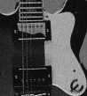

Standard Convention Publication Rates

Space reservations are due by April 26, 1998.

Contact ANELIA or D’ANNA for specific pricing.

|  |  |  |  |
| --- | --- | --- | --- |
| June/July Convention Issue  BC/Gatefold Spread** $4,050  IBC/IFC** 4,050 | | Daily  Newsletter  $2,000  1,500 | ALOA ’98 Program  $1,400  675 |
| Tab Page | N/A | N/A | 625 ** |
| Full Page | 2,000 ** | 1,100 | 450 |
| 2/3 Page | 1,782 | N/A | N/A |
| 1/2 Page (Horizontal) 1/3 Page | 1,287 | 800 | 350 |
| 1,158 | N/A | N/A |
| 1/4 Page (Vertical) | 792 | 500 | N/A |
| 1/6 Page | 715 | N/A | N/A |
|  |  | **Includes Color Charges | |

Nashville Convention Center

Nashville, Tennessee

June 14-20,1998

*Associated Locksmiths of America  
214.827.1701  
800.532.2562  
214.827.1810fax  
e-mail [convtion@anet-dfw.com](mailto:convtion@anet-dfw.com)*

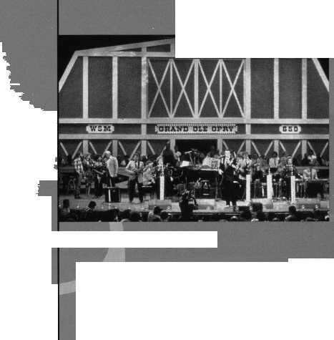

|  |  |
| --- | --- |
|  | News _ |
| (chapter |  |
|  | ^manjnJamum, CML |

***y ALOA chapter members can write to Dana Barnum at: CHAPTER NEWS; 3003 Live Oak Street; Dallas TX 75204; fax (214) 827-1810; aloa@anet-dfw. com***

So, you and some local or regional peers are ALOA members and would like to start a chapter?

This column will give you the run-down on the “who, what, why, and how” aspects of chapter-starting as well as some helpful hints.

First, let’s start off with the initial concept in planning a chapter: Why to start one?

An ALOA chapter will allow you to participate more directly with the association’s activities. Plus, the status of a chapter will attract more ALOA sponsored programs to members on regional and local levels as well as helping prepare those who have an interest in becoming an association and/or industry leader.

You can learn more about ALOA’s programs by simply networking with or speaking with various locksmiths in your area. Perhaps the best way to learn more is to simply participate in as many ALOA activities as possible. That, in itself, is a great way to exchange management, technical information and tricks of the trade with colleagues and peers.

The following is what chapters receive from ALOA:

* Support in starting new chapters and continued support for existing chapters;
* Discounts on Ace Classes, along with other continuing education opportunities;
* Technical Training videos for chapter use from the chapter video library;
* Promotion of chapter activities in Keynotes;
* Free mailing labels of all ALOA members in the chapter’s region;
* Direct support from ALOA chapter liaison staff and the ALOA committees such as the Legislative Committee; and
* Assistance in chapter officer training.

If all of this sounds good to you, then the next logical question would be, “How do we get started?”

First, contact the Regional vice president of your area. He/she will be a chapter’s reporting link to both ALOA Headquarters and the ALOA board of directors. The Regional vice president is also in charge of the guidance and formation of chapters. He/she also aids chapter growth and programs and ultimately decides the potential interest for a chapter in the area

to recommend boundaries and distribute promotional materials.

The next step is to submit a chapter petition.

This involves selecting a name (most often in reference to region, i.e. Southwest Texas, Central Michigan, etc.). The name has to be something that quickly defines the area of the chapter.

Then, boundaries must be set up. The RVP will assist you with this. If there are no other chapters within a 200 mile radius, there should be absolutely no problems. But if you’re in an area where ALOA chapters are in abundance (New York City, Los Angeles), then extra care should be taken not to infringe on another chapter’s territory.

Avoid this by simply drawing a map of the proposed boundaries and forwarding it to the adjacent chapters requesting their input in writing. When final boundaries are completed, attach a copy of the letter of agreement so the board of directors can ensure that all area chapters are in accord.

Also, attach a list of inclusive zip codes for the chartered area to the petition. This is pertinent information for the ALOA Headquarters to use in chapter assignment.

It should be noted that this is only applicable for chapters within the United States.

There must be at least 20 members in good standing to sign the petition. This shows that there’s enough interest to support this chapter.

Then, submit the petition. Include the completed Chapter Charter Petition with all attached documents (ZIP code listing, letters from surrounding chapters etc.) to the Regional vice president for endorsement.

If the RVP endorses the petition she/he will submit it to ALOA Headquarters for action by the board of directors at their next meeting.

Before all is said and done, begin generating interest from prospective members by actively recruiting in your area. Remember, however, that until the board of directors has officially approved the Chapter Charter Petition and the RVP conducts the initial election of officers, all applications must be endorsed by the RVP. After the petition is approved, an elected chapter officer may endorse applications.

*l

When the petition is approved by the board of directors, the RVP will be notified by ALOA Headquarters and sent the Chapter Charter, Policy Guide, and other stationary and literature for the chapter.

At that time, the RVP will contact the chapter to establish a date for the organiza­tional meeting. There, the RVP will conduct the initial election and installation for chapter officers and present the charter and other items.

Invitations to this meeting will be issued to all the ALOA members within the chartered area. For the purpose of the organizational meeting, a majority of the petitioners (those actually signing the petition) shall constitute a quorum for the conduct of business.

These signers of the petition will automat­ically be assigned membership into the new chapter. If any other individual, currently a member of another chapter, wishes to join, your chapter must submit a written request to Headquarters. To facilitate the process during the first few months, the chapter should make available a transfer petition for those wishing to transfer to sign.

The transfer petition should read as follows:

“We, all members in good standing of the Associated Locksmiths of America, do hereby request transfer to theChapter.”

Each member must sign the petition, print his/her name, give his/her membership number and state from which chapter he/she is transferring.

This transfer petition should be submitted with each month’s chapter activity report.

\ About the author: Dana

Barnum, CML, #05444, operates South Penn  
Lock & Safe Co. in Media, Penn. He has been on  
the board of directors of the Greater Philadelphia  
Locksmiths Association (GPLA). Dana has also  
sponsored many new ALOA members. Dana can  
be reached at FAX (610) 565-9902 or email  
him at [danabarnum@aol.com](mailto:danabarnum@aol.com)

Keynotes

April 1998

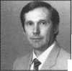

Chapter

Roster

Dept

**^ The best way to learn about ALOA’s programs  
and to network with locksmiths in your area is by  
participating in local ALOA chapter activities. This  
is your opportunity to exchange management and  
technical information, build your professional image,  
and share trade tips with your fellow locksmiths.**

**If you want to start a chapter in your area, please  
call ALOA, (214) 827-1701.**

Alabama

Alabama Locksmiths Association

2980 Hartford Hwy, #2 Dothan, AL 36305 (334) 793-5060 *James Turner, CPL- Chairman

Arizona

Grand Canyon Chapter

1905 E. Weber, Suite 108 Tempe, AZ 85281 (602) 921-0123 *John Ilk, CRL-Chairman

California

Los Angeles/

Orange Counties Chapter

P.O. Box 697

Alhambra, CA 91820-0697 (310) 869-2555 *John H. Cosby, CPL

San Diego Chapter

1049 Island Ave.

San Diego, CA 92101-7228 (619) 234-4829 Burt Fieser-Chairman

Colorado

Colorado Front Range

2055 26th St.

Boulder, CO 80302 (303)443-9740 John I. Shandy, CML- Chairman

*John M. Thomas, CRL- Vice Chairman (303) 666-8980

Connecticut

Nutmeg Chapter

Phil’s Lock Shop 360 E. Main

Meriden, CT 06450-6022 (203) 237-4602 Phillip Hobbs, CPL- Chairman

Florida

South Florida Chapter

1710 NE Miami Gardens Dr. Miami, FL 33179 (305) 944-0469 *Jerri Moeller, CRL— Secretary

Paul Renderer, CML- Chairman

Georgia

Georgia Chapter

P.O. Box 48088 Atlanta, GA 30362-1088 (404)455-6244 Michael D. Robinson, CRL- Chairman

*M.W. Whitman, Jr.

Hawaii

Hawaii Chapter

David Reisz, CRL Beaumont-Reisz Co.

P.O. Box 88225 Honolulu, HI 96830-8225 (808) 924-9644

Indiana

Central Indiana

1237 Wabash Ave.

Terre Haute, IN 47807 (812) 234-6249 *Herbert Dusenberry, CML- Chairman

Northern Indiana

122 N Orchard St. Kendallville, IN 46755 (219) 347-1754 *Steve Youngblood- Chairman

Southern Indiana

P.O. Box 185 Bloomington, IN 47402-0185 (812) 334-3737 *Daniel W. Hill, CML- Chairman

Kentucky

Kyana Chapter

510 E. Parrish Ave. Owensboro, KY 42303-3125 (502) 684-5093 *Timothy Morrison, CML-Secretary

Maryland

Chesapeake Chapter

205 Cleveland Ave. Baltimore, MD 21222 (410) 633-0111 *Bob De Weese, CPL- Chairman

Massachusetts

Massachusetts Chapter

200 Weir Street Taunton, MA 02780 (508) 823-4649

* Stephen Ehrlich, CML- Treasurer

Minnesota

Minnesota Chapter

3M Center

Bldg. 223-BE-04

St. Paul, MN 55144-1000

(612)733-6674

*Douglas Rude, CRL

Montana

Montana Chapter

Mountain Locksmithing 210 N 7th Bozeman, MT 59715 (406) 586-5187 *Jim Morrissey, CRL- Chairman

Carol Morrissey, CRL- Secretary

Nebraska

Nebraska Chapter

343 W. 2nd St.

Hastings, NE 68901 (402) 463-6661 *Brad Boden

Nevada

Sierra Nevada Chapter

C/O Pamela Vankirk P.O. Box 115 Reno, NV 89504 (702) 328-9285 *Danniel F. Howard,

CML—Chairman

New Jersey

Garden State Chapter

106 Ridgedale Ave. Morristown, NJ 07960 (201) 538-2737

* Steve Frei, Chairman

New Mexico

New Mexico Chapter

917 2nd St. NW Albuquerque, NM 87102 (505) 242-1380 *Evelyn Wersonick, CML Marc McGrannahan, Chairman

Sunbelt Chapter

1750 E. Lohman Las Cruces, NM 88011 (505)523-7147 *Joe Triste

North Dakota

North Dakota Chapter

Rte. 1 Box 67 Devil’s Lake, ND 58301-3907 (701)662-5625 *James H. Strong, CRL

Ohio

Ohio North Coast Chapter

#2 Horseshoe Drive Monroeville, OH 44847 (419) 465-4153 *Ronald Betschman, CML- Chairman

Ohio Valley Chapter

144 Julep

Cincinnati, OH 45218 (513) 825-7528 *James T. Brickler, Chairman

Pennsylvania

Keystone State Chapter

3 W 4th St.

Bridgeport, PA 19405 (610) 272-9292 *Barry Leas, CRL

South Dakota

South Dakota Chapter

402 S. Minnesota Ave.

Sioux Falls, SD 57102 (605) 331-6026 * Ronald Heidzig— Chairman

Tennessee

Smokey Mountain Chapter

2557 Middle Creek Rd. Pigeon Forge, TN 37863 (615)453-8344 *Jessie Swan, RL

West Tennessee

1261 Wellsville Rd. Memphis, TN 38117 (901)685-1130 *John Singleton

Texas

Sunbelt Chapter

see New Mexico listing

Washington, DC

Washington, DC Area

2987 Thomas Rd.

Bryan Road, MD 20616 (301)283-0145 * William Smith, Jr., CML- Chairman

Wisconsin

Fox Valley Chapter

1425 N. Richmond St. Appleton, WI 54911 (414) 731-5400

e-mail [sageinc@athenet.net](mailto:sageinc@athenet.net) *John F. Engel, CRL- Chairman Matt Swoboda- Vice Chairman

Indianhead Chapter

201 N. Barstow St.

Eau Claire, WI 54703-3525 (715) 832-4207 *John Dorsey, CPL- Chairman

Wyoming

Wyoming Chapter

5920 E. Pershing Cheyenne, WY 82001 (307) 638-8752 *Betty Crenshaw, CML

International Chapters **Korea Chapter**

Suh Man Soo, President

*Joe J. Lee

5430 Howland St.

Phila., PA 19124 Phone and fax: (215)744-5254

* Denotes contact person for this chapter.

All questions regarding chapter activities, meetings and events should he directed to this individual.

April 1998

Keynotes



It pays

to have new faces  
in the crowd.



During 1998  
each ALOA member  
who sponsors  
a new applicant  
will receive $40 cash  
(upon clearance,  
and payment

of application fee and dues).

|  |  |
| --- | --- |
| ALOA | 1 |
| Extra | 1 |



Depti

**Keynotes** Editorial Calendar

For those readers who have asked for a reminder about what we’ve got coming up during 1998, here a list of our planned topics through the end of the year. If you are planning to submit an article yourself, please remember that an article idea needs to be discussed ahead of time with the technical content advisor, John Cannon, CML, at (703) 960-6413; [jdcannon@worldnet.att.net](mailto:jdcannon@worldnet.att.net) (email). Business articles, articles about your chapter or association, or any others of a less technical nature can be discussed directly with the ALOA editorial staff (Anne Davis and Mike Emery) at (214) 827-1701; [publ@anet-dfw.com](mailto:publ@anet-dfw.com) (email). Final copy for approved articles in development is due the 15 th of the month, two months prior to the issue date. (Example: Most article ideas for June/July have already been approved; copy for that issue will be due April 15.) If you have breaking news and need a deadline extenstion, please contact Anne Davis as soon as possible.

MAY

Safes

Education

JUNE/JULY

New Products ALOA ’98 (preview)

AUGUST

Master Keying ALOA ’98 (coverage)

SEPTEMBER

Crime Prevention The ALOA Member

OCTOBER

Automotive

Chapters and Local Associations

NOVEMBER

Tools and Equipment Business Success

DECEMBER

Access Control Locksmith History

Obituaries

We recently said a regretful “Good-bye” to Ernest Moore. Moore was 79 years old and had been one of the driving forces behind Moore’s Locksmith Shop in Almena, Wis.

Earl Ames will also be sorely missed. He was a founder of the Penn-Ohio Locksmith Association (POLA) and was an avid golfer until the end.

ALOA also bid a sad farewell to another longtime member in Kenneth “Kenny” Kanode of Clay Center, Kansas. He had been the principal figure behind Kenny’s Lockshop and an ALOA member since 1963.

Pins, anyone?

All those interested in 10, 20, or any other number of decades pins, please note that they will be mailed out this month. Thank you for your patience.

Mail Box Correction

A note from “Mail Box”: The author of “To Be or Not To Be” in the March issue was incorrectly identified. The author is Don Dekuyper, president of the Association of Ontario Locksmiths.

Hint Word List

Following are the “hint” words for the crossword puzzle on page 60.

Conversion Code Yale

Keyed Alike

Hooks

Padlocks

Keyway

Stem

Drills

Spacing

Direct Code

Tumblers

Plugs

Drivers

Shell

Master Keyed

***Keynotes Advertisers Index***

RS# Advertiser

9 AT&T  
8 Abus  
5 BWD  
11 ISC _

100 Jet Hardware Mfg., Inc.

KSP

Locksmith Publishing  
Marray

Monday Security Group

NKL

Timemaster

Winfield

53

47

33

59

BC

33

36

27

53

29

7

38

Keynotes

April 1998



**MOA Conference Program eflptionak Security Confere**

**ce & Exposition**

Hfafc^tagd-ALone^ccess Control Certification • ield Micro Ke^^plonic Lode Certification • Electric Strikes Application^PfMallatio^ Complete Door with Door Closers * *5ervicinctffiflfuroinum Storefront Doors • Studymf^for And Pafii^The PRI^* Nanotechnology Certification^ Detex Hardware Certification •

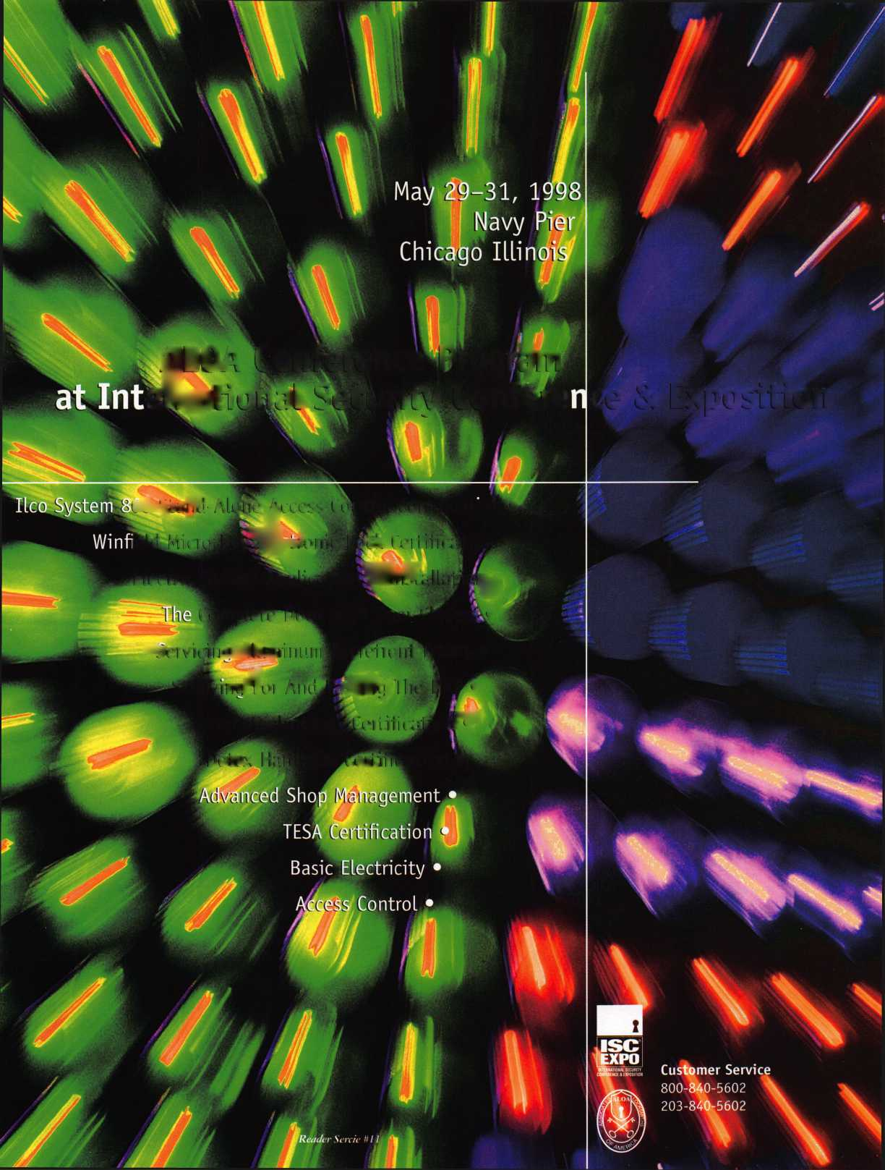

Across Clues:

Down Clues:

Answers to last month s puzzle:

April 1998

1. Pins or wafers
2. Housing
3. 473528
4. 2X05
5. Top Pins
6. Distance cut to cut
7. Secures your hasps  
   13. Broaching
8. Right one turns lock
9. Cores

2. 1 lock/2 keys

3- Modern lock inventor  
4. 2 locks/1 key  
8. “Rotary picks”

1. Lockpicking tools  
   12. Tailpiece

|  |  |  |  |  |  |
| --- | --- | --- | --- | --- | --- |
| p |  |  |  |  |  |

|  |  |
| --- | --- |
| I ■ | |
| 'h | A | R I'D] | >  m |
| TI^BT |  |
|  |  |
| ■'H 0 L | EjfelAjWl |
|  | |H| 1 I |
| ■;kWR | BiIk |
| k] E | m m" |
|  |  |
| I | gt 1 U | T | |
| IpB i | ■XhbI |
| |17|a[s|t | [e|r B |
| ■ | | |
| ■ N!S | | T IA |3L 1 L 1 |
| B k m i | IeI |
|  | V |E |

|  |  |  |  |  |  |
| --- | --- | --- | --- | --- | --- |
| p |  | 2 |  |  |  |
|  | |  |  | | |
|  |  |  |  |  |  |
|  | |  |  | | |
|  |  |  |  |  |  |
|  | |  |  | |  |
|  |  |  |  |  |  |
|  | |  |  |  |  |
|  |  |  |  |
| In |  |  |  |  |  |
|  | | | |  |  |
|  |  |
| ll 4 |  |  |  |  |  |

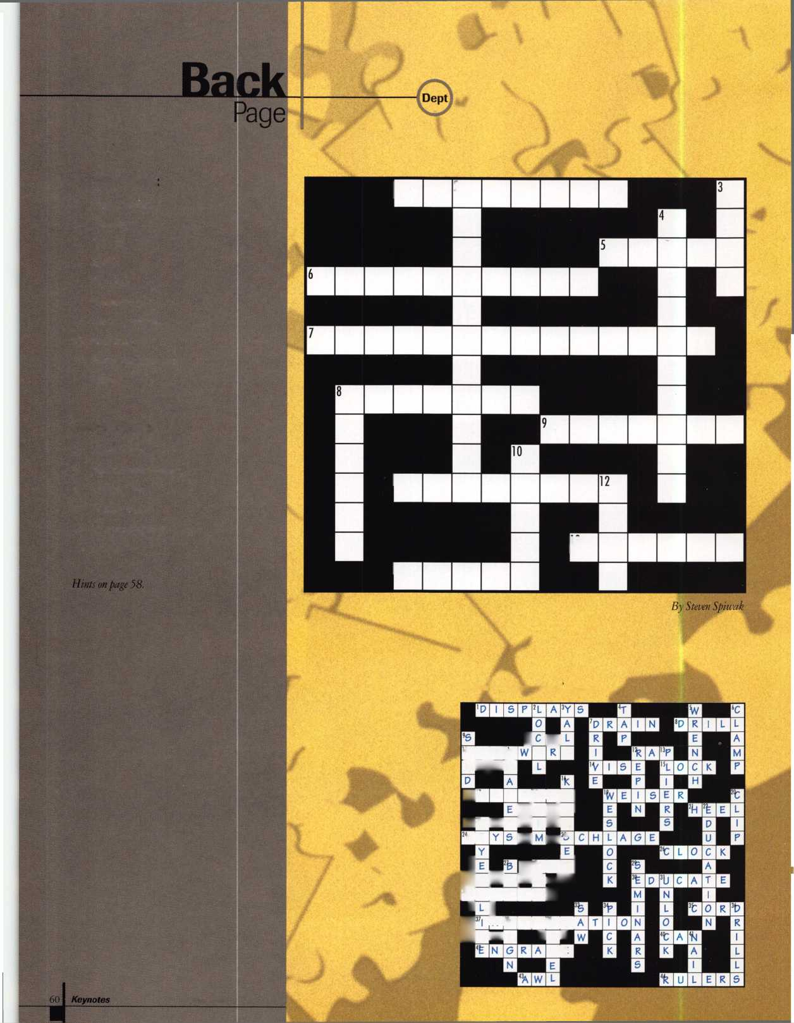

Sneak Peak The Whole Package

$100 May, June/July, August Keynotes

$500 “Sneak Peak” (May, June/July, August Keynotes),

New Product Display Area (June Convention Site),  
new products brochure, Inside Track (June hand-out,  
August insertion)



Space reservations

March 26, 1998

Contact ANELIA

or D’ANNA for

specific pricing

and information,

Nashville Convention Center

Nashville, Tennessee

June 14-20,1998

*Associated Locksmiths of America*

*214.827.1701*

*800.532.2562*

*214.827.1810 fax*

*e-mail [convtion@anet-dfw.com](mailto:convtion@anet-dfw.com)*

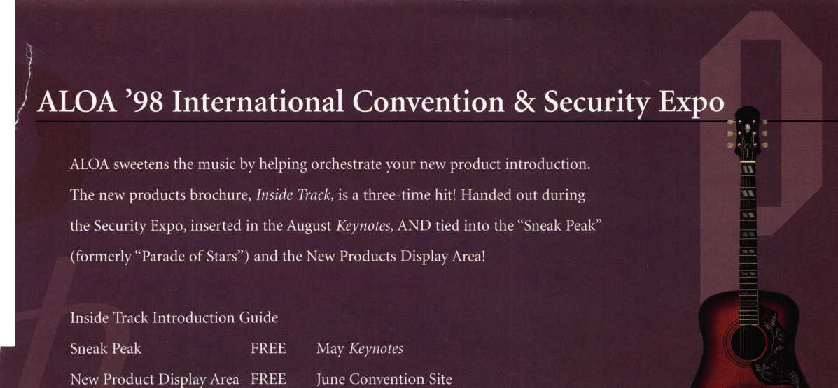

♦ ♦♦

The Jet **etd-i**

Transponder Key  
Duplication made Easy.

Don’t be locked out of the growing market of electronic anti-theft automotive security. This easy-to-use decodei quickly and accurately duplicates the most popular transponder keys, including: CADILLAC CATERA, HONDA, ACURA, MAZDA and AUDI /VOLKSWAGEN. Included with your purchase are 5 each of the above keys (a value of $ 295.00), along with a colorful window decal.

Available through your favorite JET distributor.

JET HARDWARE MANUFACTURING CORP

800 Hinsdale Street, Brooklyn NY 11207  
Free Information - Reader Service Card #100

**Don't Be locked  
Out ot the Electronic  
Auto Transoonder**

**WW m m HII vpr wills wl**

**Key Market**

